Withington Wheelers Cycling Club
25-mile Novices and open time trial
Promoted for and on behalf of Cycling time trials under their rules and Regulations
Incorporating the Cheshire points series race 4.
Saturday 2nd April 2022
Using Course J2/9.
There are road works on possibly J2/9 and on J4/8 and the course chosen at the moment is J2/9.
This may be subject to change on the day.

Headquarters - Allostock Village Hall - Chapel Ln, Allostock, Knutsford WA16 9LP
The Village Hall is located off the main A50 London Road approx. 0.5-mile past Mangoletsi Garage and just North of Boundary water park.

We should be able to park on the sports ground at the village hall weather allowing and have use of the hall, kitchen, and toilets.
Signing on and off, number collection will be in the hall. There will be a result board and refreshments after the event.

First rider off at 2-01pm

Timekeepers
START: Tony Millington FINISH: Martin Jackson

Minimum Prize List for event. (One rider one prize except for teams)
Seniors | 1st | £25.00 2nd £20.00 | 3rd | £15.00
Females | 1st | £25.00 2nd £20.00 | 3rd | £15.00
Juniors | 1st | £15.00
Juveniles | 1st | £15.00
Team |  | £10.00 each (3 riders)
Vets Std | 1st | £15.00
Fastest Vet |  | £15.00
Fastest Novice £15.00
- "For the purposes of this event a Novice is a rider who has never completed a solo event at 25 miles under RTTC/CTT regs".

Sadly, entries are lower than usual, so we have had to reduce the level of prizes and amount awarded.

J2/9 COURSE DETAILS
START At A “JS2” mark in Bomish Lane (Jodrell Bank to Goostrey road). At a telegraph pole No 2 approx. 300yds west of the A535.
Proceed East to the A535 and forward on the A535 to: - CHELFORD ISLAND 2.169 m
2nd exit left on the A537 to Seven Sisters Lane at: - OLLERTON CROSSROADS 5.219 m left along the lane to A50
left on the A50 to Twemlow Lane at: - CRANAGE 11.408 m
left into and along the lane to join the A535 at Twemlow Green,
left to: - CHELFORD ISLAND 18.064 m 2nd exit
left on the A537 to Seven Sisters Lane at OLLERTON CROSSROADS 21.052 m
left along the lane to the A50 and,
left on the A50 to: - FINISH 25.000 m
At a “JF2” mark opposite the right hand field gate post opposite and just before the entrance to the Mount Pleasant Nursing Home, approx. 500yds. past the crossroads after the Drovers Public House
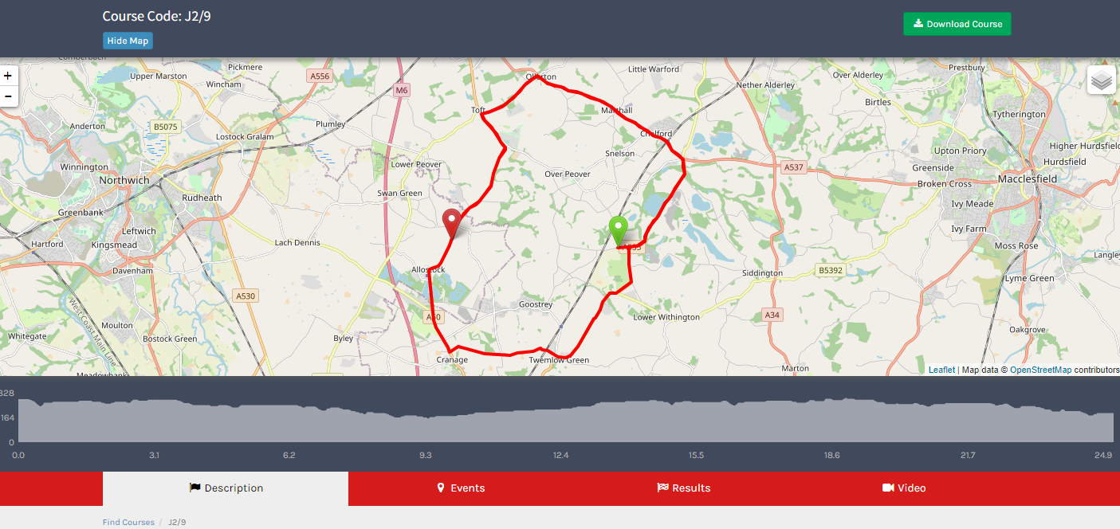

NO PARKING AT START OR FINISH OTHER THAN TIMEKEEPER VEHICLES, NO MATTER HOW BRIEF.

It is approximately 5 miles to the START from HQ please leave enough time to get there:
Leave the Hq and continue to the A50. Please be aware riders may be on their first lap as you turn on to the A50.Turn right here and continue to New Platt Lane which is the first turning on your left.
Along new Platt Lane to the next Junction turning left on to Main Road. Continue along Main Road passing the Crown inn public house and take the next left before the church.
Continue up Blackden Lane bearing to the right at the first fork and then continue straight on Bromish Lane up to the start near Jodrell Bank.

Finish to the HQ:
The finish is not far from Mount Pleasant Nursing home. Continue along the A50 for approx. 1km Turning the first right Cautiously onto Chapel Lane and the HQ is straight in front of you.

I can’t sign the left turn on New Platt Lane as this is part of the course and may get confusing. I will sign other Junctions getting to the start.
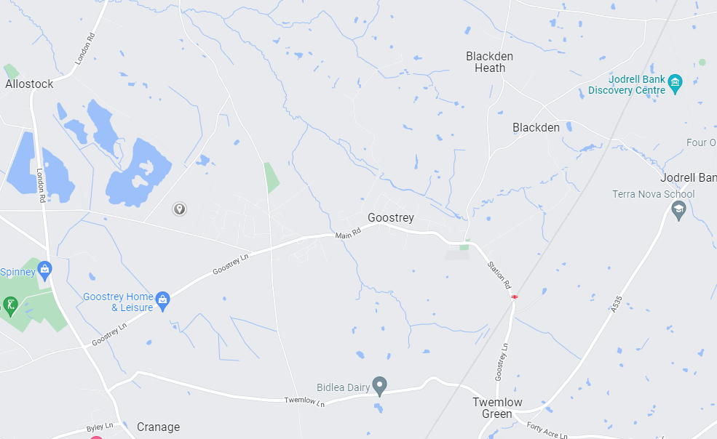
START
HQ

Before Collecting Numbers----All competitors MUST SIGN ON and SIGN-OFF when returning it, Failure to
do so will result in that rider being classified as DNF

Local Regulations
No Parking in Start or Finish Areas other than Timekeeper and Officials

Warnings:

"Vehicles must not be parked, however briefly, in any part of the access area to Mount Pleasant Nursing Home, opposite the finish."

Using Tri Bars
"Riders must negotiate Chelford Island in a safe and sensible manner in accordance with CTT Reg. 20 and the rules of the road. Riders must be able to brake and stop at the island if traffic conditions require this. Riders MUST NOT USE their tri-bars between the first bollard they pass on entering the island and the last bollard they pass leaving it. Any rider seen to be in breach of this regulation will be disqualified from the event and may be reported for further disciplinary action.”
Seven sister’s lane / A50 Junction
“Riders must take extra care when exiting from Seven Sisters Lane onto the A50.

Care at Junctions
Riders must exercise care at all junctions. Any competitor whose riding line causes him/her to cross THE WHITE LINE when approaching or leaving a junction will be liable to disqualification and may be reported to the district committee for further disciplinary action.

A competitor who swings out to the right before executing a left turn should ensure that the road behind is clear of traffic before doing so. The practice is not encouraged by the District Committee and competitors who ride in this manner are warned that in many circumstances this manoeuvre will be regarded as a contravention of regulation 47(i), (iii), (v).

No U Turns
Riders must not perform U turns in the vicinity of the start or finish of the event. Riders observed performing U turns will be reported to the District Committee who will consider disciplinary proceedings.

Safe riding
Riding with your head down such that you do not have a good view of the road ahead is dangerous - please watch out for potholes, obstacles, and other road users. Marshalls do not have the authority to control other road users, so please take care.

Helmets (CTT Reg 15) Note change to rule re: All competitors
All competitors must wear a properly affixed helmet which must be of hard/soft shell construction. Helmets should conform to a recognised Standard as detailed in CTT Reg 15.

Lights
Rear light. CTT Reg 14(i) No competitor shall be permitted to start either a Type A or Type B event unless such competitor has affixed to the rear of their machine a working rear red light, either flashing or constant, that is illuminated and in a position that is clearly visible to other road users.

Front Light. CTT Reg 14(j) No competitor shall be permitted to start either a Type A or Type B event unless such competitor has affixed to the front of their machine a working front white light, either flashing or constant, that is illuminated and in a position that is clearly visible to other road users.

Other notes A competitor overtaking another must pass without receiving or giving shelter. The onus of avoiding company riding shall be upon the rider overtaken. (CTT Reg 21)

COVID PRECAUTIONS
CTT has issued a document “Covid-19 Risk Assessment 09 08 21”. If you haven’t already read this, please download from the CTT website, and read carefully
https://www.cyclingtimetrials.org.uk/documents/index/covid-19 . These are the key messages: -

- Competitors should not attend if they feel ill in ANY way especially if they or family members have any symptoms.
- The Village Hall building will be ventilated as well as possible and we advise all those entering the HQ be sensible regarding keeping a safe distance from one another.
- Please follow government guidelines on handwashing/sanitising.
- We recommend no changing at the HQ, please come dressed ready to ride.
- No assisted push-off. The M&DTTA have decided to continue to ask riders to set off unassisted from the Start timekeeper. Do not cross the start point until you get the signal from the timekeeper.
- We will be offering HQ catering and a Results board.
- Do not approach the timekeepers or any other officials.

Ensure that you review the Risk Assessment at time of signing on!

HQ Contacts on the Day Paul Ekgren 07456 841 594

Novice’s race
"If you are shown as a Novice and have previously ridden a 25 please contact the organiser"
"For the purposes of this event a Novice is a rider who has never completed a solo event at 25 miles under RTTC/CTT regs".

NO | T/OFF | Name |  | CLUB | CAT | VETS STD
 |  | TANDEM
1 | 14:01 | Gaynor | Beckett TAN | Total Tri Training | FV49 | 01:12:51
 |  | Cheryl | Hutchins TAN | Total Tri Training | FV61
 |  | TRIKE
3 | 14:03 | Vic | Trigger TRIKE | Crewe Clarion Wheelers | MF76 | 01:23:37
 |  | Late entry’s
5 | 14:05 | Richard | Coates | Leek cc- Den Engel Belgain Bar | MV56 | 01:09:23
6 | 14:06 | Richard | Collins | Wigan Whs CC | MV50 | 01:07:56
 |  | NOVICES
7 | 14:07 | William | Renard | Macclesfield Wheelers | MV74 | 01:16:28
8 | 14:08 | Andrew | Rogers | Rochdale Tri Club | MV50 | 01:07:56
9 | 14:09 | Tracy | Gregory | Buxton CC/Sett Valley Cycles | FV56 | 01:16:00
10 | 14:10 | Carl | Hitchenson | Weaver Valley CC | MV53 | 01:08:37
11 | 14:11 | Carolyn | Hume | Cheshire Maverick Cycle Club | FV52 | 01:14:53
12 | 14:12 | Chris | MacKay | TricentralUk | MV40 | 01:06:00
13 | 14:13 | Stephen | Turner | Westmead Team 88 | MF62 | 01:11:11
14 | 14:14 | Chris | Standidge | Total Tri Training | MF42 | 01:06:22
 |  | OPEN RACE
15 | 14:15 | Robbie | Harcourt | Salford Cycling Club | MF58 | 01:09:56
16 | 14:16 | Lynsey | Astles | Congleton CC | FV45 | 01:13:14
17 | 14:17 | Warren | Giddins | Warrington Road Club/Horton Light Engineering | MF59 | 01:10:14
18 | 14:18 | Nicholas | Smith | Westmead Team 88 | M14
19 | 14:19 | Simon | Fox | Port Sunlight Wheelers | MV56 | 01:09:23
20 | 14:20 | Keith | Ainsworth | Lindsey Roads Cycling Club | MV63 | 01:11:31
21 | 14:21 | Alan | Shuttleworth | Weaver Valley CC | MV75 | 01:17:04
22 | 14:22 | Lior | Saad | University Of Manchester CC | MSEN
23 | 14:23 | Steve | Nixon | Congleton CC | MV56 | 01:09:23
24 | 14:24 | Jac | Gruffydd | Caffi Gruff | M24
25 | 14:25 | James | Brayford | Congleton CC | M24
26 | 14:26 | Griff | Lewis | Flanders Color Galloo Team | M18
27 | 14:27 | Tim | Smith | Westmead Team 88 | MV47 | 01:07:19
28 | 14:28 | Kelvin | Milward | Congleton CC | MV60 | 01:10:32
29 | 14:29 | Michelle | Fairclough | Salford Cycling Club | FV46 | 01:13:27
30 | 14:30 | Alastair | Ribbands | Congleton CC | M38
31 | 14:31 | Greg | Dancer | Stone Wheelers CC | MV68 | 01:13:28
32 | 14:32 | David | Fox | Warrington Road Club/Horton Light Engineering | MV59 | 01:10:14
33 | 14:33 | Martin | Wiggan | Seamons CC | MV49 | 01:07:43
34 | 14:34 | Claire | Deane | Manchester Triathlon Club | FV53 | 01:15:09
35 | 14:35 | James | Foggensteiner | Apus peak RT | M22
36 | 14:36 | Alex | Taylor | Holmes Chapel Velo | MV46 | 01:07:07
37 | 14:37 | Sam | Shepherd | Total Tri Training | M36
38 | 14:38 | Steve | Lee | Team Wheelguru | MV50 | 01:07:56
39 | 14:39 | Lee | Cairns | Doncaster Wheelers C.C. | MV48 | 01:07:31
40 | 14:40 | Adrian | Hughes | Seamons CC | MV54 | 01:08:52
41 | 14:41 | Derek | Black | Wigan Whs CC | MV73 | 01:15:55
42 | 14:42 | Naomi | Wright | Manchester Triathlon Club | F35
43 | 14:43 | Fraser | Snape | North Lancashire Road Club | MV54 | 01:08:52
44 | 14:44 | Phil | Pearce | West Pennine Road Club | MV47 | 01:07:19
45 | 14:45 | Ian | Holbrook | Stone Wheelers CC | MV53 | 01:08:37
46 | 14:46 | Alison | Stephenson | Congleton CC | FV52 | 01:14:53
47 | 14:47 | Rhianna | Parkinson | Stretford cc | F30
48 | 14:48 | Neil | Cooper | Liverpool Century RC | MV54 | 01:08:52
49 | 14:49 | John | Leach | Rossendale RC | MV76 | 01:17:41
50 | 14:50 | Mathew | Roberts | Team Bottrill | M35
51 | 14:51 | Sean | Caldwell | Glossop Kinder Velo Cycling Club | MV53 | 01:08:37
52 | 14:52 | Steven | Hankey | Warrington Road Club/Horton Light Engineering | MV49 | 01:07:43
53 | 14:53 | Paul | Birkin | Buxton CC/Sett Valley Cycles | MV60 | 01:10:32
54 | 14:54 | Chris | Barlow | Holmes Chapel Velo | M28
55 | 14:55 | Richard | Williams | Clwb Seiclo Caergybi / Holyhead Cycling Club | M32
56 | 14:56 | Andy | Griffin | Manchester Wheelers | MV50 | 01:07:56
57 | 14:57 | Xavier | Teece-Round | Innovation Racing | M17
58 | 14:58 | Kenny | Mitchell | East Lancashire RC | MV54 | 01:08:52
59 | 14:59 | Louis | Thomas-Messenger | Macclesfield Wheelers | M22
60 | 15:00 | Danny Glyn | Roberts | Team Bottrill | MV41 | 01:06:11
61 | 15:01 | Amanda | Skeldon | Stockport Tri Club | FV46 | 01:13:27
62 | 15:02 | Richard | Shaw | Seamons CC | MV53 | 01:08:37
63 | 15:03 | David | Wright | Warrington Road Club/Horton Light Engineering | MV63 | 01:11:31
64 | 15:04 | Matt | Lawton | Macclesfield Wheelers | MV41 | 01:06:11
65 | 15:05 | Harry | Jordan | Otley CC | M17
66 | 15:06 | Peter | Jackson | Macclesfield Wheelers | MV64 | 01:11:53
67 | 15:07 | Mike | Walker | Nantwich Cycling Group | MV43 | 01:06:32
68 | 15:08 | Philip | Wood | Macclesfield Wheelers | MV54 | 01:08:52
69 | 15:09 | Austin | Foy | North Lancashire Road Club | MV44 | 01:06:44
70 | 15:10 | Daniel | Shackleton | ABC Centreville | MF51 | 01:08:10

