‘Promoted for and on behalf of Cycling Time Trials under their Rules and Regulations’

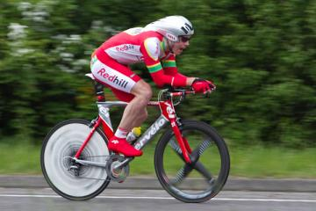

Redhill Cycling Club
18 mile 'Sporting' Time Trial – GS/478
Sunday 27th February 2022 at 09:00

https://www.cyclingtimetrials.org.uk/race-details/23885

Event Secretary: Rick Gregory
redhillcctt@gmail.com
07747 010 714(for contact on the day)
3 The Headway, Epsom, Surrey
KT17 1UJ

Headquarters: St John’s Hall
Furlong Road
Westcott
Dorking
RH4 3PP

Timekeepers: Mr. Mick Irons
Mr. Paul Tunnell
Signing On
- Opens at 08:10 (first rider off 09:01)
- Sign-on and start numbers at Event HQ
- Numbers are to be worn in conjunction with Regulation 16. “No time may be recorded if number is not correctly positioned.”
- Under 18 age entries must download parental consent in order to complete on-line entry.
These must be presented “before signing on”. No parental consent, then no ride.
- Allow 5 minutes from HQ to START turn right heading west on A25 out of HQ (approximately 0.5 miles)

Signing out
In Type A events a competitor must return to the event HQ either during the event or within a reasonable time after the last rider has finished the event and must (i) return their race number(s) and (ii) sign the official Signing-out Sheet.

Safety Instructions
- Key CTT Regulations including latest revisions (in red)
  - CTT regulations require the use of a helmet that meets internationally accepted safety standards.
  - CTT Regulations now require that no competitor shall be permitted to start either a Type A or Type B event unless such competitor has affixed to the rear of their machine a working rear red light, and to the front of their machine a working front white light, either flashing or constant, that are illuminated and positioned to be clearly visible to other road users.”
  - It is not the Timekeepers responsibility to check this. The ‘pusher off’ or other observer can note and draw to the rider’s attention the fact that they will be recorded as DNS if they are not in compliance.
  - Competitors are requested not to warm up on the course after the first rider has started.
  - Official Observers will be stationed around the course. See guidance Note 04.
  - Competitors must not use ANY audio equipment except prescribed hearing aids.
NB A competitor in breach of this regulation shall be disqualified.
NB Competitors must not use a mobile phone while mounted on their machines.
- London South District Regulation and recommendation:
  - No Vehicles, except those of the Timekeepers’ and Event Officials, shall be parked in the vicinity of the start and finish areas.
  - London South DC strongly recommend that riders do not wear black or dark clothing during any event held on the public road.
- Details of any additional hazards not listed on the start sheet will be displayed at the signing on point. All competitors must read these details when they sign on.
- The road surface on the course has deteriorated significantly in recent years, and there are now a number of potholes and areas of very rough road on the course. In particular, the descent just after the Punchbowl pub in Oakwoodhill and back up to the A29 there are a number of potholes and ruts scattered on this section please take care. Competitors are reminded that a safe ride is more important than a fast ride – please exercise extreme care. Remember its February – use common sense when choosing what tyres to ride with.
- No times will be given at the finish.

Specific to Event
- Due to the number of novice riders in this event with no prior times to assist with seeding, riders’ attention is drawn to the regulations that govern Time Trials and prohibits drafting (riding in company).

Parking
- The HQ is located at St Johns Hall in Westcott (http://www.stjohnswestcott.org.uk/find-us.html ) very near Nirvana Cycles in the centre of Westcott. W3W /// hike.sing.green
No parking available unfortunately.
- Free public car park between Dorking and Westcott on A25 - Milton Heath and The Nower Car Park approximately ¾ mile from the HQ.
W3W /// frame.carbon.evenly
When the car park is full please park considerately and DO NOT block driveways. Use common sense when parking and act with respect toward local residents and other road users.

PLEASE RESPECT THE SURROUNDING HOUSEHOLDERS AND PARK WITH CARE

Prizes

Prize List | 1st
Men | £25
Women | £25
Road Bike | £25
Junior <18 | £25
- One cash prize per rider
- Fastest Redhill CC rider will hold the Peter Appleyard Memorial Trophy for 1 year

Road Bike Competition

To be eligible for this category you must be riding a bicycle that has:
• Drop handlebars
• No aerobars fitted
• No Discs or Tri/Quad spoke wheels; disc brakes are allowed (Road Race legal deep section wheels allowed)

For the rider
• Must wear a helmet that is legal in a road race i.e., no pointy TT helmet
• Skinsuits are permitted
• Shoe covers are permitted

If you intend to enter the road bike category, please tell the signing-on sheet volunteer.

Please email Rick Gregory on redhillcctt@gmail.com if you have any queries as to whether your bike/equipment/clothing is suitable. It is not the role of the timekeeper or any start line staff to provide guidance on eligibility – this must be confirmed in advance. The organisers’ decision on eligibility is final and any bikes deemed ineligible will for the road bike category will still be eligible for the TT category.

Course
- London South DC – 18 mile course - GS/478
DORKING/ABINGER HAMMER/FOREST GREEN/OAKWOODHILL/BEARE GREEN/NORTH HOLMWOOD -A25/B2126/B2127/A29/A24
- Strava link to the course: https://www.strava.com/segments/887716?hl=en-GB
- The course details are as follows:

START A25 JUNCTION WITH Logmore Lane (Westcott Heath west entance) | 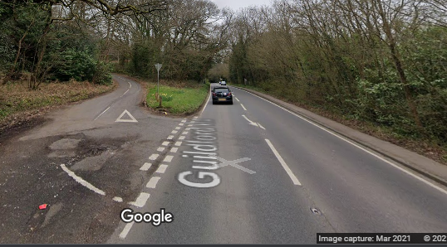  S | 0.00
LEFT TURN INTO B2126 (Marshalled) | 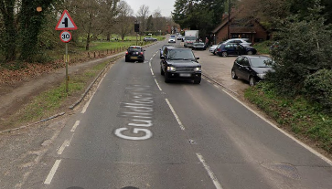 | 2.9 Miles
RIGHT TURN ONTO B2127 (Marshalled) (Give way to Left and Right) | 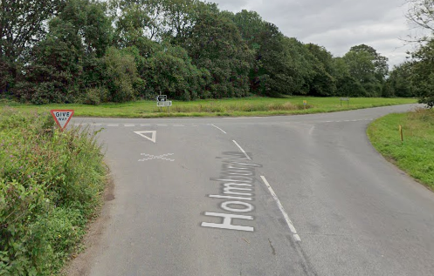 | 7.4 Miles
LEFT TURN INTO HORSHAM ROAD (Marshalled) | 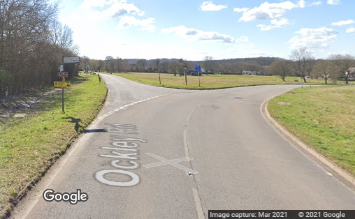 | 7.6 Miles
LEFT TURN INTO OAKWOODHILL (Marshalled) | 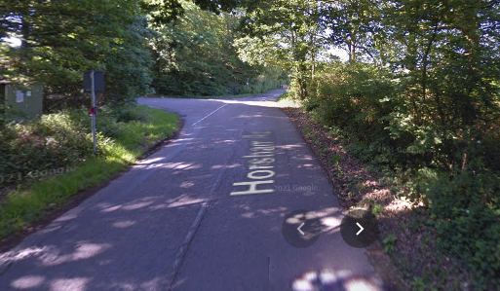 | 9.8 Miles
BEAR LEFT AT JUNCTION WITH HONEYWOOD LANE (Give way to Right) (Marshalled) | 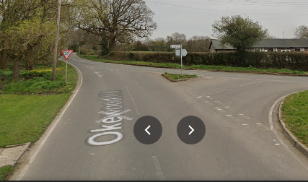 | 10.7 Miles
LEFT TURN ONTO A29 NORTHBOUND (Marshalled) (Give way to Right) | 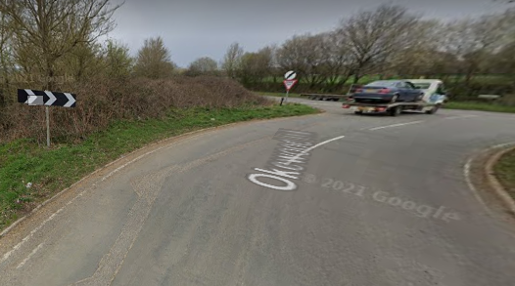 | 11.4 Miles
LEFT TURN AT ROUNDABOUT ONTO A24 NORTH (Marshalled)(Give way to Right) | 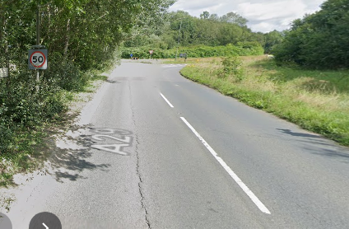 | 15.6 Miles
FINISH AT RED CHILLI (Continue straight on towards Dorking and HQ, do not stop at the Finish) | 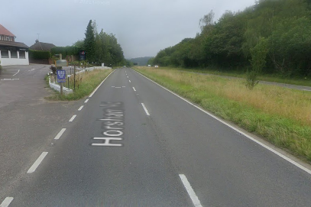 | 18.0 Miles

RETURN ROUTE TO HEADQUARTERS IN WESTCOTT | 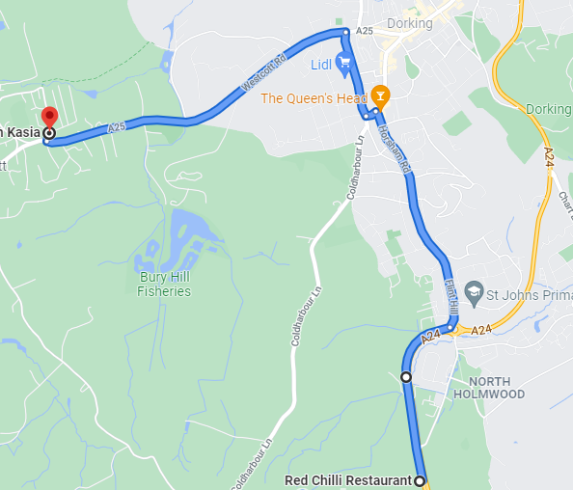 | 3.3 Miles

COURSE MAP
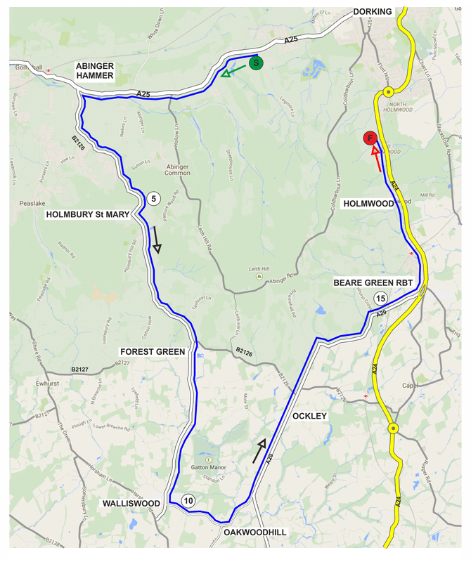

Wishing you a SAFE and FAST ride. Keep your head up.

Please exchange race number for a free drink at HQ and DON’T FORGET YOU MUST SIGN OUT

Redhill Cycling Club
www.redhillcc.co.uk

