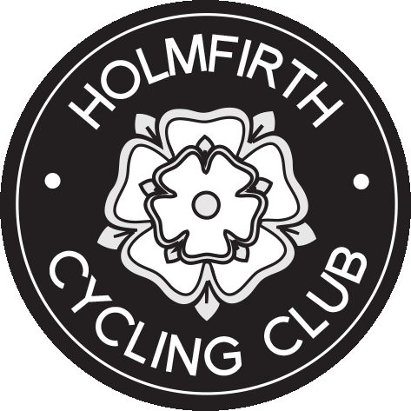
Promoted for and on behalf of Cycling Time Trials,
under their Rules and Regulations.
Yorkshire Cycling Federation
10 (9.7) mile open time trial, Sunday 2nd April 2017
First rider off at 10.01

Event Secretary - Rachael Mellor  35 The Cutting, Brockholes, Holmfirth, HD9 7HL  Tel. 01484 664488 Mob. 07969663881 | Timekeepers  George Barker - Pennine CC  Phil Hurt - Yorkshire RC

Prize List
1st fastest male – David Bramley  Team Swift | 21:30 | 1st Vet 40 – 49 – Ian Garbutt  Holmfirth CC | 22:38
Equal 2nd fastest male – Richard Sharp  York CycleWorks | 21:43 | 1st Vet 50 – 59 – Blair Buss  SSLL RT | 22:03
Equal 2nd fastest male – Harry Buxton  T.H.R.E | 21:43 | 1st Vet 60+ - David Buxton  Rotherham Wheelers | 26:03
1st fastest female – Fiona Sharp  York CycleWorks | 24:52 | 1st Female Vet 40 – 49 – Alix Archer  Sheffrec CC | 26:40
2nd fastest female – Vicky Jowett  Albarosa CC | 25:24 | 1st Female Vet 50 - 59 – Tracey Coldwell Holmfirth CC | 32:13
3rd fastest female – Alex Smethurst  Team Swift | 25:34 | Female Vet 60+ (no entries in this category)
Fastest Male team (3 to count)  Team Swift Bramley/Dean/Wolstenholme  Fastest Female team (2 to count)  Holmfirth CC Breakey/Yates |  | 1st Junior rider male – Harry Buxton  T.H.R.E. | 21:43
Fastest first timer (N = novice rider)  Alex Harris – Holme Valley Wheelers | 27:27 | 1st Junior rider female – Harriet Breakey – Holmfirth CC | 30:03
This event is part of the YCF Points Competition 2017 | CONGRATULATIONS TO ALL THE PRIZE WINNERS !

NO EVENT CAN BE RUN WITHOUT THE NUMEROUS VOLUNTEERS AND DUE TO THE LARGE NUMBER OF TI’S THIS ONE NEEDED A LOT!! SO THANK YOU TO ALL FROM HOLMFIRTH CC, especially Tilly & Lee Brown for the results; Jan & Bronwyn for the amazing cakes;
Thanks to Phil, George & Brian for the timing and pushing off; Mark who arrived at just the right time and Peter and Alex who I never saw but were on Roundabout 4 at Upton!

Look for our next Yorkshire Spocco event on Sunday June 25th on our local challenging course the V915. Great cakes and why not spend the afternoon exploring the lovely Holme Valley and Holmfirth!

