Veterans Time Trials Association
London & Home Counties
10 Mile Open Time Trial
Wednesday 18th August 2021

For and on behalf of Cycling Time Trials under their Rules & Regulations

Event
VTTA London & Home Counties Group

Date
Wednesday18th August 2021 at 14:33 (delayed 30 minutes from the original 14:03)

Description
VTTA London & Home Counties 10m Time Trial – Longwick Course

Headquarters
Event HQ opens at 1pm (13:00). The sign on will most probably be in the carpark if the weather is fine, otherwise it will be in the hall. Toilets in the Village Hall will be available – best to wear a mask when using them.

Haddenham Village Hall
c/o Parish Office
Banks Park
Banks Road
Haddenham
Buckinghamshire
HP17 8EE

Their website has an excellent map of their location
https://haddenhamvh.uk/
What Three Words reference: ///clicker.cooked.branched

Route HQ to Start (5 mile!)
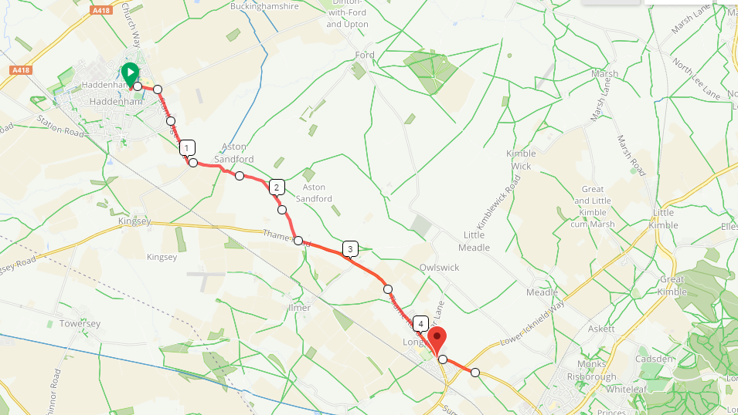
Total distance to start 4.7 miles. Allow plenty of time. The flag is where there are temporary 3-way traffic lights, which this version of the course avoids.
Leave the village hall carpark by the one-way system and
Turn LEFT into Churchway (heading North),
Almost immediately at the double mini-RAB Turn RIGHT (heading East) along Wood Ways for approximately 0.3miles
At the next junction you will be joining the Time Trial course.
Turn RIGHT into Stanbridge Road and proceed along the course for a short distance, passing the Haddenham Garden Centre.
After a total of 1.0 miles just after a small bridge, turn left and ride a further 1.4 miles and turn LEFT onto Thame Road A4129 (2.4 miles in total). Continue into Longwick (passing the Finish) and proceed to the 3-way temporary traffic lights on Longwick Road. (total 4.3 miles). Proceed on the main road through the traffic lights to the roundabout (Shell garage alongside). Take the 2nd exit and continue up the hill a further 0.2 miles to the start (total 4.7 miles). Dismount and walk across the road.to the Start.
Ensure that your back light is working – no light no ride.

Route Finish to HQ (4 miles)
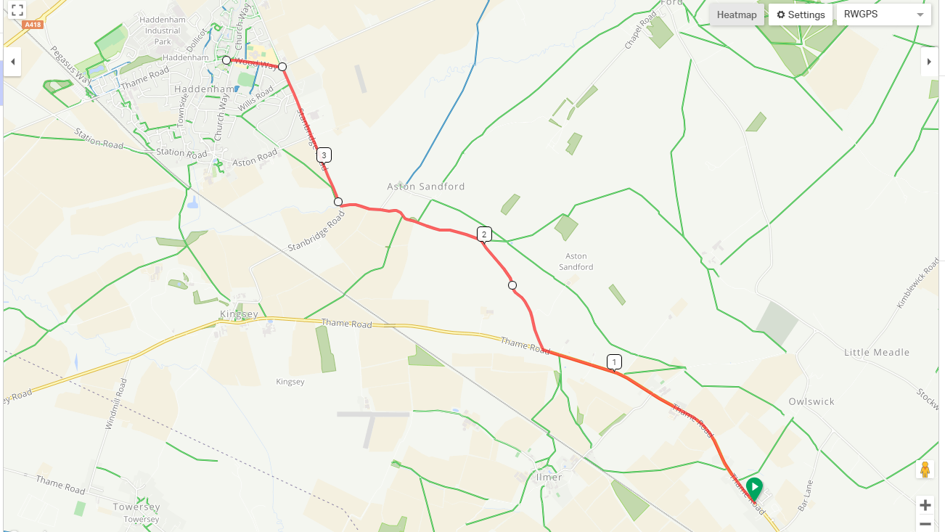
Total distance to finish 3.8 miles.
After passing the finish time turn LEFT into a cul-de-sac called Walkers Road (What3words /// custodian.access.bathtubs). It has a wide frontage so is easy to spot. Make a U-turn in the cul-de-sac, taking care, and stop at the T-junction at the exit.
Turn RIGHT and carefully retrace the course back to the HQ, bearing in mind that there will be on-coming riders on the course, riding the course in an anti-clockwise direct, some riding to the start and others competing at speed.
Take particular care when turning RIGHT off the main road, as there will be traffic approaching at speed in both directions. Dismount and walk across if this course of action is safer.

Course Details
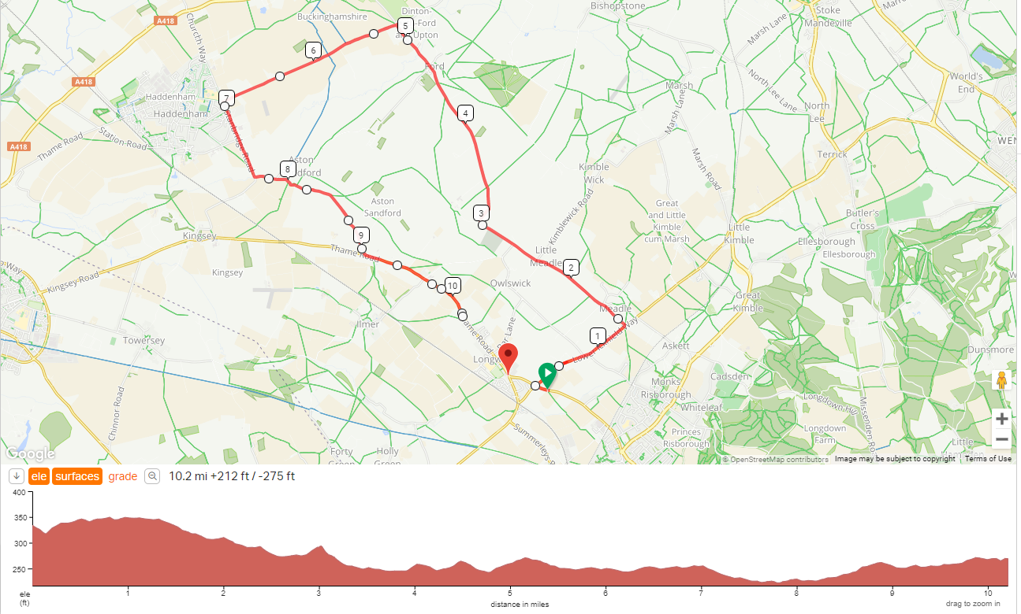

Course Description

Longwick Circuit Course (HCC178D) Description:

Start on the A4129, by the traffic information roundabout sign next to a field entrance (What3words ///cuts.devoured.scorpions), a short distance away from Lammas Close, on the outskirts of Longwick.

Go West on the A4129, for 100 yards, to the roundabout at the junction with the B4009 at the Sportsman's Shell Garage Take the third exit (M1) onto the B4009 and proceed to the second turning on the left. Turn left (M2) and go through Ford to the Haddenham-Aylesbury crossroads. Turn left (M3) to the first junction at Haddenham. Turn left (M4) for 0.77 mile to take the first turning left (M5) to the junction with the A4129. Turn left (M6) and continue southeast on A4129 to Longwick. Pass through the the Longwick village sign to the Finish, which is shortly thereafter.

Finish 10.1 miles at a telegraph pole (number 6 and 851734) and water hydrant (N21 100H6) by an LCD traffic speed display (“30 SLOW DOWN”). (What3words ///mouth.steam.relieves)

After the finish riders should turn left into Walkers Road (What3words /// custodian.access.bathtubs) , a housing estate, to effect a u-turn. To return to the HQ they turn right out of Walkers Road and return back along the course in the reverse direction.

Notes:

Start: There is ample parking in Lammas Close (a new small housing development) (What3words /// genius.bumpy.makes). Riders are not to park in this road.

Marshals referred to in this course description (M1, M2) etc may be provided solely to indicate the course direction. They have no role whatsoever in the risk assessment itself.

Local Regulations

LWDC 2 – Restriction of Parking at the Start and Finish. No vehicles, with the exception of the Timekeepers’ or Timekeepers’ Assistant shall be parked in the vicinity of the Start or Finish points.
LWDC 7 – Location of Numbers Riders’ numbers shall be issued from the headquarters.
LWDC 8 – Prohibition of U-Turns U-Turns are not permitted within sight of the Start or Finish points, nor on the course. Offenders will be liable to disqualification and will be reported to the District Committee. This may lead to disciplinary action being taken against the rider.

Organiser Contact Details
Geoff Perry
8 The Meadway Loughton Milton Keynes
07808 905879
geoffreyperry@aol.com

Officials
Start Time 14:03
Start Timekeeper: Katja Rietdorf – Born to Bike – VTTA LHC Group
Finish Timekeeper – Howard Waller – Python RT – VTTA LHC Group
Marshalls and Helpers: Members and friends of London & Home Counties Group.

Course Records HCC178D
This is a new version of the HCC178 course

Awards
Awards are only made to VTTA members only. Membership has been checked against the VTTA National Membership database.
Gold-Silver-Bronze Medals for Men BOS (Best On Standard) 1-2-3, which will also be the same as Mens Fastest 1-2-3 on Vets’ Handicap Times
Gold-Silver-Bronze Medals for Women BOS 1-2-3 which will also be the same as Womens Fastest 1-2-3 on Vets’ Handicap Times
Gold-Silver-Bronze Medals for Women BOS 1-2-3 which will also be the same as Womens Fastest 1-2-3 on Vets’ Handicap Times
Gold Medal - Fastest rider on Actual Time
These will be presented at the VTTA LHC Annual Luncheon (if it is held in person).

Start List (Revised start times)

BIB | START | Rider | Club | M/F | STD | VH | Grp | VTTA ID
3 | 14:33 | Malcolm Moore | Team Jewson - MI Racing ~Poly Pipe~McCann | M | 28:58 | 2:52 | MIDS | 15028
4 | 14:34 | Bob Loader | Sydenham Whs | M | 34:43 | 8:37 | KENT | 1431
5 | 14:35 | Michael Garvey | High Wycombe CC | M | 27:18 | 1:12 | L&HC | 4996
6 | 14:36 | Richard Moule | Bossard Whs | M | 28:22 | 2:16 | L&HC | 1688
7 | 14:37 | David Cook | Bedfordshire Road RT | M | 28:30 | 2:24 | L&HC | 5530
8 | 14:38 | Judy Reid | Icknield RC | F | 30:03 | 3:57 | L&HC | 14387
9 | 14:39 | Gina Brown | Redhill CC | F | 29:26 | 3:20 | L&HC | 15203
10 | 14:40 | Hans Nilsson | London Phoenix CC | M | 28:30 | 2:24 | L&HC | 5855
11 | 14:41 | George Turner | VTTA (London & Home Counties) | M | 26:14 | 0:08 | L&HC | 14684
12 | 14:42 | Joy Payne | High Wycombe CC | F | 30:29 | 4:23 | L&HC | 6038
13 | 14:43 | Peter Cookson | Willesden CC | M | 29:19 | 3:13 | L&HC | 3447
14 | 14:44 | Ian Hall | Serpentine Running Club | M | 28:58 | 2:52 | #N/A
15 | 14:45 | Philip Watts | North Hampshire RC | M | 27:58 | 1:52 | WSSX | 4922
16 | 14:46 | Dave Johnson | VC 10 | M | 28:13 | 2:07 | #N/A
17 | 14:47 | David Ashworth | Team Jewson - MI Racing ~Poly Pipe~McCann | M | 27:01 | 0:55 | #N/A
18 | 14:48 | Richard Pratt | Icknield RC | M | 28:06 | 2:00 | #N/A
19 | 14:49 | Les Gardner | Maidenhead & District CC | M | 30:07 | 4:01 | L&HC | 4471
20 | 14:50 | Peter Richards | Icknield RC | M | 27:30 | 1:24 | L&HC | 14249
21 | 14:51 | Alan Allcock | Didcot Phoenix CC | M | 28:39 | 2:33 | L&HC | 4117
22 | 14:52 | John McGlashan | Redmon CC | M | 29:19 | 3:13 | KENT | 4690
23 | 14:53 | Alastair Merrill | VC 10 | M | 26:56 | 0:50 | L&HC | 15080
24 | 14:54 | Hilary Walker | Serpentine Running Club | F | 30:58 | 4:52 | L&HC | 4293
25 | 14:55 | Mark Wise | Team Jewson - MI Racing ~Poly Pipe~McCann | M | 27:30 | 1:24 | MIDS | 5687
26 | 14:56 | Roger Porter | Verulam CC | M | 30:07 | 4:01 | L&HC | 3070
27 | 14:57 | Linda Dewhurst | Team Milton Keynes | F | 30:11 | 4:05 | L&HC | 11704
28 | 14:58 | Martin Webb | Icknield RC | M | 28:30 | 2:24 | L&HC | 15200
29 | 14:59 | John Hassall | Bossard Whs | M | 30:35 | 4:29 | L&HC | 3066
30 | 15:00 | Michael Parker | TMG Horizon Cycling Team | M | 27:24 | 1:18 | L&HC | 5554

