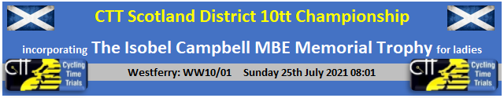

Entries Men - https://www.cyclingtimetrials.org.uk/race-details/22932
Entries Women/Juniors - https://www.cyclingtimetrials.org.uk/race-details/22933
Entries Tandem - https://www.cyclingtimetrials.org.uk/race-details/22934

Gender Equality in Prize Awards - £100 to winner

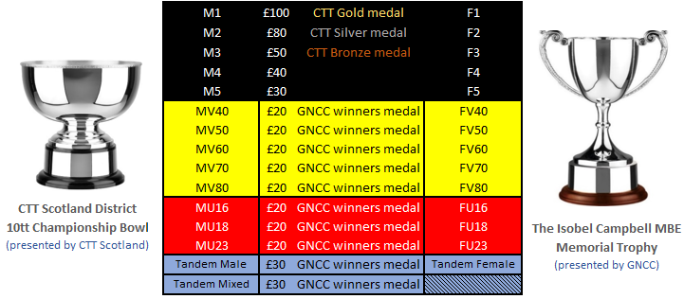

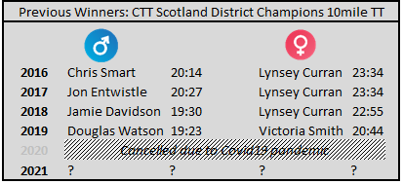

Event HQ: Bishopton Community Hall, Gledstane Rd, Bishopton, PA7 5AU
Event Sign-On from 7:00 am
Event Organiser: Graeme Cockburn

The Isobel Campbell MBE Memorial Trophy

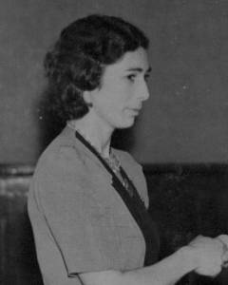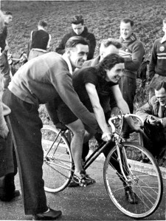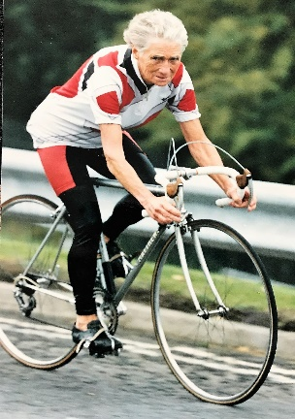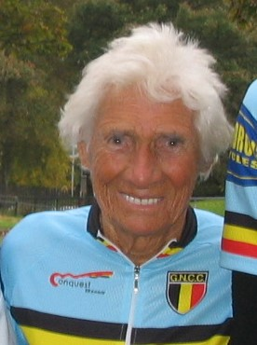
Isobel Campbell, who died in January 2017, at the age of 103, was President of the Glasgow Nightingale Cycling Club and a remarkable woman by any standards. Her membership of the Club lasted 74 years. Her racing career lasted for around 59 years, she held Club, Scottish and British records and her contribution to cycling earned her an MBE.
In the first 92 years of the Club’s existence GNCC only had two presidents’, our founder-president, Malcolm Smith, who died in 1983 at the age of 97 and Isobel, who died in January at the age of 103. If nothing else, it shows that cycling is good for you.
She moved to Glasgow, from Bo’ness, with her parents before the Second World War and began cycling. She had her first wins, at 10 and 25miles, in 1939. Whether she was a member of another club or unattached we don’t know. However, in 1943 she joined the Glasgow Nightingale and was a member for the rest of her life.
At the end of the war normal racing resumed, as did Isobel’s winning ways, with a string of National and Club records. She set Scottish competition records at 10, 25, 50 and 100 miles and broke the British Women’s 12-hour record twice, in 1946 and 1948. In 1949, Isobel (nee Adams) married fellow Club member, Bill Campbell.
In 1973 she won the inaugural British Women’s Veterans Championship and again in 1982. She was Club B.A.R. Champion in 1977, 1980 and 1983, leaving the male members of the Club in her wake. She didn’t give up easily, riding her last competitive event at the age of 88.
On another level, she was awarded the Scottish Cycling Union’s Gold Medal in 1983 and was honoured with an MBE in 1998 for services to cycling. Also, in 1983 Isobel became President of the Club following the death of Founder-President Malcolm Smith.
She lived quietly in her later years spending much of the winter at her daughter’s home in Mallorca
but, until latterly, was able to attend Club functions. We were privileged to have her present the trophies at the Club’s 80th Anniversary Dinner in 2005.

Notes for Competitors

- Sign on will be open from 7:00 am in the Bishopton Hall car park
- Under 18s must complete a parental consent form (attached at the end of this document) and hand it in at sign on. No form = No ride.
- The distance from Race HQ is approximately 2.5miles, heading West – please allow plenty of time to reach the start area before your allocated time.
- Course Marshals have no legal authority to stop traffic on the course, and as such will only provide course directional information.
- Please read the enclosed anti-doping notice.
- Once a rider has completed their ride they must return their race number and sign out, failure to do either will result in a DNF
- Safety is paramount to the Organiser, Promoting Club and Governing Body hence why we have moved the start to 8.01am;
- Riders MUST have a powerful light fixed to the rear of their bike, visible and working
- Riders MUST not wear dark coloured clothing.
- Riders MUST not ride with their head down at any point
- Riders MUST ensure their bicycle is mechanically fit-for-purpose (steering; brakes; drive-train; contact points etc).
- Riders MUST NOT change lanes at any point on the course except where manoeuvring safely into the outside lane for the Newark Castle turn roundabout. Any crossing of the central white line will be an automatic disqualification.
- Riders MUST adhere to the rules and regulations of the Highway. Marshals and Police will be monitoring riding standards.
- Any rider that is reported for breach of any of the above WILL incur sanctions - this may include disqualification.

Covid-19

NO requirement to bring along a license/membership card to leave as deposit for your number.
NO toilet, changing or shower facilities available.
NO catering provided.
NO live results
NO prize ceremony
NO pens will be provided so bring your own pen for sign on and sign out
NO safety pins will be provided so bring your own
NO warming up in the car park, please warm up on the roads
NO gathering at the start line. Adhere to the traffic cones placed at 2m intervals
NO leaving personal belongings with the Time Keeper
NO pusher permitted, NO track stands permitted, it’s a foot down start
Adhere to all Government guidelines about social distancing and wearing of face masks

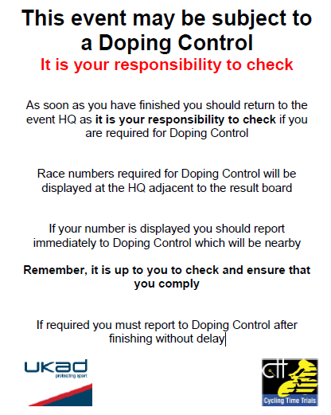

Course Details: Westferry WW10/01

1. Start under railway bridge on Greenock Rd heading West… approx. 2.5miles from RaceHQ
2. … Immediate LEFT on slip-road to A8 at Westferry roundabout…
3. …. Proceed westbound on A8…
4. …. Straight through first roundabout at Langbank….
5. …. Take 2nd exit at second roundabout at Woodhall…
6. …. Continue on A8 to TURN at Newark Roundabout… PLEASE OBSERVE EXTREME CAUTION.
7. …. Retrace to finish at slip-road to Westferry roundabout.

- Race HQ -> Start holding area
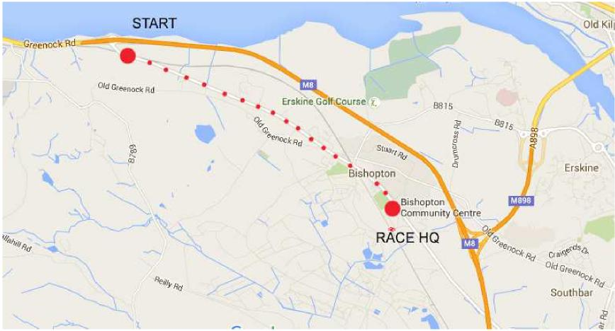

- Route Map with reference points 1-7 as above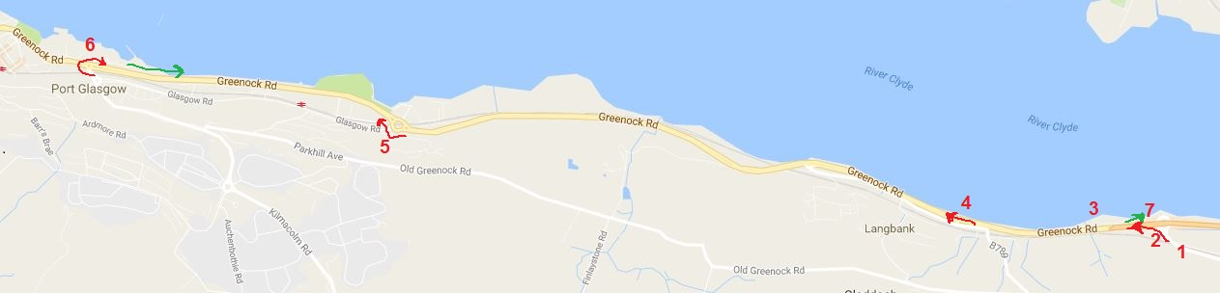
- Start and Finish points with Langbank roundabout (points 1,2,3,4,7)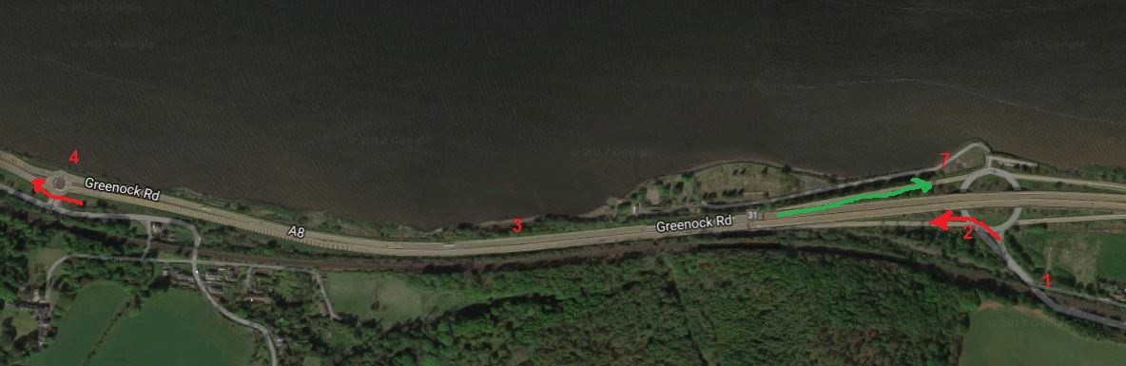

- Woodhall roundabout – exit 2nd left out and return legs (point 5)
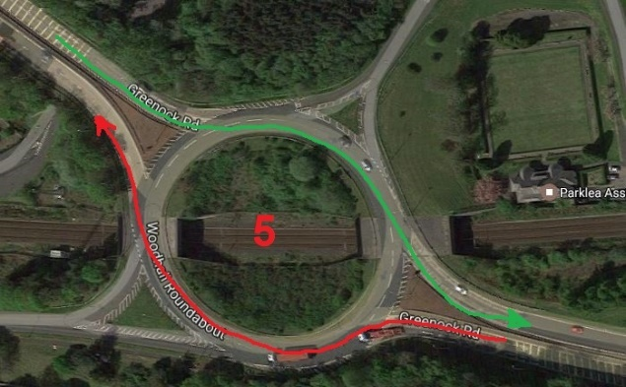
- TURN roundabout – PLEASE EXERCISE EXTREME CAUTION with approaching traffic (point 6)
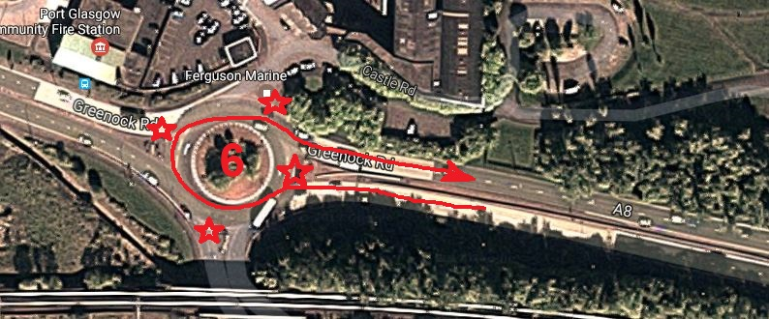
- Finish Slip-Road Approach (point 7)
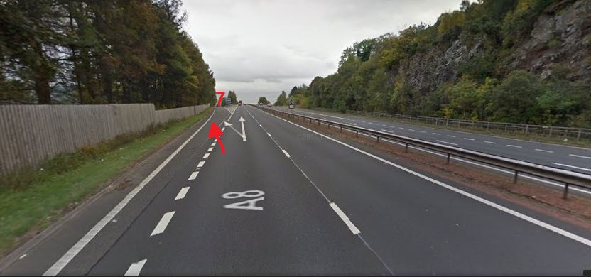

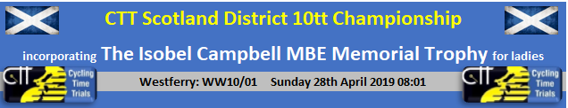

< START SHEET TO BE INCLUDED POST CLOSE DATE >

