COURSE L5012 (50 MILES).
https://ridewithgps.com/routes/28210998

START at eastern side of the junction of the old road with the northern side of the A66 which is 0.36 miles east of Braithwaite Village Hall (Event Headquarters, Exit HQ turning left).
(the old road runs adjacent to the course for about 750meters and can be used for parking (limited, please park curtiously), please do not congregate at the start and socially distance. Belongings CAN NOT be left with the timekeeper)

Proceed in an easterly direction along the A66 to TURN by encircling the traffic island at the junction of the A66 and A591 near Keswick (1.95 miles). Take fourth exit and retrace along the A66 past the starting point and continue to TURN by encircling the traffic island near Cockermouth (14.80 miles). Take the fourth exit and retrace along the A66, through the starting point, to TURN by encircling the traffic island at the junction of the A66 and A591 (27.65 miles).

Retrace along the A66 to TURN by encircling the traffic island near Cockermouth (40.50 miles) and retrace along the A66 to FINISH at the East end of the tarmac footpath in layby on North East side and 50 yards short of the overhead bridge which is one mile west of the event headquarters.

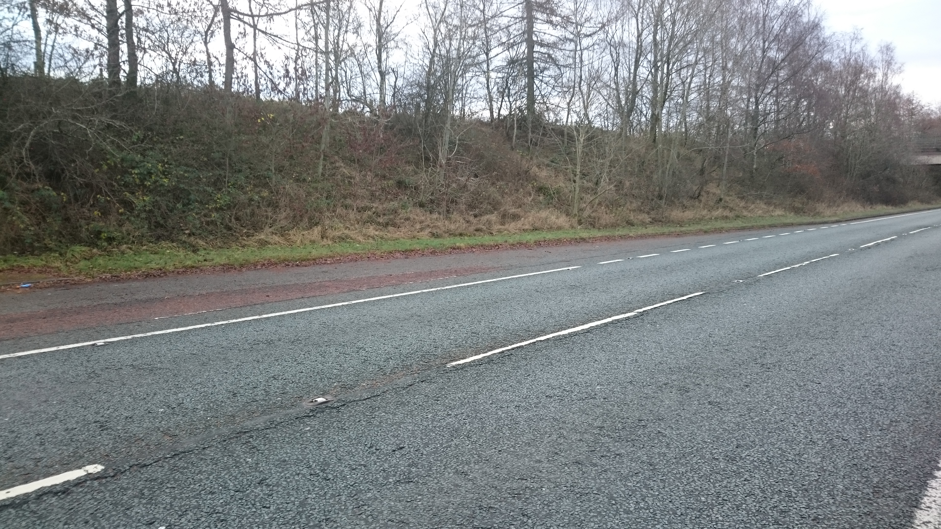
Image of finish, overpass in background

Notes
Previously L505R – renumbered and finish description clarified

