ICKNIELD ROAD CLUB
Charity 10 Mile Time Trial
To be held on Saturday 7th September 2019

Promoted for and on behalf of Cycling Time Trials under their Rules and Regulations

Official Start Sheet
Timekeepers Event Organiser
Gordon Hart Icknield R.C Mr Matt Price
Eileen Cray Icknield R.C. 100 Coltsfoot Green
Luton, Bedfordshire
LU4 0XT
07866 495235
mattbombhead@me.com
START TIME 14.01 PM
Course F11/10
Course description.
START on southbound slip road to A41 on the Western Tring junction approx 40 yards from the start of the slip road. Proceed along A41 to come off at first slip road (Eastern Tring junction) to:-
TURN (approx 2.0 miles) by taking 4th exit out of RAB and under the A41, going around 2nd RAB to take 2nd exit back onto the A41 westbound and continue past all junctions to RAB at end of Aston Clinton by-pass to:-
TURN (7.87 miles) by taking 3rd exit out of RAB back along the by-pass, again ignoring College Road junction to:-
FINISH on Buckland slip road 9 yards south-east of manhole cover on grass verge, about 91 yards nth-west of (i.e. before) separation of slip road and main carriageway, also about 460 yards north-west of the B489 over bridge.

Finishing riders MUST leave the main carriageway at the START of the exit slip road to B489. Failure to do so will be recorded as DNF and no time given – further information is given below.

Event Headquarters
Ashton Clinton Junior School, Twitchell Ln, Aston Clinton, Aylesbury HP22 5JJ
Sign on is in the Main Hall, Open from 12.30pm
There is ample car parking, in the School Car Park but if you have to park in adjacent roads please ensure you do not block entry to private houses.
Please DO NOT wear cycling shoes in the Main Hall so as not to damage the floor
Allow about 15 minutes to ride from Event H/Q to the Start.
Sign On and collect your number in Hall and remember to Sign Back in when finished.

Reserve Riders
As this is event is a full field, with a full quota of reserve riders, any rider who has not signed in 45mins prior to their start time will have their entry transferred to a reserve rider. Also, please inform the organiser ASAP if you cannot ride for whatever reason.

AWARDS
There are no Awards in this event as all proceeds after CTT Levy and other expenses are donated to a local Charity which is selected by the Icknield Road Club Committee
All competitors under the age of 18 years and/or Junior must wear a properly affixed helmet which must be of a hard/soft shell construction and present a Parent Consent Form when signing in.

F11/10 Additional Course Information

This course often sees several riders with no finishing time (DNF) because they DO NOT follow the course and the specific finishing instructions, which are in place for the rider’s safety, as cars enter the slip-road early and at speed.
Last year 11 riders out of 150 were DNF’d. You are advised to fully study the illustrations & photos which follow:

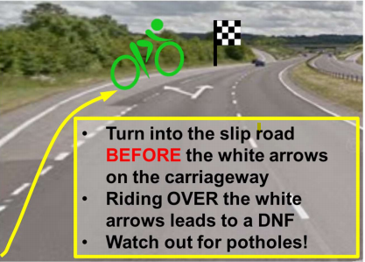

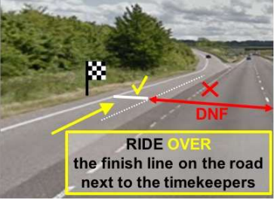

Cars DO enter the slip road early, so beware!
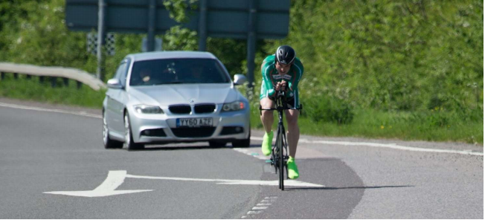

The following two riders are demonstrating etiquette which WILL result in a DNF (no time issued)
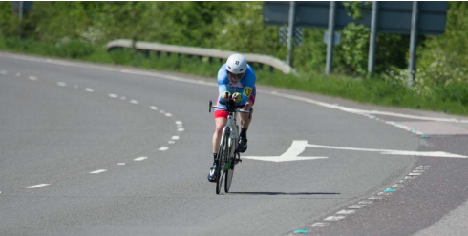

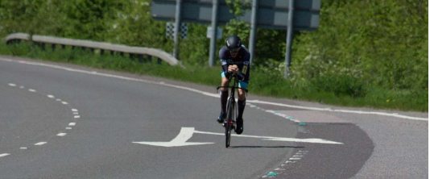

By quirk of fate a previous event was recorded on Google Maps (satellite view), and if you look carefully you can see:
- The start timekeeper with riders ready to start.
- Riders on the course
- The finish time keepers and their cars
- The finish line can be seen!
- The big white fork arrows that you must remain to the left of at the entrance to the finish slip road.

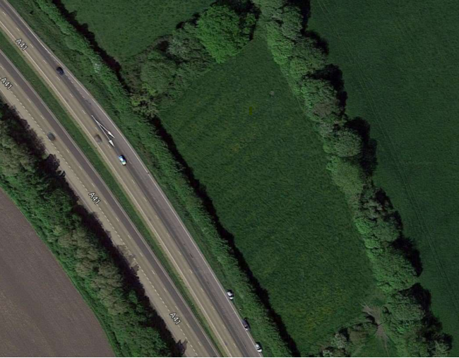

- Local Regulation 1 – No U Turns should be made at any time while riding on the public highway.
- Conduct in the Start Area - DO NOT RIDE YOUR BIKE UP THE SLIP ROAD WHERE THE START IS LOCATED. Should you need to leave the Start Area prior to your start, you MUST walk your bicycle up the slip road. Any competitors observed riding up the slip road will be not be allowed to start and may face further sanctions.
- Car Parking - There must be no parking of motor vehicles on any part of the A41 apart from those of the officials. All parking must be in the HQ car park.
- HQ to start route Please note that the route from the HQ to the Start is a reasonably steep hill so allow at least 15 minutes to get to the start from the HQ. It does however provide a good warm-up!

