

 **Sunday 19th February at 09:30 am**

**Hard Riders Pain on Portsdown Circuit ~ Course P828/18**

**(An 18.1 mile Sporting course with both Road and TT categories)**

(Promoted for and on behalf of Cycling Time Trials under their Rules and Regulations)

**The Headquarters -** The Wickham Centre, Mill Lane, Wickham, Hampshire PO17 5AL

**(Will be open from 08.00)**

***Timing Crew:***

***Start Timekeeper:*** *Trevor Beauchamp (Liphook Cycles)*

***Prime :*** *Chris Thomas (...a3crg)* ***~ Finish:*** *Kathleen Collard-Berry (...a3crg)*

***Recorder:*** *Maria Golden (...a3crg)*

***Results:*** *Martin Whitty & Paddy “ The stump “ Brennan (...a3crg)*

***Start Line Stewards:*** *General Dawson & Penfold Pickers* ***Both x TT legends***

***Marshals and Catering Squad:*** *VC St Raphael (x) Riders /family / Friends*

***Prizes ! ! !***

|  |  |  |
| --- | --- | --- |
| **Category** | **Road Bike** | **Solo TT** |
| **1st Overall** | **£50 + Trophy** | **£40 + Prosecco** |
| **2nd Overall** | **£30 + Trophy** | **£30.00** |
| **3rd Overall** | **£20 + Trophy** | **£ 20.00** |
| **4th Overtall** | **£10.00** | **£10.00** |
| **First Woman** | **£30.00** | **£30.00** |
| **Second Woman** | **£15.00** | **£15.00** |
| **Third Woman** | **Prosecco** | **Prosecco** |
| **First Espoir** | **£15.00** | **£15.00** |
| **Second Espoir** | **£10.00** | **£10.00** |
| **First Junior** | **£20.00** |  |
| **Second Junior** | **£15.00** |  |
| **First Team** | **£45.00** | **£45.00** |
| **Second Team** | **£30.00** | **£30.00** |
| **Third Team** | **Bottles of Red x 3** | **Bottles of Red x 3** |
| **GPM/KOM 4.5mile** | **£25.00** | **£25.00** |
| **GPM/QOM 4.5mile** | **£25.00** | **£25.00** |

**Mike Anderson, VC St Raphael Has kindly supplied the Road Bike category Prizes.**

**1st Trophy and £50 00 ~ 2nd Trophy and £30.00 ~ 3rd Trophy and £20**

**(To win the GPM – KOM/QOM prize you must finish)**

**Remember to Sign in & Sign out (New Reg)**

Prizes will be presented **quickly** after the both events. **Prizes not collected on the day** will be deemed to have been donated, unless prior arrangements have been made **and No** I won’t be sending bottles of Prosecco or Wine through the post.

**IN THE INTERESTS OF YOUR OWN SAFETY, Cycling Time Trials and the event promoters strongly advise you to wear a HARD SHELL HELMET that meets an internationally accepted safety standard. It is recommended that a WORKING REAR LIGHT, either flashing or constant, is fitted to the machine in a position visible to following road users and is active while the machine is in use.**

The Two Event are included in the South Districts Sporting Time Trial Series which is open to all South District Clubs and Teams.

Full details & Results on: [www.sportingtt.co.uk](http://www.sportingtt.com)



**Event and VC ST Raphael Team Sponsor:** Mick Waite, 249 Havant Road, Farlington, PO6 1DB.

Tel.: 023 9237 9753~ Mobile 07860627863 ~ email: [vcstraphael@hotmail.com](mailto:vcstraphael@hotmail.com)

**Event organiser: Simon Berogna**, 10 Crisspyn Close, Horndean, Hants,

PO8 9JT Mobile 07703020691 ~ email: [s_berogna@hotmail.com](mailto:s_berogna@hotmail.com)

**When you Finish, Hand in your Number & Sign-Out ~ Failure to do so is a DNF (New Regulation)**

**Course Details**: (Southwick - Boar Hunt - Portsdown -Southwick)

**START** at Mellish Bottom at Farm shop in layby on B2177.  
Proceed East to Staple crossroads.  
Continue on to Southwick rbt, carry straight on B2177 up Southwick Hill towards Portsmouth to turn at roundabout junction with James Callaghan Drive (GR 648066) (Portsdown Roundabout) 4.633 miles. Retrace to Southwick rbt taking the 2nd exit and Proceed on B2177 to Staple Cross road, then left to South Boarhunt across small bridge bear right on the bend to climb through South Boarhunt then turn left into Swivelton Lane (10 miles) continue on to junction with Portsdown Hill road turn left continue along Portsdown Hill road to main roundabout (Portsdown Roundabout). Take 1st exit onto B2177 to descend Portsdown Hill to Southwick Roundabout , Take the 2nd exit and proceed on the B2177 (15.00 miles ) towards Wickham passing through the start where the **FINISH** at Holts Mead in line with TP134 0.375 miles west of start (18.1)

**Map of the Course**

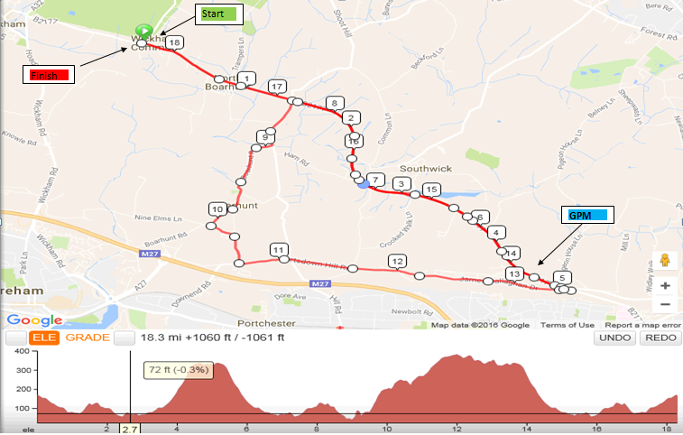

**To get to the Start:** After coming out of the HQ (Turn right) Head South on Mill lane towards Dickson Park 0.1m , Turn right into Station Rd 0.1m ,Turn left onto Bridge Street 0.1m , Continue onto Southwick Road (B2177)1.1m , proceed passed Hundred acres road and the start 0.1m.

**When you Finish, Hand in your Number & Sign-Out ~ Failure to do so is a DNF (New Regulation)**

**Event One ~ Road Bike Category**

**Road Bike Spec**: No clip-ons, no disc or tri spokes, no wheels deeper than 60mm or pointy hat.

|  |  |  |  |  |
| --- | --- | --- | --- | --- |
| **Num** | **Rider** | **Team/Club** | **Cat** | **Start Time** |
| 1 | Sam Stewart | Southdown Velo | Sen | 09:31 |
| 2 | Sarah Reese | Bournemouth Arrow CC | WS | 09:32 |
| 3 | Tim Crumpton | Velo Club St Raphael | Vet | 09:33 |
| 4 | Danny Havey | Fareham Wheelers CC | Juv | 09:34 |
| 5 | Jason Frizzell | Portsmouth Triathletes | Vet | 09:35 |
| 6 | Jacob Schnabel | Fareham Wheelers CC | Juv | 09:36 |
| 7 | Robert Pretorius | ...a3crg | Vet | 09:37 |
| 8 | Tamina Oliver | Oxford University CC | WS | 09:38 |
| 9 | Freya Richardson | Portsmouth North End CC | WJuv | 09:39 |
| 10 | Max Doyle | ...a3crg | Jun | 09:40 |
| 11 | Lara Clarke | Bec CC | WS | 09:41 |
| 12 | Vaughan Marris | Fareham Wheelers CC | Juv | 09:42 |
| 13 | Tim Bailey | Portsdown Hill CC | Vet | 09:43 |
| 14 | Marianne Holt | Fareham Wheelers CC | WS | 09:44 |
| 15 | John Way | ...a3crg | Vet | 09:45 |
| 16 | Angela Carpenter | i-Team CC | WV | 09:46 |
| 17 | Jonathan Lacey | Southdown Velo | Vet | 09:47 |
| 18 | Colin Mooney | Portsdown Hill CC | Vet | 09:48 |
| 19 | David Libby | Portsmouth Triathletes | Vet | 09:49 |
| 20 | Peter Graham | North Hampshire RC | Vet | 09:50 |
| 21 | Tom Kelly | Poole Wheelers | Vet | 09:51 |
| 22 | Peter Golding | Twickenham CC | Vet | 09:52 |
| 23 | Graham King | Portsmouth North End CC | Sen | 09:53 |
| 24 | John Schnabel | Fareham Wheelers CC | Vet | 09:54 |
| 25 | Mark Dinwiddy | Southdown Velo | Vet | 09:55 |
| 26 | Alex Collins | Primera-Teamjobs | Jun | 09:56 |
| 27 | John Pennington | Bec CC | Vet | 09:57 |
| 28 | Mike Garner | ...a3crg | Vet | 09:58 |
| 29 | Will Ranoe | Morvelo Basso RT | Sen | 09:59 |
| 30 | Den Tapping | ...a3crg | Vet | 10:00 |
| 31 | Mark Capocci | Portsmouth North End CC | Vet | 10:01 |
| 32 | John Glaysher | ...a3crg | Sen | 10:02 |
| 33 | Ruud Jonkers | Portsmouth Triathletes | Sen | 10:03 |
| 34 | Warren Peters | ...a3crg | Vet | 10:04 |
| 35 | Sam Dorkings | GS Avanti | Sen | 10:05 |
| 36 | Cameron Thompson | Andover Wheelers | Esp | 10:06 |
| 37 | Paddy Brennan | ...a3crg | Sen | 10:07 |
| 38 | Bob Richardson | Bournemouth Jubilee Wheelers | Vet | 10:08 |
| 39 | Andrew Phipps | Royal Navy & Royal Marines CA | Vet | 10:09 |
| 40 | Dave Dent | GS Stella | Vet | 10:10 |
| 41 | Craig Wallington | Sarum Velo | Sen | 10:11 |
| 42 | Ollie Mitchell | ...a3crg | Sen | 10:12 |
| 43 | Andy Self | North Hampshire RC | Vet | 10:13 |
| 44 | Jerry Bromyard | ...a3crg | Vet | 10:14 |
| 45 | Thomas Key | Primera-Teamjobs | Sen | 10:15 |
| 46 | James Joel Garner | ...a3crg | Vet | 10:16 |
| 47 | Ben Briffett | Southdown Velo | Esp | 10:17 |
| 48 | Michael Cripps | Army Cycling Union | Sen | 10:18 |
| 49 | James Peckham | Sotonia CC | Sen | 10:19 |
| 50 | Matthew Downie | Primera-Teamjobs | Esp | 10:20 |
| 51 | Rob Sherrin | ...a3crg | Vet | 10:21 |
| 52 | Phil Wilks | Sotonia CC | Sen | 10:22 |
| 53 | Tom Bandy | Portsdown Hill CC | Sen | 10:23 |
| 54 | Nick Jones | Bournemouth Jubilee Wheelers | Vet | 10:24 |
| 55 | Kim Little | Gillingham and District Wheelers | Sen | 10:25 |

**Event Two ~ Solo TT Spec:** All the Gear and lots of bling.

|  |  |  |  |  |
| --- | --- | --- | --- | --- |
| **Num** | **Rider** | **Team/Club** | **Cat** | **Start Time** |
| 56 |  |  |  | 10:26 |
| 57 | Simon Berogna | Velo Club St Raphael | Vet | 10:27 |
| 58 | Steve Hutt | Portsmouth Triathletes | Vet | 10:28 |
| 59 | Neil Dyble | Bournemouth Arrow CC | Vet | 10:29 |
| 60 | Perry Lee | Southdown Velo | Vet | 10:30 |
| 61 | Martin Jones | Fareham Wheelers CC | Vet | 10:31 |
| 62 | Gareth Smith | Southdown Velo | Vet | 10:32 |
| 63 | Lili Mclean | Abbotts Ann Cycles | W Esp | 10:33 |
| 64 | Craig Haslam | Poole Wheelers | Vet | 10:34 |
| 65 | Deborah Smith | Southdown Velo | WV | 10:35 |
| 66 | William Sawyer | Abbotts Ann Cycles | Vet | 10:36 |
| 67 | Sarah Matthews | ...a3crg | WV | 10:37 |
| 68 | Stuart Thompson | Andover Wheelers | Vet | 10:38 |
| 69 | Graham Lenton | New Forest CC | Vet | 10:39 |
| 70 | Simone Dailey | ...a3crg | WS | 10:40 |
| 71 | Joe Clark | i-Team CC |  | 10:41 |
| 72 | Andrew Thomas | ...a3crg | Sen | 10:42 |
| 73 | Craig Haslam | Poole Wheelers DUPLICATE NAME | Vet | 10:43 |
| 74 | John Banham | Southdown Velo | Vet | 10:44 |
| 75 | Nigel Donaghy | Portsmouth Triathletes | Vet | 10:45 |
| 76 | Martin Beale | Velo Club St Raphael | Vet | 10:46 |
| 77 | Darryl Barr | ...a3crg | Vet | 10:47 |
| 78 | Nigel Pratt | Andover Wheelers | Vet | 10:48 |
| 79 | Nick Cridlan | Velo Club St Raphael | Sen | 10:49 |
| 80 | Gary Chambers | NOPINZ | Sen | 10:50 |
| 81 | Jon Smith | Velo Club St Raphael | Vet | 10:51 |
| 82 | Shaun Smart | Southdown Velo | Vet | 10:52 |
| 83 | Paul Morris | Fareham Wheelers CC | Sen | 10:53 |
| 84 | Richard Porter | CC Weymouth | Vet | 10:54 |
| 85 | Phill Sykes | Velo Club St Raphael | Vet | 10:55 |
| 86 | Arthur Venables | ...a3crg | Esp | 10:56 |
| 87 | James Brickell | Fareham Wheelers CC | Esp | 10:57 |
| 88 | Andy Langdown | Blazing Saddles | Vet | 10:58 |
| 89 | Andrew Rivett | Velo Club St Raphael | Vet | 10:59 |
| 90 | James Mapley | Blazing Saddles | Esp | 11:00 |
| 91 | David Dalton | Fareham Wheelers CC | Vet | 11:01 |
| 92 | Tom Pritchard | Hampshire RC | Sen | 11:02 |
| 93 | Andy Smith | Velo Club St Raphael | Vet | 11:03 |
| 94 | Jon Hughes | Velo Club Godalming & Haslemere | Vet | 11:04 |
| 95 | James Copeland | Fareham Wheelers CC | Sen | 11:05 |
| 96 | John Samways | Bournemouth Jubilee Wheelers | Vet | 11:06 |
| 97 | Brendan Reese | Bournemouth Arrow CC | Sen | 11:07 |
| 98 | Charlie Leech | Southampton University Road Club | Sen | 11:08 |
| 99 | Peter Oliver | Fairly United Cycling Team | Vet | 11:09 |
| 100 | Christopher McNamara | Nuun-Sigma Sport-London RT | Vet | 11:10 |

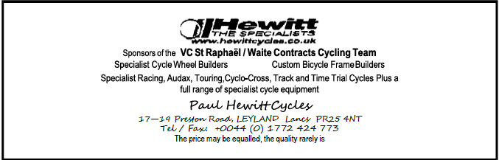

**Don't Forget, When you Finish Hand in your Number & Sign-Out.**

**Failure to do so is a DNF (New Regulation)**