Oxonian CC 25 Mile Open Time Trial
Date: 30/06/2019. Start time 8am.
Course: h25/17

HQ details:
Race HQ at Wootton & Dry Sandford Community Centre (OX13 6DA) opens at 07.00 for sign on etc.
ROOF-RACK or VAN? Beware that there is sometimes a high-level barrier at the entrance to the car-park.
I will try to get it opened, but please take care.

Route Hq to Start:
The start is 3km North from the HQ along the Cumnor Road (B4017).

Course Details:
Start on the corner of the westbound slip road leading from the B4017 near Cumnor to the A420. Head along A420 for around 13miles to the roundabout at Faringdon, turn around and ride back! There are some roundabouts on route, but remain on the main road.
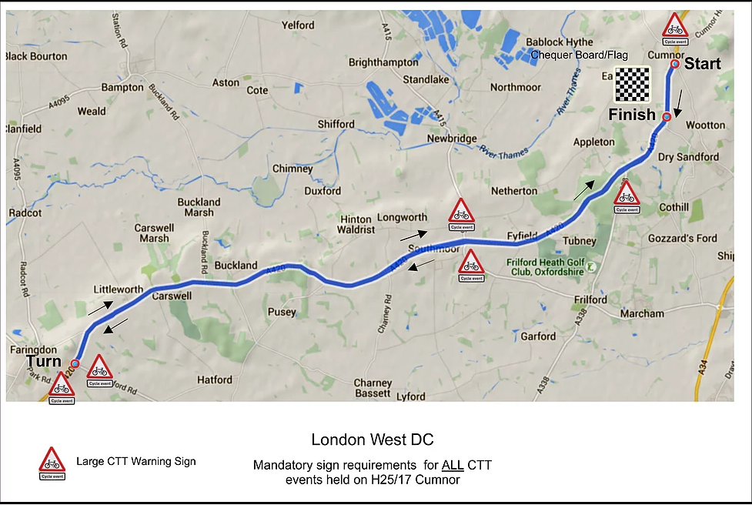
The full details from the London West District are below.
Start on the corner of the westbound slip road leading from the B4017 near Cumnor to the A420, five yards east and before lamp post number four and the ‘Give Way’ signs Go down the slip road to join the A420 westbound (care of fast traffic from the right— warning sign) Continue to the A338 roundabout and take the second exit to continue along the A420. (Sign M1) Continue to the large roundabout on the Kingston Bagpuise by-pass. Take the second exit to continue straight on along the A420 (Sign, M2 and M3) Turn around the A420-A417 Stanford road roundabout at the top of the hill before Faringdon and take the third exit to return eastwards on the A420. (Care) (Check, Sign M4, M5) Continue to the Kingston Bagpuise roundabout Continue to the Kingston Bagpuise roundabout and take the second exit to go straight on along the Kingston Bagpuise by-pass. (M6, M7) Go straight on along A420 at the A338 roundabout on the next stretch of dual carriageway in Tubney Wood (Sign) Take the first exit to continue on A420 to finish near the top of Bessels Leigh hill about 363 yards east of the bus stop lay-by at the bottom and four yards east of and beyond the road sign ‘Oxford A420, Cumnor 1½ Miles’, four yards west of a drain and almost opposite the centre of the upper of two roads on the west leading to Wootton.
For further details see: https://www.londonwestdc.co.uk/courses

Safety | Riders are strongly advised to wear a hard shell helmet that meets an internationally accepted safety standard, and show a red flashing rear light.
General | The A420 is a busy road. The start sheet has been organised so we will all be off the road by 10am. Please be careful on your return to the HQ. Remaining on the A420 and coming off at the junction near the start is probably safer than taking a right turn from the A420 and heading in on Besselsleigh Road.  I am not your mum and you are all grown up, please be safe.
Awards:
FREDDIE GREEN MEMORIAL TROPHY
Subscribed for Club members in 1945 in memory of Freddie Green and other members who laid down their lives in the War. Awarded annually to the winner of the Oxonian Open 25 Time Trial.

Prizes: Mens 1st, 2nd, 3rd (£20,15,10)
Ladies 1st, 2nd, 3rd (£20,15,10)
Fastest Team of 3 (3x £10)
VTTA 1st, 2nd, 3rd (£20,15,10)

Also, for Oxonian Members this event forms part of the club Short Distance BAR, and the Sir Walter Gray Cup.

Organiser Contact Details:
Matthew Robson, 52 Hazeldene Close Eynsham Witney
07940 807186. matthew.robson@oxoniancc.co.uk
Officials:
TK's: Patrick Smith, Howard Waller
Timing analytics provided by Paul Warren and/or Mick Fountain

Records:
Course record: Marcin Bialoblocki: 45:49. 10-Jun-2018
Event record: Hamish Bond: 45:52. 17-Jun-2018

Bib | Start Time | Firstname | Lastname | Club | Gender
5 | 08:05:00 | Emma | Mcdermott | Oxonian CC | Female
6 | 08:06:00 | Jeff | King | Oxonian CC | Male
7 | 08:07:00 | Dave | Wilson | St Neots CC | Male
8 | 08:08:00 | Victoria | Lawson | Didcot Phoenix CC | Female
9 | 08:09:00 | Charlotte | Fisher | Swindon Wheelers | Female
10 | 08:10:00 | Adrian | Mason | Bicester Millennium CC | Male
11 | 08:11:00 | Glen | Knight | Newbury RC | Male
12 | 08:12:00 | Jo | Wilkie | Ride 24/7 | Female
13 | 08:13:00 | Jonathan | Davies | Stourbridge Velo | Male
14 | 08:14:00 | Helen | French | Banbury Star Cyclists' Club | Female
15 | 08:15:00 | Paul | Renshaw | Vector Cycling Race Team | Male
16 | 08:16:00 | Daniel | Crossley | Didcot Phoenix CC | Male
17 | 08:17:00 | Linda | Dewhurst | Team Milton Keynes | Female
18 | 08:18:00 | Frankie | Snare | Mickey Cranks Cycling Club | Female
19 | 08:19:00 | Lindsay | Scott | Northants Tri Club | Female
20 | 08:20:00 | Hans | Nilsson | London Phoenix CC | Male
21 | 08:21:00 | Joe | Graystone | Cowley Road Condors CC | Male
22 | 08:22:00 | Martin | Arundel | Verulam CC | Male
23 | 08:23:00 | Steven | Buckley | Ride 24/7 | Male
24 | 08:24:00 | Sharon | Scott | Swindon Road Club | Female
25 | 08:25:00 | Stuart | Quick | Banbury Star Cyclists' Club | Male
26 | 08:26:00 | Aimee | Jones | Cowley Road Condors CC | Female
27 | 08:27:00 | Edward | James | VTTA (London & Home Counties) | Male
28 | 08:28:00 | Gillian | Morgan | Westerley Cycling Club | Female
29 | 08:29:00 | Mike | Kirby | Banbury Star Cyclists' Club | Male
30 | 08:30:00 | Andrew | Pollard | Cowley Road Condors CC | Male
31 | 08:31:00 | Ed | Dupee | Didcot Phoenix CC | Male
32 | 08:32:00 | Peter | Davies | Brighton Mitre CC | Male
33 | 08:33:00 | John | Howells | Corinium Cycle Club | Male
34 | 08:34:00 | Stephen | Legge | Oxonian CC | Male
35 | 08:35:00 | Chris | Aitken | Thames Valley Triathletes | Male
36 | 08:36:00 | Pete | Scott | Swindon Road Club | Male
37 | 08:37:00 | Helen | Roby | Spirit Bikes CC | Female
38 | 08:38:00 | Michael1 | Murkin | Swindon Road Club | Male
39 | 08:39:00 | Richard | Kenny | Performance Cycles CC | Male
40 | 08:40:00 | Simon | Bull | Banbury Star Cyclists' Club | Male
41 | 08:41:00 | Matthew | Miller | Team Bottrill | Male
42 | 08:42:00 | Alexander | Donger | Cowley Road Condors CC | Male
43 | 08:43:00 | Richard | Coleman | Stourbridge Velo | Male
44 | 08:44:00 | James | Schofield | Cowley Road Condors CC | Male
45 | 08:45:00 | Matthew | Rowley | Oxonian CC | Male
46 | 08:46:00 | Anthony | Turner | Mickey Cranks Cycling Club | Male
47 | 08:47:00 | Dan | Blake | Oxonian CC | Male
48 | 08:48:00 | Gavin | Stevens | Royal Air Force Cycling Association | Male
49 | 08:49:00 | Ewan | Macdonald | Oxonian CC | Male
50 | 08:50:00 | Robin | Short | Performance Cycles CC | Male
51 | 08:51:00 | Mark | Woolford | Team Swindon Cycles | Male
52 | 08:52:00 | Peter | Lloyd | N+1 - Lindfield Coffee Works | Male
53 | 08:53:00 | John | French | Oxford City RC | Male
54 | 08:54:00 | Matthew | Robson | Oxonian CC | Male
55 | 08:55:00 | Michael | Parker | TMG Horizon Cycling Team | Male
56 | 08:56:00 | Matthew | Alder | Fairly United Cycling Team | Male
57 | 08:57:00 | Daniel | Homer | London Phoenix CC | Male
58 | 08:58:00 | David | Holland | Cowley Road Condors CC | Male
59 | 08:59:00 | Andrew | Payne | Maidenhead & District CC | Male
60 | 09:00:00 | Malcolm | Rose | Oxonian CC | Male

