Promoted for and on behalf of Cycling Time Trials under its Rules and Regulations

GARY DIGHTON MEMORIAL 10 MILE TIME TRIAL
SUNDAY 23RD JUNE 2019
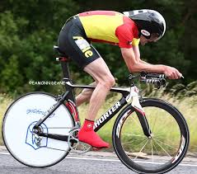

Organiser: Mark Valentine, 16 Cowper Road, Moordown, Bournemouth BH9 2UJ.
078133 21314 sirmarkavalentine@hotmail.com
Timekeepers:
John Pick Chronos RT
Ros Spencer Poole Wheelers
Recorder Joan Price Poole Wheelers

PRIZE LIST
First man £40 first lady £40
Second man £30 second lady £30
Third man £20 third lady £20
Fourth man £10 fourth lady £10
First vet on Std £25 Fastest Vet £25
Second vet on Std £20 Second Vet £20
First Junior £15 Fastest team £10 each

PLEASE NOTE ONE PRIZE PER RIDER APART FROM THE TEAM PRIZE.

A PRIZE PRESENTATION WILL TAKE PLACE AFTER THE EVENT SO PLEASE STAY FOR THAT.

In the interests of safety Cycling Time Trials and the event promotors strongly advise you to wear a hard shell helmet that meets an internationally accepted safety standard.
All junior competitors must wear protective hard shell helmets.
It is recommended at a WORKING REAR LIGHT either flashing or constant is fitted to the machine in the position visible to following road users and is active whilst the machine is in use.

P415 COURSE:

START at the drain cover near the entrance to the side road adjacent to the AUDI
Garage on Old Wareham Road approx 400 yards east of the roundabout at the junction with the A3049 Dorset Way where take first exit to proceed along A3049 via Fleetsbridge flyover to Holes Bay Roundabout. Take 2nd exit (straight on) along A35 to the Bakers Arms roundabout where circle and retrace along A35 and A3049 to finish near the footpath coming through from the Nuffield Industrial Estate.

No U turns within sight of the start or finish, no warming up on the course after the event has started please.

The fire station emergency lights at Holes Bay Roundabout are operational, any rider observed going through a red light will be disqualified and South DC will be informed.

WHEN APPROACHING BAKERS ARMS ROUNDABOUT, COMPETITORS MUST KEEP TO THE LEFT UNTIL THEY HAVE PASSED THE LEFT HAND “REDUCE SPEED NOW” SIGN. RIDERS NOT ADEARING TO THIS RISK BEING DISQUALIFIED.

Headquarters:
Rossmore Leisure Centre, Herbert Avenue, Parkstone, Poole BH12 4HR.

Access to the Centre will be from 6am when signing on etc will commence. Do not forget to SIGN OUT after the event, failure to do so will result in disqualification. Please return and exchange your number for a free tea or coffee at the end.

To get to the start (about 1 mile) turn right out of the Leisure Centre and proceed to the end of Herbert Avenue, take the first exit at both the mini roundabouts and travel to the next roundabout on the B3068. At this roundabout take the second exit for Old Wareham Road where the start is located.

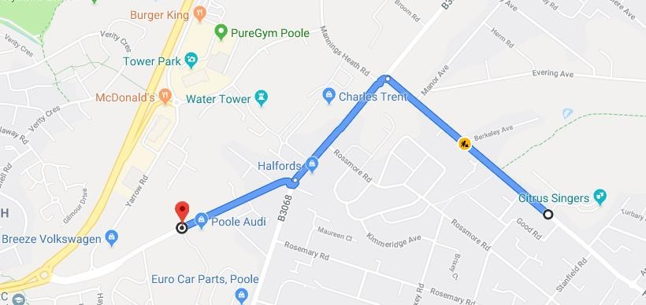

Start Sheet
Number | Firstname | Lastname | Club | Gender | Category | Start Time
1 | Pete | Watkins | Poole Whs | Male | Senior | 07:01
2 | Jonathan | Hyndman | New Forest CC | Male | Veteran | 07:02
3 | Mike | Anderson | Club Cycliste Moncontourais | Male | Veteran | 07:03
4 | Lauren | Bishop | Poole Whs | Female | Senior | 07:04
5 | Richard | Porter | CC Weymouth | Male | Veteran | 07:05
6 | Robert | Flynn | Poole Whs | Male | Senior | 07:06
7 | Adrian | Watkins | Tornado Road Cycling Club | Male | Veteran | 07:07
8 | John | Beaven | 1st Chard Wheelers | Male | Veteran | 07:08
9 | Jonathan | Terry | Poole Whs | Male | Veteran | 07:09
10 | Phil | Brown | trainSharp | Male | Veteran | 07:10
11 | Doug | Parker | Sid Valley CC | Male | Veteran | 07:11
12 | Bob | Ghandour | Poole Whs | Male | Veteran | 07:12
13 | Steve | Wiltshire | Somer Valley Cycling Club | Male | Veteran | 07:13
14 | Chris | Hill | Poole Whs | Male | Veteran | 07:14
15 | Peter | Lynk | Poole Whs | Male | Veteran | 07:15
16 | Michael | Akers | Julian Porter Cycling | Male | Senior | 07:16
17 | John | Rivett | Poole Whs | Male | Veteran | 07:17
18 | Lizzy | Stocker | IRIS Race Team | Female | Senior | 07:18
19 | Mat | Jessop | Tornado Road Cycling Club | Male | Senior | 07:19
20 | Tom | Stocker | Bournemouth Jubilee Whs | Male | Senior | 07:20
21 | Paul | Axon | Poole Whs | Male | Veteran | 07:21
22 | Mark | German | 1st Chard Wheelers | Male | Veteran | 07:22
23 | Dean | Ward | 1st Chard Wheelers | Male | Senior | 07:23
24 | Jackie | Courtney | Poole Whs | Female | Veteran | 07:24
25 | Graham | Harman | Sotonia CC | Male | Veteran | 07:25
26 | Jack | Martin | Velo Club Venta | Male | Espoir | 07:26
27 | Phillip | Scriven | Bournemouth Jubilee Whs | Male | Veteran | 07:27
28 | Ian | Dryden | Poole Whs | Male | Veteran | 07:28
29 | Robert | Jolliffe | New Forest CC | Male | Veteran | 07:29
30 | Alex | Allen | Royal Navy & Royal Marines CA | Male | Senior | 07:30
31 | Ian | Taylor | Beacon Roads CC | Male | Veteran | 07:31
32 | Gary | Trudgett | Poole Whs | Male | Veteran | 07:32
33 | David | England | Crabwood CC | Male | Veteran | 07:33
34 | Maria | Núñez | Poole Whs | Female | Veteran | 07:34
35 | Martin | Andrews | Velo Club Venta | Male | Veteran | 07:35
36 | Nicholas | Barks | Poole Whs | Male | Veteran | 07:36
37 | Simon | Wharton | Royal Navy & Royal Marines CA | Male | Senior | 07:37
38 | Pete | Carter | Poole Whs | Male | Veteran | 07:38
39 | Ellie | Rendell | Poole Whs | Female | Senior | 07:39
40 | Jamie | Whitcher | Bournemouth Cycleworks - Vitec Fire - Ford Civil - Trek | Male | Juvenile | 07:40
41 | Colin | Brumble | CC Weymouth | Male | Veteran | 07:41
42 | Richard | Ryder | Gillingham and District Wheelers / Wheels Cycles | Male | Senior | 07:42
43 | Bradley | Perkins | PDQ Cycle Coaching | Male | Juvenile | 07:43
44 | Sonia | Laurie | New Forest CC | Female | Veteran | 07:44
45 | Jon | Brumfield | CC Weymouth | Male | Veteran | 07:45
46 | Thomas | Piloni | Bournemouth Jubilee Whs | Male | Senior | 07:46
47 | Ben | Whitcher | Poole Whs | Male | Veteran | 07:47
48 | Barry | Hards | New Forest CC | Male | Veteran | 07:48
49 | David | Arrowsmith | CC Weymouth | Male | Veteran | 07:49
50 | Terry | Icke | CC Weymouth | Male | Veteran | 07:50
51 | Tom | Clements | POLICE SPORT UK CRT (PSUKCRT) | Male | Veteran | 07:51
52 | Ian | Diaper | Bournemouth Jubilee Whs | Male | Veteran | 07:52
53 | Neil | Dyble | Bournemouth Arrow CC | Male | Veteran | 07:53
54 | Sarah | Bascombe | Poole Whs | Female | Senior | 07:54
55 | Simon | Rogers | Royal Navy & Royal Marines CA | Male | Veteran | 07:55
56 | Aron | Kelly | New Forest CC | Male | Senior | 07:56
57 | Andrew | Mayfield | Bournemouth Arrow CC | Male | Veteran | 07:57
58 | Chris | Simpson | Bournemouth Jubilee Whs | Male | Veteran | 07:58
59 | Timothy | Shepherd | Poole Whs | Male | Veteran | 07:59
60 | Julian | Lockwood | Primera-Teamjobs | Male | Veteran | 08:00
61 | Craig | Weston | Poole Whs | Male | Veteran | 08:01
62 | Richard | Wyeth | Tornado Road Cycling Club | Male | Veteran | 08:02
63 | Robb | Tooley | Poole Whs | Male | Veteran | 08:03
64 | Suzy | Watkins | Poole Whs | Female | Senior | 08:04
65 | Jason | Streather | PDQ Cycle Coaching | Male | Veteran | 08:05
66 | Nicholas | Hitchens | Team Bottrill | Male | Veteran | 08:06
67 | Conor | Boyle | Woking Cycle Club | Male | Veteran | 08:07
68 | Lou | Dutch | Poole Whs | Female | Veteran | 08:08
69 | Matt | Blythe | Bournemouth Arrow CC | Male | Veteran | 08:09
70 | Bryce | Riglar | CC Weymouth | Male | Senior | 08:10
71 | Kevin | Baker | Andover Wheelers | Male | Senior | 08:11
72 | James | Horton | Velo Club St Raphael | Male | Senior | 08:12
73 | Shawn | Gray | Gillingham and District Wheelers / Wheels Cycles | Male | Veteran | 08:13
74 | Jason | Gault | Primera-Teamjobs | Male | Veteran | 08:14
75 | Nic | Stevenson | Westerley Cycling Club | Male | Senior | 08:15
76 | Steven | Pink | Poole Whs | Male | Veteran | 08:16
77 | Thomas | Day | Giant CC Halo Films | Male | Junior | 08:17
78 | Paul | Jones | Primera-Teamjobs | Male | Veteran | 08:18
79 | Andrew | Perkins | Mid Devon CC | Male | Veteran | 08:19
80 | Tim | Cartwright | Newbury RC | Male | Veteran | 08:20

