Western Time Trials Association
100 mile time trial U86/100
16/06/2019 – 6:01am
This is a counting event in both the WTTA
and National Best All Rounder competitions
Promoted for and on behalf of Cycling Time Trials under their Rules and Regulations
Event Secretary Time Keepers
Emma Angove Ian & Bridget Boon
2 Derriads Lane
Chippenham
Wiltshire Start/Finish Official
SN14 0QH Bernie Brown
Mobile: (07827) 337543
Email: eangove@yahoo.com

Prizes to be awarded on the day (one prize per rider)
First Overall | £25.00 | First Vet 40 | £20.00
Second Overall | £15.00 | First Vet 50+ | £20.00
First Woman | £25.00

HQ – Minety Village Hall, Hornbury Hill, Minety, Malmesbury SN16 9QH.
From the B4040, turn north on to Silver Street, follow the road as it turns left into Hornbury Hill. The HQ is approx 0.2 miles along Hornbury Hill on your left.
The HQ will be open from around 5am. No cleats to be worn in the village hall at any time.
Please be mindful of local residents park considerably and legally. Be quiet early in the morning. No Turbo trainers or warming up in the car park or within 100m of residential property.

Route to Start
Leave the HQ turn right, follow Hornbury Hill and Silver Street back to the B4040 Minety Crossroads. On reaching the B4040 at the Turnpike Inn, carefully cross straight over onto the minor road. The start is approximately 1 mile down the road.

Marshalls
Each turn on the course will be marked with arrows ahead, there should be a marshall at each of the five turns on the first couple of laps. Where possible we will marshall throughout the event, but we may not have sufficient marshalls to do this so make sure you know the course.

Bottle Station
My hope is we can run a bottle station around the top of the minor climb between Garsdon and Minety cross roads. You will need to ensure all your bottles are labelled (available at HQ beforehand) with your race number and drop off in the box at the HQ before the start. We will have a number checker and hand the bottle to you if possible, but it will be your responsibility to get your bottle please remember these are volunteers doing you a favour and be mindful of other riders. Any bottles you want to discard, only do so in the metres prior to the bottle station, they will be collected and returned to HQ post event for you. Check on the day if we are able to do this.
Signing In/Out
Riders must sign on at race HQ to collect their number and check for any last minute information regarding the event or course.
Please return your number for a free tea or coffee, and ensure you sign out at the same time.
Failure to sign-on AND sign-off will result in DNF recorded on your result

Course Description
The course is generally expected to be quiet during the event. After 10am the A429 may become busier when the supermarket opens. Please find below details of the U86/100 course, the onus is on the rider to know the course.

Start: Start is in the hard standing entrance to Ravenhurst farm, in line with the H 100/8. On the minor road south of Minety (south from Turnpike Inn).
Course: Leaving the start, progress north to Minety. On reaching the B4040 turn left onto the B4040. Proceed westward through Charlton (two sharp left hand corners circled on map below) and onto the RAB on the A429 just before Malmesbury. Left to turn south on the A429. Proceed to next RAB with the B4042, where left onto the B4042. Proceed eastward, passing through Brinkworth, and The Common till reaching the B4696 (just before the M4 motorway). Left onto the B4696 (sign posted Ashton Keynes, Cricklade, Cirencester). After approximately 2 miles, take the left turn at Braydon Cross (sign posted Garsdon). Follow to top of minor climb, where follow the road through its right turn (signed Minety 1½). Follow through to pass the start. This forms the first loop.
The loop is performed five times. Each loop being 19.99 miles.
On passing the start for the 5th time, the finish is just over the brow hill north of the start.
Finish: The finish is in line with the HP Gas Pole about 200m north of the start.

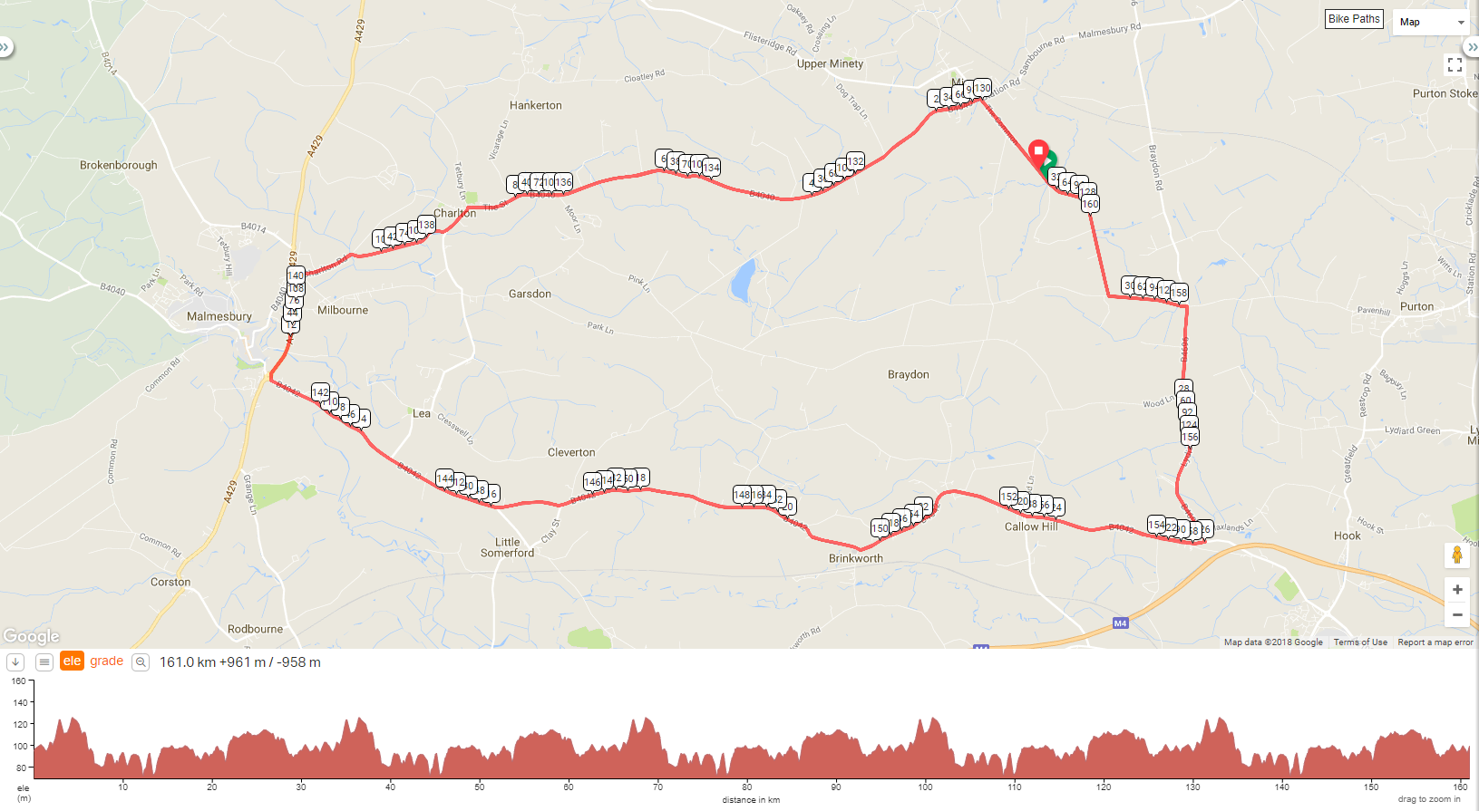
Link to course on Ridewithgps: https://ridewithgps.com/routes/27152597

IN THE INTERESTS OF YOUR OWN SAFETY
The race takes place on public roads with live traffic on the course so competitors must obey the Highway Code at all times and not impede other road users.
Cycling Time Trials recommends that all competitors wear a hard shell helmet that meets internationally recognised safety standards
All junior/juvenile riders MUST wear protective hard shell helmets
Please keep your head up for a safe ride

