FAREHAM WHEELERS CYCLING CLUB
FWCC – Est. 1927
Open 10 mile Time trial
P881r
Course Record & South DC All Comers District Record:
00:17:55 – Hamish Bond

Saturday 8th June 2019
First rider start at 1601hrs.

PROMOTED FOR AND ON BEHALF OF CYCLING TIME TRIALS UNDER THEIR RULES AND REGULATIONS

HEADQUARTERS: Bohunt School, Longmoor Road, Liphook, Hampshire GU30 7NY (SU837316).

Ample free off street parking.
TOILET FACILITIES: Bohunt School, Longmoor Road, Liphook, Hampshire GU307NY(SU837316).

SAFETY INSTRUCTIONS
Riders must:
Any rider observed riding in a manner which may jeopardise his or her own safety, the safety of others and the future of the sport will be disqualified and reported to the South district council of Cycling Time Trials.
DUTY OF CARE
- The Riders
The primary “duty of care” rests with the riders. It is their responsibility to:
- Comply with traffic law and regulations; the Highway Code and the risk assessment. Failure to comply renders a rider liable to disqualification and possible further disciplinary action.
- Observe the measures taken by the Highways authorities to reduce risks and conflict with other road users.
- Ride in a manner that is safe for themselves and all others.
- Accept they participate at their own risk and must rely on their own ability and judgement in dealing with all hazards.

RISK ASSESSMENT.
Will be available on the day.
SIGNING-ON SHEET & RACE NUMBERS
Riders must sign the Official signing-on sheet at the Event HQ to obtain their race number and sign off at the event HQ at the completion of the ride as soon as practicable.
Route to Start From Bohunt School (SU837316) Turn left onto Longmoor road and ride west for approximately 1.2 miles to the start holding area situated at the top of the ‘On’ slip road for the A3 South West. When directed by an official, proceed down the slip road to the start area just before the slip road joins the main A3 carriageway (SU 81667 31751) Riders waiting to start will be restricted at the actual start.
ROUTE FROM FINISH: Continue on slip road after finish, over the A3 and follow the Longmoor road back to HQ as a reverse route taken to the start.
COURSE P881r
Start. On entry slip road to A3 at Griggs Green interchange.
Ride south west to join A3 (signposted Petersfield and Portsmouth).
Proceed on A3 passing exit slip road at Longmoor Interchange (Signposted A325 Farnham) to Ham Barn RAB (SU 772295).
Take 2nd Exit and continue on A3 until reaching the exit slip road signposted Liss (1/2 mile past the lay-by), take this exit slip road to the Prince’s Bridge RAB (SU 770270).
Take 2nd exit and then bear RIGHT following the sign, A3 Guildford, to cross Prince’s bridge flyover where TURN (5.00 Miles).
Rejoin the A3 and proceed north to Ham Barn RAB (SU 772295)
Take 2nd exit and proceed north east on A3 passing the exit slip road at Longmoor interchange (signposted A325 Farnham).
Take the 2nd exit slip road (signposted, Griggs Green) to
FINISH on exit slip road at Griggs Green interchange

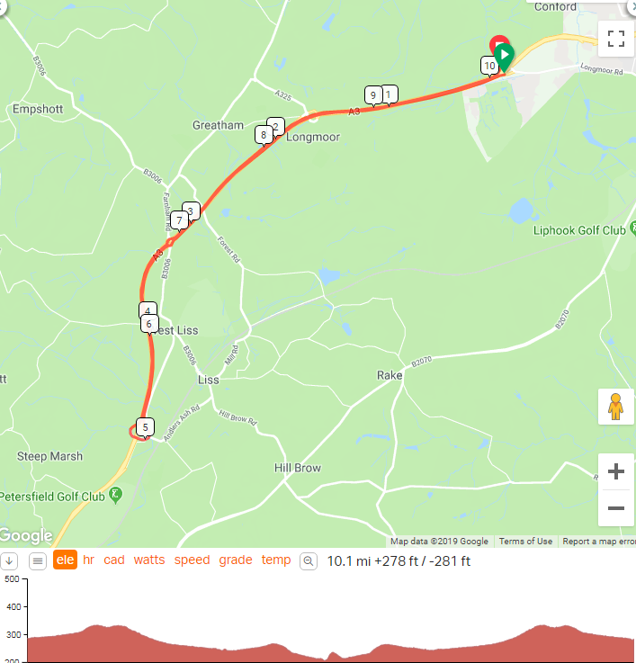

ORGANISER: Nigel Sign. 35 Gibson close, Lee on the Solent. Hampshire PO13 8JD 07909942071
TIMEKEEPERS: Kathy Collard-Berry & Maria Golden

STARTER:

MARSHALLS: TBC

AWARDS
• 1st Man: £50
- 2nd Man: £30
- 3rd Man: £20

• 1st Woman: £50
- 2nd Woman: £30
- 3rd Woman: £20

• 1st Team: £45
- 2nd Team: £30
- 3rd Team: £15 each team member

- Veteran on standard: 40-49yrs £10
- 50-59yrs £10
- 60-60yrs £10
- 70+yrs £10
- 80+yrs £10

Note: With the exception of Team prizes, only one prize per competitor. The higher value of prize taking precedence.

EVENT ABANDONMENT Should the event need to be abandoned; this will be done in accordance with CTT guidelines.

