GLOUCESTER CITY CYCLING CLUB

President: Malcolm Taylor
SPONSORED by RUDY PROJECT

U72 TG Hall Cup & Handicap Cup 25 MILE Time Trial
RESULTS 20th April 2019
Promoted for and on behalf of Cycling Time Trials under their Rules and Regulations
.
Course: U72

Event Secretary: - Nigel Jones - 12 Church Road
Longlevens
Gloucester GL2 0AQ
Tel: 07751 165705
nigeljones661@virginmedia.com

Dear Rider,

Please find enclosed the results of the recent Time Trial you entered on the U72.
Once again I would like to thank you all who raced on the day.
It is a challenging but scenic course, but one our club would certainly like to remain using, so I thank you all again for supporting this Event.

A big thank you also to all the volunteers below, who helped out on the day to make it possible, and again without these people we cannot ride these events.

Timekeepers: Martin Mcreary, Aleksa & Pushers off: Colin & Ken
Malcolm Grainger

Marshalls: Ted, Adrian, Mike Clements, Malcolm T, Ian Wareing, Mark Mills
Results from Finish: Aleksa

Results Board at HQ: Simon Chapman, Nigel
Traffic Count – Simon Wicks

Handicapper: Neville Lockwood

Kitchen: Pauline Burge,

Congratulations to Felix Wilkinson – VC Montpellier on Winning the TG Hall Cup in a time of 54:49

Also to Pete Errington - Gloucester City CC on Winning the TG Hall handicap cup in a time of 1:00:38 for being the fastest Gloucester rider.

1st TG Hall Cup Winner: Felix Wilkinson -VC Montpellier 54:49
2nd Place Rob Grover - Bradford Upon Avon CC 55:23
3rd Place Tony Chapman - Frome & District 57:37
Team Event was won by Cheltenham in a time of 2:59:45 secs
Jordan Wintle, Ben Cox , Gary Rickards
Fastest Lady: Joanne Jago - Performance cycles 1:06:00
2nd Lady – Kate Derrick – Chippenham & District 1:08:55
1st V60 Pete Errington - Gloucester City CC 1:00:59
2nd V60 Chris Broad drake – Swindon RC 1:02:47
1st V50 Simon Coles - Northover VT 58:00
2nd V50 Steve Cottington - Bath CC 59:02
1st V40 Peter Scott - Swindon RC 59:36
2nd V40 Simon Ward - Bristol RC 1:00:34

Please see below for all results:
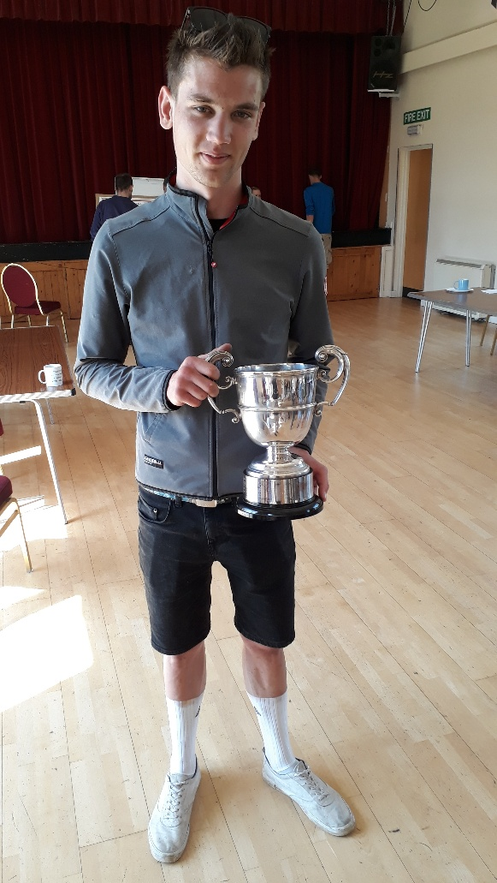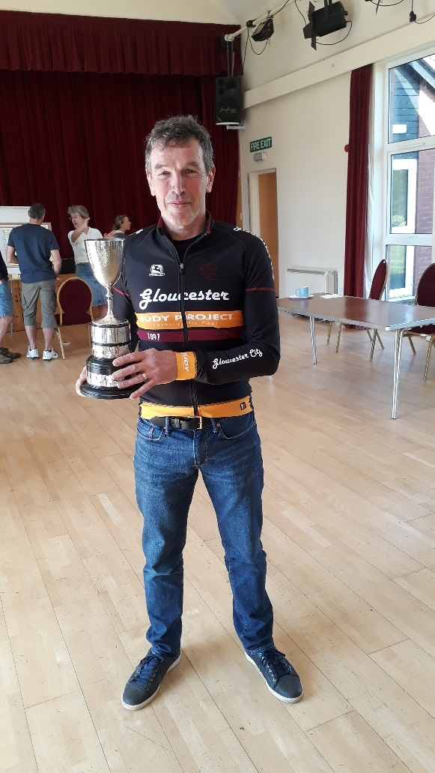
Felix Wilkinson Pete Errington
Bib | Start time |  |  | Firstname |  | Last name | Club |  |  | Cat |  | Time
60 | 10:00 |  |  | Felix |  | Wilkinson | Velo Club Montpellier |  |  | S |  | 00:54:49
11 | 09:11 |  |  | Robert |  | Grover | Bradford-on-Avon Cycling Club |  |  | S |  | 00:55:23
50 | 09:50 |  |  | Tony |  | Chapman | Frome and District Wheelers |  |  | V4 |  | 00:57:37
65 | 10:05 |  |  | Simon |  | Coles | Northover VT / Rudy Project / SCS |  |  | V5 |  | 00:58:00
66 | 10:06 |  |  | Jordan |  | Wintle | Cheltenham & County Cycling Club |  |  | S |  | 00:58:39
5 | 09:05 |  |  | Ben |  | Price | Cheltenham & County Cycling Club |  |  | S |  | 00:58:46
40 | 09:40 |  |  | Steven |  | Cottington | Bath Cycling Club |  |  | V5 |  | 00:59:02
31 | 09:31 |  |  | Lloyd |  | Dobson | Army Cycling |  |  | S |  | 00:59:09
49 | 09:49 |  |  | Pete |  | Scott | Swindon Road Club |  |  | V4 |  | 00:59:36
17 | 09:17 |  |  | Wayne |  | Mayer | VeloVitesse/ALLCAP/James Barry/SiS |  |  | V5 |  | 00:59:56
35 | 09:35 |  |  | Luke |  | Smith | Bristol South Cycling Club |  |  | V5 |  | 01:00:28
37 | 09:37 |  |  | Simon |  | Ward | Bristol Road Club |  |  | V4 |  | 01:00:34
27 | 09:27 |  |  | Peter |  | Errington | Gloucester City Cycling Club |  |  | V6 |  | 01:00:38
64 | 10:04 |  |  | Lester |  | Grant | Auchencrow Thistle CC |  |  | S |  | 01:00:40
23 | 09:23 |  |  | Arran |  | Armstrong | Velo Club Walcot |  |  | V4 |  | 01:01:46
10 | 09:10 |  |  | Earl |  | Smith | Royal Dean Forest Cycle Club |  |  | V4 |  | 01:01:52
32 | 09:32 |  |  | Roy |  | Carless | Swindon Road Club |  |  | V5 |  | 01:01:57
20 | 09:20 |  |  | Peter |  | Garnett | Swindon Road Club |  |  | V4 |  | 01:02:07
41 | 09:41 |  |  | Gary |  | Rickards | Cheltenham & County Cycling Club |  |  | V5 |  | 01:02:20
22 | 09:22 |  |  | Chris |  | Broad-drake | Swindon Road Club |  |  | V6 |  | 01:02:47
42 | 09:42 |  |  | Alex |  | Mccree | VeloVitesse/ALLCAP/James Barry/SiS |  |  | V4 |  | 01:02:59
45 | 09:45 |  |  | Simon |  | Cox | Chippenham & District Wheelers |  |  | V4 |  | 01:03:11
15 | 09:15 |  |  | Daniel |  | Kempe | Bristol South Cycling Club |  |  | V5 |  | 01:03:23
63 | 10:03 |  |  | Jake |  | Tay | Severn Road Club |  |  | V4 |  | 01:03:34
21 | 09:21 |  |  | Derek |  | Dowdeswell | Gloucester City Cycling Club |  |  | V6 |  | 01:04:54
46 | 09:46 |  |  | Ross |  | Mahoney | Swindon Road Club |  |  | S |  | 01:04:58
3 | 09:03 |  |  | Stephen |  | White | Dursley Road Club |  |  | V5 |  | 01:04:58
25 | 09:25 |  |  | Joe |  | Schvartz | Team Swindon Cycles |  |  | V5 |  | 01:05:05
26 | 09:26 |  |  | Andy |  | Kelly | Bristol South Cycling Club |  |  | V5 |  | 01:05:07
59 | 09:59 |  |  | Matthew |  | Hill | Gloucester City Cycling Club |  |  | V4 |  | 01:05:19
38 | 09:38 |  |  | Allan |  | Hodgson | Newport Phoenix CC |  |  | V5 |  | 01:05:26
1 | 09:01 |  |  | Jamie |  | Richardson Paige | Chippenham & District Wheelers |  |  | S |  | 01:05:41
6 | 09:06 |  |  | Joanne |  | Jago | Performance Cycles CC |  |  | L |  | 01:06:00
34 | 09:34 |  |  | Mark |  | Smith | Team Swindon Cycles |  |  | S |  | 01:06:10
47 | 09:47 |  |  | Mark |  | Evans | Chippenham & District Wheelers |  |  | V5 |  | 01:06:18
18 | 09:18 |  |  | Daryl |  | Stroud | Tri Team Glos |  |  | V5 |  | 01:06:24
2 | 09:02 |  |  | Tonymartin |  | Lake | Gloucester City Cycling Club |  |  | V4 |  | 01:06:45
16 | 09:16 |  |  | Paul |  | Freegard | Chippenham & District Wheelers |  |  | V6 |  | 01:06:58
4 | 09:04 |  |  | Steve |  | Harding | Velo Club Walcot |  |  | V4 |  | 01:07:53
61 | 10:01 |  |  | David |  | Evans | Team Echelon |  |  | V6 |  | 01:08:15
13 | 09:13 |  |  | Nathaniel |  | Powys | Wyre Forest Cycle Racing Club |  |  | J |  | 01:08:20
53 | 09:53 |  |  | Steven |  | Buckley | Ride 24/7 |  |  | V6 |  | 01:08:22
33 | 09:33 |  |  | Gary |  | Harvey | Dursley Road Club |  |  | V5 |  | 01:08:38
29 | 09:29 |  |  | Kate |  | Derrick | Chippenham & District Wheelers |  |  | L |  | 01:08:55
43 | 09:43 |  |  | Tim |  | Besien | Cheltenham & County Cycling Club |  |  | V4 |  | 01:10:22
28 | 09:28 |  |  | Clementina |  | Davies | Yeovil Cycling Club |  |  | L |  | 01:10:37
39 | 09:39 |  |  | Sharon |  | Scott | Swindon Road Club |  |  | L |  | 01:11:07
57 | 09:57 |  |  | Chris |  | Lowe | Swindon Road Club |  |  | V6 |  | 01:11:23
54 | 09:54 |  |  | Richard |  | Emery | Severn Road Club |  |  | V5 |  | 01:11:33
48 | 09:48 |  |  | Ali |  | Charles | Gloucester City Cycling Club |  |  | L |  | 01:12:20
58 | 09:58 |  |  | Graham |  | Smith | Severn Road Club |  |  | V5 |  | 01:16:10
44 | 09:44 |  |  | Mary-jane |  | Hutchinson | Bristol South Cycling Club |  |  | L |  | 01:16:30
9 | 09:09 |  |  | Charlotte |  | Fisher | Swindon Wheelers |  |  | L |  | 01:22:40
19 | 09:19 |  |  | Lindsey |  | Lyes | VeloVitesse/ALLCAP/James Barry/SiS |  |  | L |  | DNS
30 | 09:30 |  |  | Mark |  | Hudson | Bristol South Cycling Club |  |  | S |  | DNS
14 | 09:14 |  |  | Daniel |  | Kelly | Gloucester City Cycling Club |  |  | S |  | DNS
52 | 09:52 |  |  | Charles |  | Coleman | Rogue Racing |  |  | S |  | DNS
62 | 10:02 |  |  | James |  | Coleman | Rogue Racing |  |  | S |  | DNS
56 | 09:56 |  |  | Jeremy |  | Redford | Army Cycling |  |  | V4 |  | DNS
12 | 09:12 |  |  | Digby |  | Rusling | Royal Dean Forest Cycle Club |  |  | V4 |  | DNS
55 | 09:55 |  |  | Les |  | Liddiard | Team Jewson - MI Racing ~Poly Pipe |  |  | V6 |  | DNS
24 | 09:24 |  |  | Nadia |  | Tramontin | Tri Team Glos |  |  | L |  | DNSA
7 | 09:07 |  |  | George |  | Thorne | Beacon Roads CC |  |  | S |  | DNSA
36 | 09:36 |  |  | Simon |  | Witts | Gloucester City Cycling Club |  |  | V4 |  | DNSA
8 | 09:08 |  |  | Peter |  | Ballinger | Tri Team Glos |  |  | V4 |  | DNSA
51 | 09:51 |  |  | Jim |  | Beales | Veloce |  |  | V5 |  | DNSA
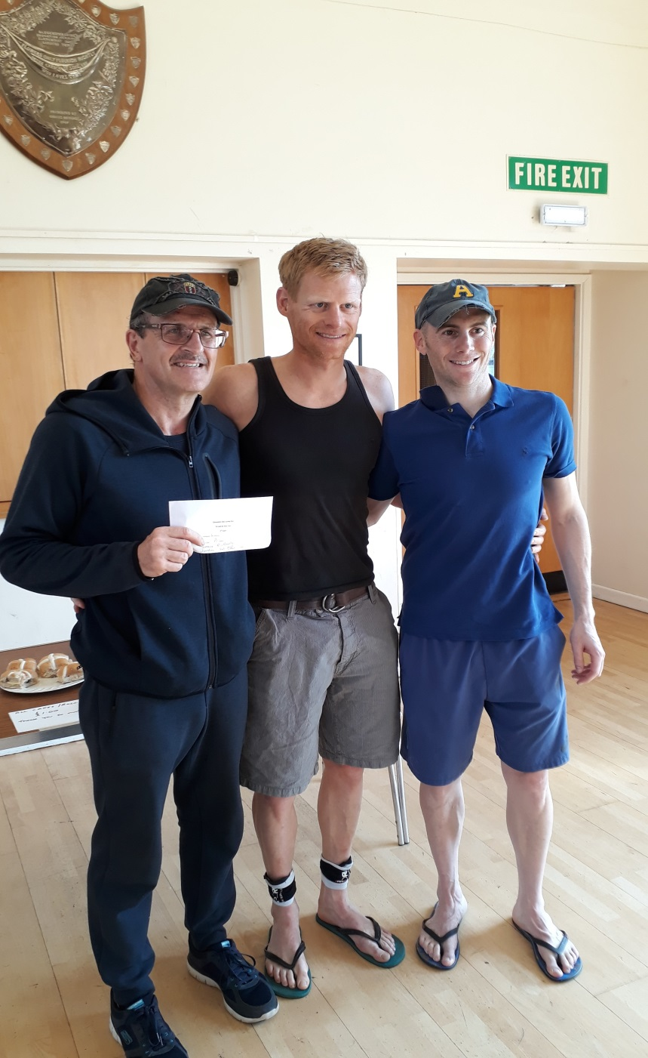
Cheltenham CC

