Sunday 28th April 2019
HQ: North Cerney Memorial Village Hall, GL7 7BZ
WESTERN TIME TRIALS ASSOCIATION
HARDRIDERS
CHELTENHAM & COUNTY CYCLING CLUB
"Promoted for and on behalf of Cycling Time Trials under their Rules and Regulations”

Event Secretaries Harry Walton, Scott McArdle
Time Keepers Martin McGreary, Don Muir
Laura Finucane
Catering Laura Finucane
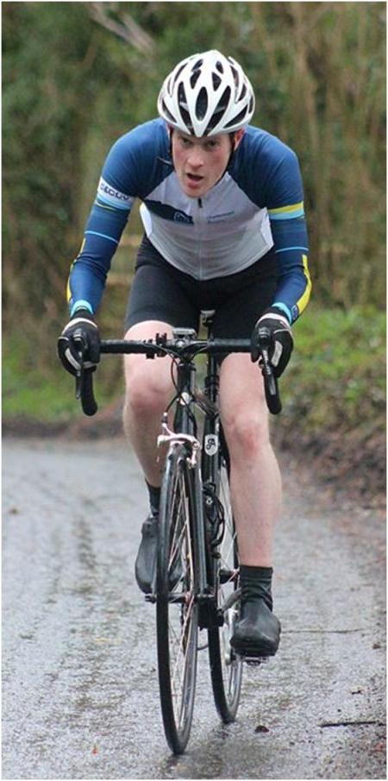
PRIZES
1st Female | 20
2nd Female | 15
3rd Female | 10
1st Male | 20
2nd Male | 15
3rd Male | 10
Fastest V40+ | 15
Fastest V50+ | 15
Fastest V60+ | 15

Free refreshments at the HQ after the event with donations to
Great Western Air Ambulance

All riders are asked to:
- Keep your head up, be aware of your surroundings
- IN THE INTERESTS OF YOUR OWN SAFETY Cycling Time Trials and the Event Promoters strongly advise you to wear a HARD SHELL HELMET that meets an internationally accepted standard. In accordance with Regulation 15 ALL JUNIOR competitors must wear protective helmets.
- It is recommended that a working rear light, either flashing or constant, is fitted to the machine in a position visible to following road users and is active whilst the machine is in use.
- This event may be subject to doping control. It is YOUR responsibility to check.
- No passing the start time keeper or warming up on the course.
- No turbo within 100m of residential areas

HQ & Signing on
HQ is open from 08:00 am
North Cerney Memorial Village Hall, North Cerney, Cirencester, GL7 7BZ
Parking is tight though there should be adequate space in the road in front of the hall and into the village. Please be careful to minimise disruption to the locals. There are also a few large laybys around, e.g. on the A435 near Perrots Brook and near the start.
Don’t forget to return your number and sign out

Getting to the Start
It is 3.0 miles to the start from the HQ. You should leave 20 minutes to be on the safe side. We suggest you build the journey into your warm up
Suggested route: https://goo.gl/maps/GNjYuqUUJkk

Getting back to the HQ
It is 2.2 miles from the finish to the HQ.
Suggested route: https://goo.gl/maps/dL5TAGWPXuC2

Course
The course is the U75 (22 miles, 35km)
https://www.strava.com/segments/8824345
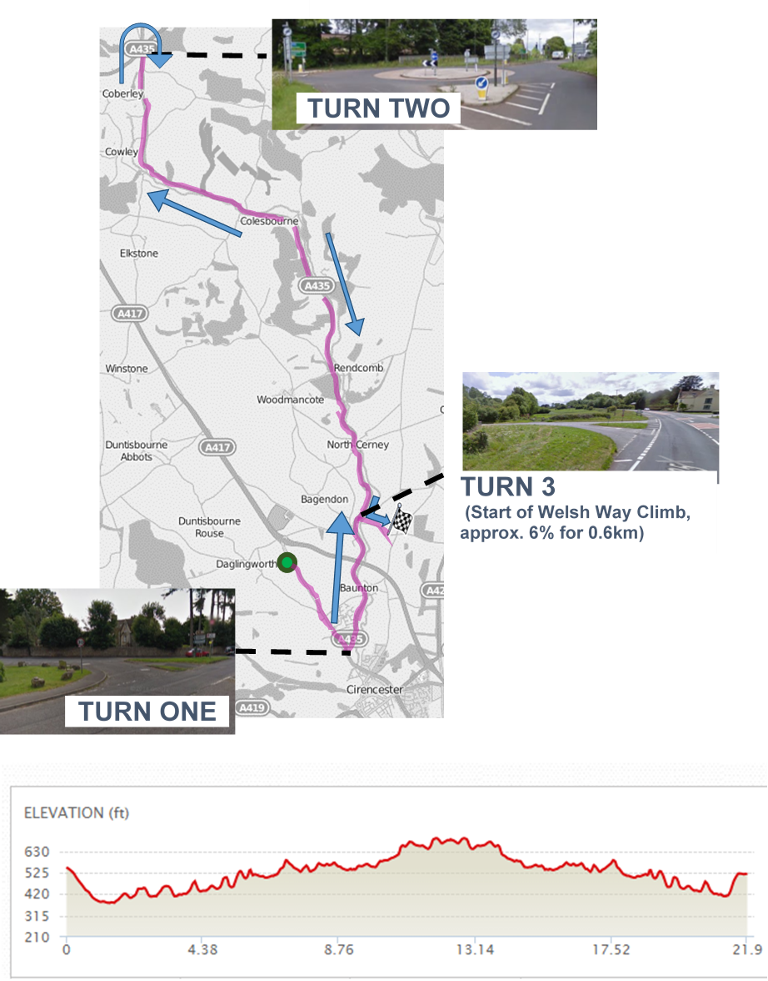
Course Records
Men – David Janes 46:40 (2017)
Women – Pfeiffer Georgi 54:31 (2018)
START on Gloucester Road in south end of layby 650m south of A417 junction. Proceed 1.4 miles south to Stratton and TURN LEFT onto A435. Proceed 10.9 miles to Severn Springs Roundabout. TAKE THIRD EXIT to rejoin A435 on southbound carriageway. Proceed 8.9 miles and TURN LEFT onto Welsh Way. Continue 1.3 miles to FINISH by field entrance 0.2 miles before junction with White Way.

