Welcome to Carrick CC hilly TT
This is the 2nd running of the TT an hopefully not the last but due to be such a small club we are running the race with minimal support so thanks go out to all who have chipped in to help.

The race starts at the loch Doon turn off from the A713 and head directly south to Carsphairn village where you will turn round the monument and head directly back to where you started. The course is 17.8 miles long and has 800 ft of climbing.

The strip is at Doon Academy school Dalmellington, Ayr Road, KA6 7SJ and sign on will start at 8.45am with the first rider away at 10am, please allow yourself 10-15 mins to get to the start which is 2 miles away south on the A713

Please do not park at the loch Doon car park as these spaces are required for time keepers and marshals and is very limited please park at the school and use the car park which is marked in the green area.

There will be toilets and changing facilities at the hall and showers.

Please use common sense when riding and a rear light would be beneficial as depending on the weather it can get misty up on top of the course.

See you all on Saturday
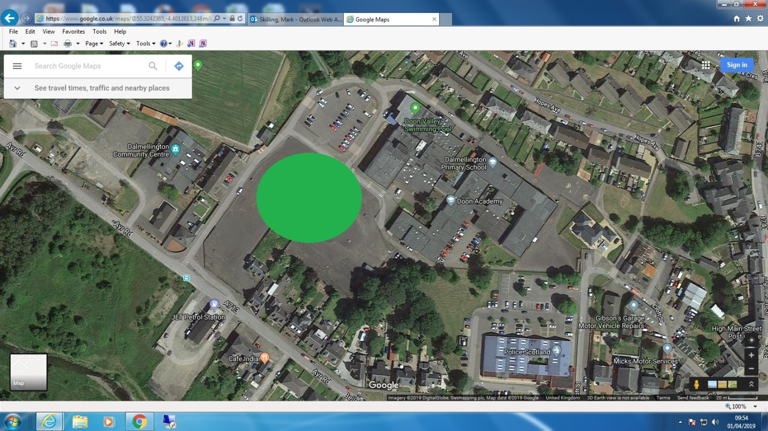
Start
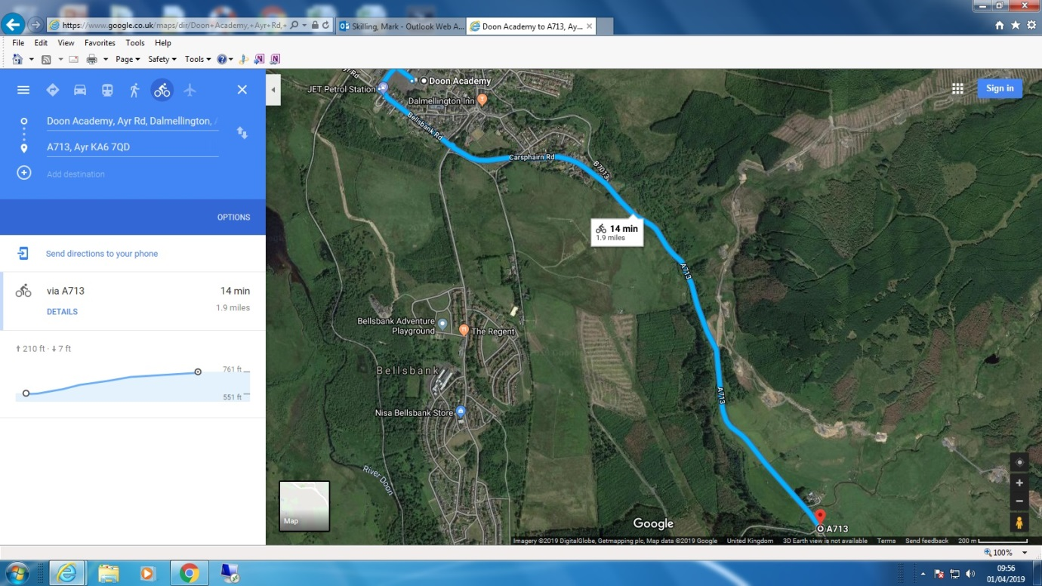

Turn
