Gloucester City CC -rudy project
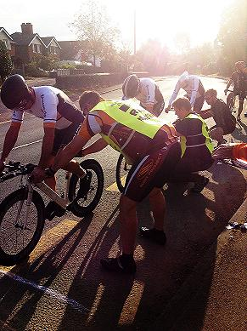 as clearly illustrated heads up!

RESULT SHEET - Gloucester 25 mile and 3up Time Trial.
Sunday 2nd October 2016 on course U72
(Promoted for and on behalf of Cycling Time trials under their rules and regulations)

Maisemore Village Hall, Church Road , Maisemore, Gloucester.GL2 8JE

Event Secretary: Gerry McGarr Phone No: 01452 612818
11 Rendcomb Close Email: valmcgarr@valmcgarr.f9.co.uk
Abbeymead
Gloucester
GL4 5UH

PRIZE WINNERS:
3UP Fastest Team: 1st Cycology Bikes Will Crudington,Matt Griffin,Mark Trefall £60 Plus hold the Dr Henry Trophy
2nd Bath CC Steven Cottington ,Darren Gardiner,Iain Cade £45
3rd Cycology Bikes Edward Griffin,Jonathan Griffin,Kirk Latham£30
LADIES 1stSalt and Sham CC Caroline Butler,Fiona Wyatt,Gemma Eason £30

Solo 25: Men 1stDean Robson NOPINZ £30 2ndDanny Axford Artic Tacx RT £25 3rdSean Townsend Gloucester City CC£20

Ladies 1^{s}Mary-Jane Hutchinson Bristol South CC £10 2ndAlison Vuagniaux Bath CC£5
V40 1st Graeme Davis Dursley RC£20 2nd Mike Brearton The Endurance Store £15 3rdSimon Witts Gloucester City CC £10
V50 1st Gary Rickards Cheltenham &County CC £15 ,2ndJames Hargreaves Kenilworth Whls £10
V60 1stDerek Dowdeswell,Gloucester City CC £15 2ndRobert Hutchinson ,Bristol South CC£10
Winning Team: Gloucester City CC Townsend, Witts, Dowdeswell £10 each

Thanks
It starts with the timekeepers Mike and Shiela Edwards from Chippenham and Dist Whls and Malcolm Grainger Gloucester City CC – we cannot hold a TT without these people. Please consider getting members of your club to take up the important role in the sport because we very low in the West DC. Anne and John Barnes Ledbury Turn and half way times,Catering team Pauline and Karen you did a fantastic job and I really appreciated your work throughout the morning. Roy Hook registration and Result board sterling work, Jamie Woodward and Daughter,Adrian Rowley,Ken Sheldon,Paul Douglas,Mike Hale and Colin Edmunds who does great job for all club races by printing out the result boards.
Congratulations to all prize winners and all riders we were blessed with a good day and some good times recorded.
Next year I will go back to providing some hot food so we can all have a good chat around our toast and beans !
Podium : Many famous riders have stood on that podium from youngsters who went on to become World Champions ! How about Nicole Cook, Tracy Moseley,Fionne Griffiths the Athertons,Commonwealth Gold Medallist Liam Killeen and Will Bergfelt ,Simon Richardson all riders were youngsters. Then ex Professional National Champions Gary Crewe and Mick Ives.even ex Tour De France riders like Martin Early and Sean Yates TT stars Michael Hutchinson – Julie Shaw- but now comes the time to make a new one !

Have a good safe,warm winter

Gerry McGarr

