2018 Scottish District Hill Climb Championship CTT
Riders Information Pack
Saturday 13th October 2018, 1st Rider off at 0901 hours
HQ at: Johnstone Wheelers Club Rooms
1a Miller Street, Johnstone, PA5 8HP

HQ – open from 0800 hours for sign on and post-race presentation
HQ – Toilets, Teas & coffees with snacks are available

Organiser: Stevie Blom, 18 Queen St Flat 2/3, Paisley, Renfrewshire, PA1 2TU. Tel: 0141 0141 389 0738. Email: stephenblom@hotmail.com. Mobile number for use on the day: 07423666960 (note that reception will be patchy, so text messages are likely best on the day)
Timekeepers: Linda Smith, Geoff Smith, Jim Smith
Pushing off: Joe Hands
Marshals: Matt Hennen + Danny O’Neil
Neutral observer: Willie Cosh

Course: 1.8 Mile Hill Climb
Men and Male Espoir’s, Woman, Juveniles, Juniors, Veterans are to complete 1.8mile Course.
CTT Map link of course: - https://www.cyclingtimetrials.org.uk/race-details/17838

Course Description and Notes
Start line is just along from Adams Care home adjacent to the 30 MPH sign post
Auchenlodment Road, Johnstone
Please refer to Adams Care home Post Code ‘PA5 9NX’ as a guide to reach Start line
1, Continue up the climb for 1.8 Miles until you reach the Finish line
2, Remain on the Auchenlodment road from start until finish, do not deviate.
3,1st section will cover a series of short sharp hair pin bends
4, You will pass by 2 junctions on your right-hand side, The only 2 on this course. please be cautious of any on coming traffic as well as potential traffic joining the Auchenlodment road from both junctions
5, The course will have 1 Marshall on each junction
6, Please recce the course and familiarise yourself PRIOR Racing
7, Please allow 20 minutes from HQ to Start line
8, Please ensure you have a flashing rear Red Light, Weather is reported to be poor so maximise your visibility to be seen.
9, Please ensure you have a fully working bike, fit for purpose, it is your responsibility!

Regulations
Riders must exercise caution at all junctions. No "U" turns near the start and finish. Observers will be watching. Head up and always observe local regulations. Pace must not be given or received, and the onus is on the caught riders to adhere to this rule.
Please respect the Time keepers during race proceedings, do not gather round within the vicinity of the start and finish.
If you have any issues with Time’s recorded, please speak to Stevie Blom and Time keepers back at the HQ to discuss.
Once you have finished the event please remember to sign out at the HQ, this is important as it will tell us you are back safely and if called upon by Drug testers, they will know you are back.
Failure to do so will result in Disqualification from the event.

Post Event Presentation
If you can please stay for the Medals and Prizes presentation.
Medals will be presented for the following categories: -
Female 1, 2, 3
Male 1, 2, 3
Juvenile Boys 1, 2, 3
Fastest Vet
Team medals

Message from Race Organiser

Welcome to this year’s 2018 Hill climb District Championships, this is our 4th open event this year. Big thank you to the Johnstone wheelers for allowing us to use their Club rooms. Nice to be back at this special club where it all began for me which seems a lifetime ago.
We would like to thank those attending our event and to everyone who has helped at all the events this season. It is a volunteer-based sport and without them it would be mighty difficult to have any events at all.
The event is also open to Juveniles, these young athletes are our future so all the best young guns!

Sponsorship: -
Joe Hands from Hands Gas has very generously donated funds to cover expenses for this event, Thank you Joe.

Finally, I would like to take this opportunity to thank our Rider, Dougie Watson, He donated all his prize winnings this season to Return to Life Renal Charity. £795.00
Thank you, Dougie, fantastic example.
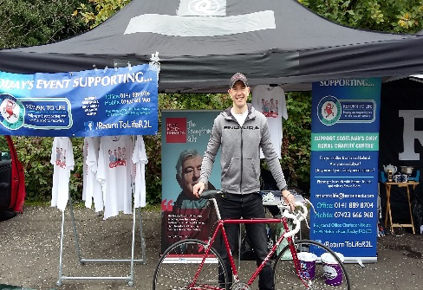
From everyone at GTR – Return to Life, we wish you a safe and fantastic race!

Namaste
Stevie Blom & the Team.

