CHIPPENHAM & DISTRICT WHEELERS

OPEN 3-UP TEAM TIME TRIAL

Under C.T.T. Regulations

Sunday 7th October, 2018

Time of start – 09:00 hours

Timekeepers Event Secretary

Mrs S Edwards Chippenham & District Wheelers Mr A Cook
Mrs S Andrews Chippenham & District Wheelers 13 Lords Mead, Chippenham,
Wiltshire. SN14 OLJ
07811156141 Mobile

On the day organiser: Mrs Jacqui Cook - 07974275934

Please note that this is not our normal 3 Up TTT course. We have had to use a new course due to road works in Devizes.

HQ – Minety Village Hall, Hornbury Hill, Minety, Malmesbury SN16 9QH.
From the B4040, turn north on to Silver Street, follow the road as it turns left into Hornbury Hill. The HQ is approx 0.2 miles along Hornbury Hill on your left.

The HQ will be open from around 7.30am. No cleats to be worn in the village hall at any time.
Please be mindful of local residents park considerably and legally. Be quiet early in the morning. No Turbo trainers or warming up in the car park or within 100m of residential property.

PARKING: At HQ, School & adjacent roads. Please park sensibly and DO NOT obstruct local resident’s driveways, entrances to farmland etc. Locals have grumbled in the past due to inconsiderate parking (understandably!)

TOILETS: At Headquarters.

NUMBERS & SIGNING ON: At headquarters.
Please remember to sign out after the event when returning your number

C.T.T. Team Time Trial Regulations:

Please note particularly regulation 32
Riders should be attired in jerseys of a similar design to help the time keepers!

Route to Start
Leave the HQ turn right, follow Hornbury Hill and Silver Street back to the B4040 Minety Crossroads. On reaching the B4040 at the Turnpike Inn, carefully cross straight over onto the minor road. The start is approximately 1 mile down the road.

U86/20 - COURSE DETAILS

Signing In/Out
Riders must sign on at race HQ to collect their number and check for any last minute information regarding the event or course.
Please return your number for a free tea or coffee, and ensure you sign out at the same time.
Failure to sign-on AND sign-off will result in DNF recorded on your result

Course Description
The course is generally expected to be quiet during the event. After 10am the A429 may become busier when the supermarket opens. Please find below details of the U86/100 course, the onus is on the rider to know the course.

Start: Start is in the hard standing entrance to Ravenhurst farm, in line with the H 100/8. On the minor road south of Minety (south from Turnpike Inn).

Course: Leaving the start, progress north to Minety. On reaching the B4040 turn left onto the B4040. Proceed westward through Charlton (two sharp left hand corners circled on map below) and onto the RAB on the A429 just before Malmesbury. Left to turn south on the A429. Proceed to next RAB with the B4042, where left onto the B4042. Proceed eastward, passing through Brinkworth, and The Common till reaching the B4696 (just before the M4 motorway). Left onto the B4696 (sign posted Ashton Keynes, Cricklade, Cirencester). After approximately 2 miles, take the left turn at Braydon Cross (sign posted Garsdon). Follow to top of minor climb, where follow the road through its right turn (signed Minety 1½). Follow through to pass the start. On passing the start the finish is just over the brow hill north of the start.
Finish: The finish is in line with the HP Gas Pole about 200m north of the start.

DO NOT STOP on finishing, but continue to the HQ.

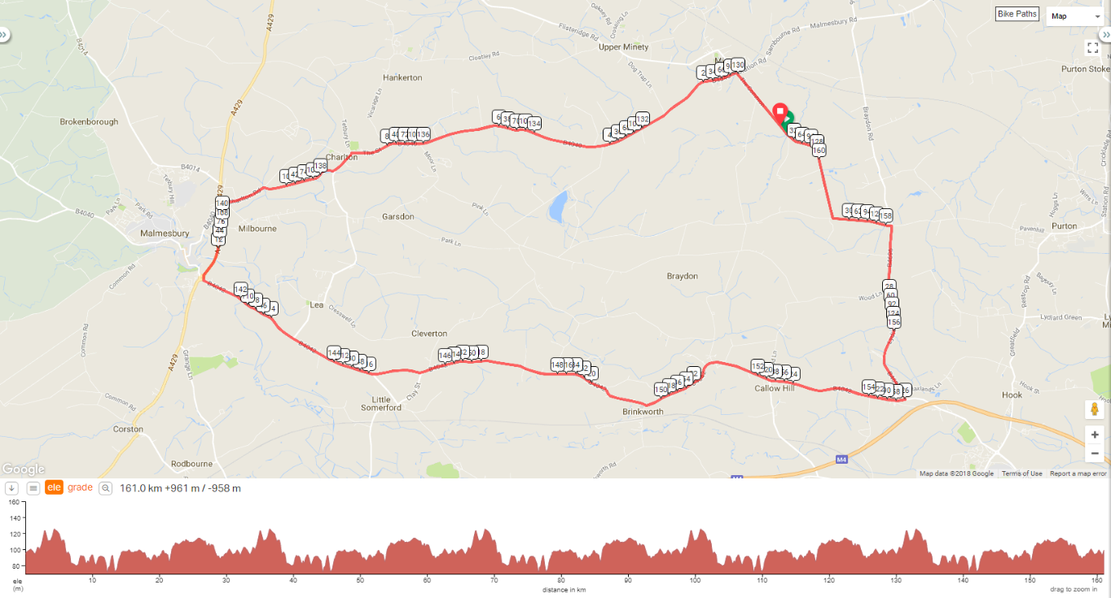
Link to course on Ridewithgps: https://ridewithgps.com/routes/27152597
(Don’t panic I have had to use the 100 mile course map, the 3 Up is only one lap of this course)

IN THE INTERESTS OF YOUR OWN SAFETY
The race takes place on public roads with live traffic on the course so competitors must obey the Highway Code at all times and not impede other road users.
Cycling Time Trials recommends that all competitors wear a hard shell helmet that meets internationally recognised safety standards
All junior/juvenile riders MUST wear protective hard shell helmets
Please keep your head up for a safe ride

PRIZE VALUES (One prize per team)

OVERALL | 1st Vet | Composite
1st £75 | 1st £75 | 1st £60
2nd £60
3rd £45 | All Lady | Any Combination – V/L/Snr
4th £30 | 1st £75 | 1st £60

Note: Composite teams may not compete for any other prizes other than composite
Start Time | Rider Number | Rider |  | Club | Cat
09:03 | 1 | Patrick | Laban | Salt and Sham Cycle Club | Composite
 | 2 | Mat | Parry | Chippenham and District Wheelers | Composite
 | 3 | Jeremy | Milsom | Chippenham and District Wheelers | Composite
09:06 | 4 | Cerys | Davies | Salt and Sham Cycle Club | L
 | 5 | Sian | Thomas | Salt and Sham Cycle Club | L
 | 6 | Ellen | Errington | Salt and Sham Cycle Club | L
09:09 | 7 | Lydia | Blackman | Salt and Sham Cycle Club | L
 | 8 | Melanie | Miliner | Salt and Sham Cycle Club | L
 | 9 | Doylie | Jones | Salt and Sham Cycle Club | L
09:12 | 10 | Neil | Paramor | Salt and Sham Cycle Club | V
 | 11 | Kevin | Devonold | Salt and Sham Cycle Club | V
 | 12 | Paul | Rogoll | Salt and Sham Cycle Club | V
09:15 | 13 | Gareth | Hughes | Salt and Sham Cycle Club | S
 | 14 | Ifan | Jones | Salt and Sham Cycle Club | S
 | 15 | Chris | Hughes | Salt and Sham Cycle Club | V
09:18 | 16 | James | Chapman | Salt and Sham Cycle Club | V
 | 17 | Tom | Errington | Salt and Sham Cycle Club | V
 | 18 | Stuart | Rideout | Salt and Sham Cycle Club | V
09:21 | 19 | John | Critchly-roper | Salt and Sham Cycle Club | S
 | 20 | Jayme | Fraioli-harper | Salt and Sham Cycle Club | L
 | 21 | James | Townley | Salt and Sham Cycle Club | S
09:24 | 22 | Neil | Amesbury | Salt and Sham Cycle Club | V
 | 23 | Richard | Nelson | Salt and Sham Cycle Club | V
 | 24 | Graham | Holmes | Salt and Sham Cycle Club | V
09:27 | 25 | Barry | Pope | Salt and Sham Cycle Club | V
 | 26 | Darren | Broomfield | Salt and Sham Cycle Club | V
 | 27 | Jason | Sheppard | Salt and Sham Cycle Club | V
09:30 | 28 | Rob | Stephen | Salt and Sham Cycle Club | V
 | 29 | Simon | Starling | Salt and Sham Cycle Club | V
 | 30 | Nick | Frost | Salt and Sham Cycle Club | V
09:33 | 31 | Tim | Scrutton | Salt and Sham Cycle Club | V
 | 32 | Nick | Woodward | Salt and Sham Cycle Club | V
 | 33 | Hamish | Crow | Salt and Sham Cycle Club | S
09:36 | 34 | Mark | Nash | Salt and Sham Cycle Club | V
 | 35 | Robert | Evans | Salt and Sham Cycle Club | V
 | 36 | Harvey | Nicholls | Salt and Sham Cycle Club | V
09:39 | 37 | Stuart | Olds | Salt and Sham Cycle Club | V
 | 38 | Owen | Neal | Salt and Sham Cycle Club | V
 | 39 | Ian | Mansell | Salt and Sham Cycle Club | V
09:42 | 40 | Ken | Evans | PDQ Cycle Coaching | V
 | 41 | Andy | Morgan | PDQ Cycle Coaching | V
 | 42 | Bob | Symons | PDQ Cycle Coaching | V

09:45 | 43 | Nicky | Taylor | Salt and Sham Cycle Club | L
 | 44 | Laura | Dear | Salt and Sham Cycle Club | L
 | 45 | Paul | Cann | Salt and Sham Cycle Club | V
09:48 | 46 | Martin | Neill | Performance Cycles CC | Composite
 | 47 | Thomas | Riches | Performance Cycles CC | Composite
 | 48 | Mark | Evans | Chippenham & District Wheelers | Composite
09:51 | 49 | Joanna | Goodhead | Avid Sport | L
 | 50 | Sally | Crocker | Avid Sport | L
 | 51 | Isobel | Crowther | Avid Sport | L
09:54 | 52 | Andrew | Henderson | Frome and District Wheelers | Composite
 | 53 | Michael | Hoare | A2B Cycle Repair Race Team | Composite
 | 54 | Jon | Wiggins | Frome and District Wheelers | Composite
09:57 | 55 | Mike | Smith | Gillingham and District Wheelers / Wheels Cycles | Composite
 | 56 | Olive | Holliday | Somer Valley Cycling Club | Composite
 | 57 | Adam | Whittaker | Salt and Sham Cycle Club | Composite
10:00 | 58 | Shrirunga | Bristowe | Bradford-on-Avon Cycling Club | S
 | 59 | Frankie | Whitwell | Bradford-on-Avon Cycling Club | S
 | 60 | John | Benjamin | Bradford-on-Avon Cycling Club | S
10:03 | 61 | Frank | Kilsby | Velo Club St Raphael | S
 | 62 | Simon | Brooks | Velo Club St Raphael | V
 | 63 | Jason | Streather | Velo Club St Raphael | V
10:06 | 64 | Amanda | Karlsson | VeloVitesse/ALLCAP/James Barry/Johnson Controls – Hitachi/SiS | L
 | 65 | Trish | Chalk | Velo Club St Raphael | L
 | 66 | Jo | Buckland | Bush Healthcare CRT | L
10:09 | 67 | Ian | Potts | Chippenham & District Wheelers | V
 | 68 | Mike | Gibbons | Chippenham & District Wheelers | V
 | 69 | Paul | Winchcombe | Chippenham & District Wheelers | V
10:12 | 70 | Louise | Hargreaves | Salt and Sham Cycle Club | L
 | 71 | Annamarie | Miles | Salt and Sham Cycle Club | L
 | 72 | Rob | Hall | Salt and Sham Cycle Club | V
10:15 | 73 | Andy | King | North Hampshire RC | V
 | 74 | Gavin | Draper | North Hampshire RC | V
 | 75 | Philip | Watts | North Hampshire RC | V
10:18 | 76 | Jay | Hookins | Velo Club Cycling | S
 | 77 | Alex | Hookins | Velo Club Cycling | S
 | 78 | Billy | Dyer | Velo Club Cycling | V
10:21 | 79 | Chris | Broad-drake | Swindon Road Club | V
 | 80 | Roy | Carless | Swindon Road Club | V
 | 81 | Peter | Garnett | Swindon Road Club | V
10:24 | 82 | Robert | Tucker | PDQ Cycle Coaching | V
 | 83 | Kevin | Garland | PDQ Cycle Coaching | V
 | 84 | Mark | Gateshill | PDQ Cycle Coaching | S
10:27 | 85 | Kevin | Wright | Salt and Sham Cycle Club | Composite
 | 86 | Tom | Bass | Latchem Sunwise RT | Composite
 | 87 | Jeff | Lawrence | Salt and Sham Cycle Club | Composite
10:30 | 88 | Mariano | Sanchez Luppi | Salt and Sham Cycle Club | V
 | 89 | Daniel | Carr | Salt and Sham Cycle Club | V
 | 90 | Steve | Bray | Salt and Sham Cycle Club | V
10:33 | 91 | Edward | Griffin | Radeon-Cycology RT | S
 | 92 | Jonathan | Griffin | Radeon-Cycology RT | V
 | 93 | Matt | Griffin | Radeon-Cycology RT | S
10:36 | 94 | Charles | Coleman | Velo Club Walcot | S
 | 95 | James | Coleman | Velo Club Walcot | S
 | 96 | Tavis | Walker | Velo Club Walcot | S
10:39 | 97 | Iain | Cade | Bath Cycling Club | S
 | 98 | Darren | Gardner | Bath Cycling Club | V
 | 99 | Steven | Cottington | Bath Cycling Club | V

