SVTTA

OPEN 15 MILE TIME TRIAL (INCORPORATING SVTTA Speed Family Trophy) Sunday 30 September 2018.
Event HQ: Is Cambusbarron Village Hall, St. Ninians Road. Cambusbarron. STIRLING. FK7 9NU.

Parking:

There is a small car park at the centre. Some limited on-street parking on St Ninians Road and some side streets available but please park considerately.

Please DO NOT park in the housing estate behind the hall.

Sign on: Hall should be open from 08:00 hours and sign on should start shortly after this once we are set up.

Start:

The start is on the A811 approximately ½ mile to the East of the Kersebonny Road end, Cambusbarron. It is approx. 1 ½ miles from the event HQ.

The start is accessed from Cambusbarron village by turning right from the HQ entrance, proceeding into the village, turning right down Mill Brae after about a quarter of a mile and left onto Mill Road, which leads to Kersebonny Road. Turn right at the end of the Kersebonny Road (please take extra care as you will be turning over the course/traffic and riders will already be underway) and head East towards Stirling Castle. Cross the motorway flyover and the start is approx. 320 m west of Clay Toll Roundabout.
Please DO NOT warm up on the course but note that you will need to cross through the finish line to make your way to the start. If you are on the way to your start DO NOT adopt a racing position as you go through the finish area to avoid confusion for the timekeeper.

Map of route from HQ to the A811
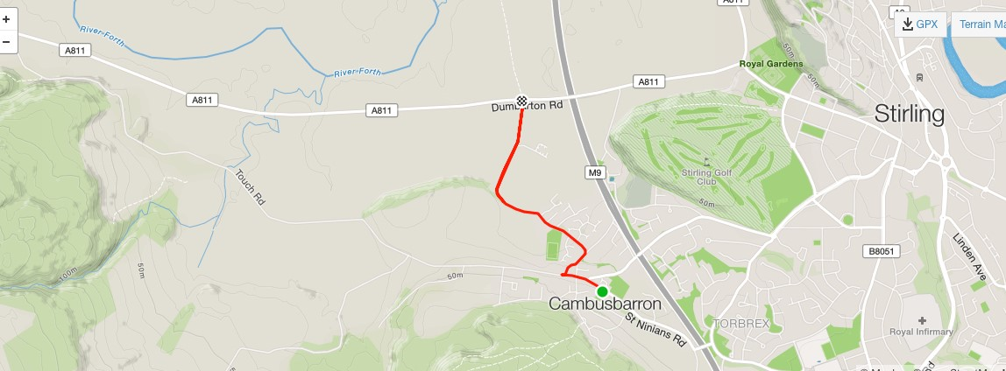
The course:

The course is an out and back along the A811. From the start it heads west to turn at the Kippen roundabout. There will be Marshals at this point. They are not allowed to stop traffic so riders must adhere to highway code when negotiating the roundabout. Retrace along the A811 crossing over the motorway flyover and finish at the entrance to Falleninch Farm.

Prize giving will take place back at HQ after the last riders are finished.

Start sheet for SVTTA 15 Mile TT on 30 September

Bib | Start Time | Firstname | Lastname | Club
1 | 09:01:00 | George | Adam | SVTTA
2 | 09:02:00 | Edwin | Nelson | Glasgow Couriers
3 | 09:03:00
4 | 09:04:00 | A MacLean | I Fletcher | VC Glasgow South
5 | 09:05:00 | Kirsty | Ellis | Synergy Cycles
6 | 09:06:00 | Alan | Jardine | VC Glasgow South
7 | 09:07:00 | Dave | Bean | Kennoway RC
8 | 09:08:00 | Allan | Duncan | Fullarton Wheelers
9 | 09:09:00 | Brian | Laffoley | Fife Century RC
10 | 09:10:00 | Robert | Clements | Law Wheelers
11 | 09:11:00 | James | Cluckie | Coatbridge Clarion CC
12 | 09:12:00 | Andrew | Wilson | St Christophers
13 | 09:13:00 | Stewart | Mitchell | Deeside Thistle CC
14 | 08:14:00 | Steve | Donaldson | Fullarton Wheelers
15 | 08:15:00 | Eddie | Addis | RT23
16 | 09:16:00 | Angus | Swanson | Stirling Bike Club
17 | 09:17:00 | Alan | Solway | Kennoway RC
18 | 09:18:00 | James | Robb | Deeside Thistle CC
19 | 09:19:00 | Miriam | Rennet | SVTTA
20 | 09:20:00 | David | Irving | Inverclyde Velo
21 | 09:21:00 | Archie | Johnstone | Stirling Bike Club
22 | 09:22:00 | George | Skinner | Royal Albert
23 | 09:23:00 | Mike | Ferguson | Johnstone Wheelers
24 | 09:24:00 | Andrew | Stewart | Dunfermline CC
25 | 09:25:00 | Lindsay | Foster | Hitchin Nomads CC
26 | 09:26:00 | Des | Grant | Coatbridge Clarion CC
27 | 09:27:00 | Robert | Brown | EH Star Cycling
28 | 09:28:00 | John | Gormlie | Coatbridge Clarion CC
29 | 09:29:00 | Martin | Shields | Fullarton Wheelers
30 | 09:30:00 | Iain | Cowden | Garstang CC
31 | 09:31:00 | Christina | McKenzie | Stirling Bike Club
32 | 09:32:00 | Catherine | Logan | Fullarton Wheelers
33 | 09:33:00 | James | Muir | SVTTA
34 | 09:34:00 | William | Munro | Glasgow Wheelers
35 | 09:35:00 | James | Truswell | Fruin RC
36 | 09:36:00 | Edward | Atkinson | Elgin CC
37 | 09:37:00 | Jim | Smith | Glasgow Nightingale
38 | 09:38:00 | Bill | Groves | EH Star Cycling
39 | 09:39:00 | Frederick | Connor | VC Glasgow South
40 | 09:40:00 | James | Snodgrass | Johnstone Wheelers
41 | 09:41:00 | Charles | Adams | VC Glasgow South
42 | 09:42:00 | Sandy | Wallace | Fife Century RC
43 | 09:43:00 | Brian | Cameron | Lomond Roads CC
44 | 09:44:00 | Allan | Ross | Fruin RC
45 | 09:45:00 | Alex | Munro | SVTTA
46 | 09:46:00 | John | Leonard | Velopreda
47 | 09:47:00
48 | 09:48:00 | MLeadbetter | D McLean | Stirling Bike Club
49 | 09:49:00 | Alan | MacIntyre | Coatbridge Clarion CC
50 | 09:50:00 | Frank | Anderson | SVTTA
51 | 09:51:00 | Kevin | Lackie | RT23
52 | 09:52:00 | Stuart | Whitelaw | Fruin RC
53 | 09:53:00 | Jon | Clarke | GTR – Return to Life
54 | 09:54:00 | Gordon | Graham | Fullarton Wheelers
55 | 09:55:00 | Brian | Muir | Royal Albert CC
56 | 09:56:00 | Ian | Dobbie | West Lothian Clarion
57 | 09:57:00 | Sean | Quinn | Law Wheelers
58 | 09:58:00 | Val | Martin | Dooleys Cycles
59 | 09:59:00 | Graham | Jones | Edinburgh Road Club
60 | 10:00:00 | Marc | Anderson | Loudoun RC
61 | 10:01:00 | Mark | Skilling | Carrick CC
62 | 10:02:00 | Alex | McPhee | Dooleys Cycles
63 | 10:03:00 | Carlos | Riise | Shetland Wheelers
64 | 10:04:00 | Paul | McLafferty | Glasgow Ivy
65 | 10:05:00 | Jim | Cusick | Dooleys Cycles
66 | 10:06:00 | Neil | Pendrich | SVTTA
67 | 10:07:00 | Douglas | Watson | GTR – Return to Life

