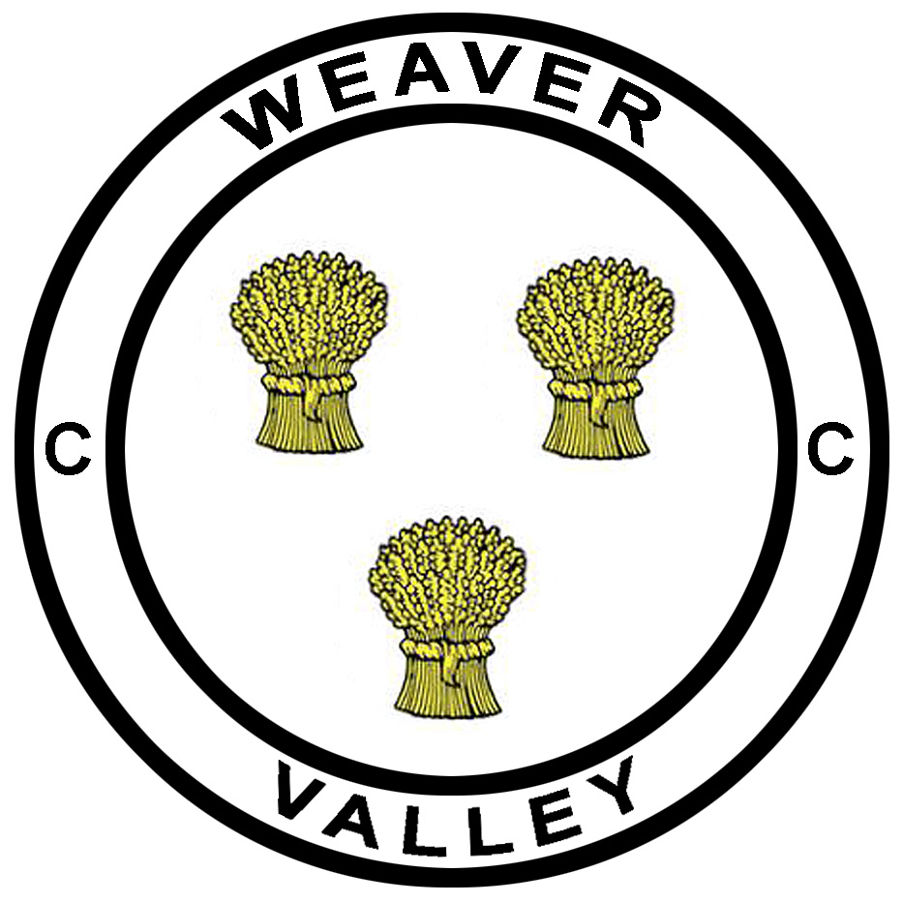Weaver Valley CC

J9/7 – ‘Cat and Fiddle’

Hill Climb - Results
Sunday 16th September 2018 at 10:05

Promoted for and on behalf of Cycling Time Trials under their Rules and Regulations

Event Secretary: Alistair Stanway, 44 Moss Road, Winnington, Northwich, Cheshire, CW8 4BJ.
Phone: 07590 578114
Email: alistair_stanway@yahoo.co.uk

Timkeepers: Jimmy Williams & Graham Lawrence

Prizes will be distributed ASAP.

Thanks’ must go out to all who helped in organising and running the event again this year, and to all riders who battled the conditions on a tough morning on the Cat!

Weather warned of wind and rain and sure enough it appeared right on cue for the riders. Our first lady starter, Carol Robson, was first on the road to get things started at 10:05 and battled to a winning time of 32:06. As times came through for the men’s event it was clear that things were indeed ‘quite tough’ out there and we had a few reports of a couple of crashes both up the hill and down! All riders OK thankfully with just a few cuts and grazes. Hope you are healing well

Our overall winner on the day was Leon Wright with an excellent time of 20:12 with Tony Cope of Leek CC taking victory in the V40-49 category, Andy Ashurst taking the win in the V50-59 category and Andrew Grace taking the V60+ category honours.

Junior entrant Darren Rider of Team PB Performance rode to an impressive overall top 10 place on the day, whilst also taking the Junior category win. It’ll be great to see some more juniors out on the course next year.

In the team event, Macclesfield Wheelers seemed very pleased to have gained victory over Lyme RC with Crewe Clarion in third place.

I trust all riders enjoyed the day, despite conditions. I hope to see you all again next year.

Alistair Stanway

