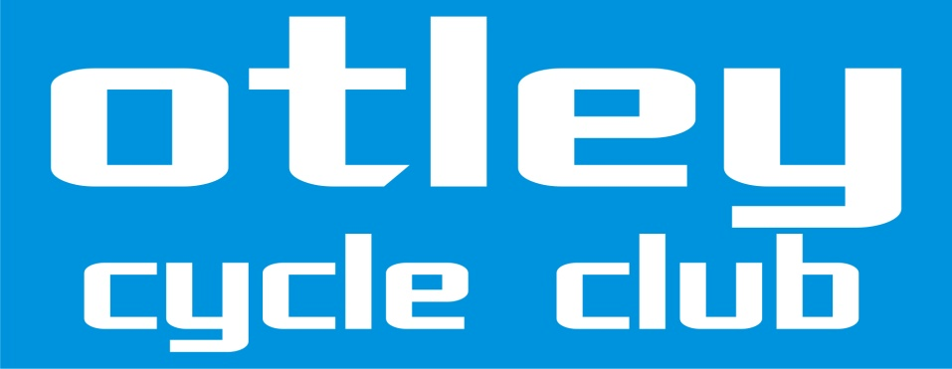

OPEN 25 MILE TIME TRIAL
Solos and Tandems Promoted for and on behalf of Cycling Time Trials under their Rules and Regulations

Course V235 - A168 Boroughbridge – Walshford – Boroughbridge x 2

Sunday 16th September 2018

Event Organiser Martin Tallontire 43 Whiteley Croft Road, Otley, West Yorks. LS21 3NS Tel 01943 461950 & 07772 620081

Timekeepers Mr G Barker and Mr M Phillips

AWARDS

Fastest rider
1st £40 Andy Jackson Aerocoach 55:05
2nd £20 Michael Schofield York Cycleworks 56:58
3rd £15 Liam Golton Selby CC 57:03
4th £15* Pete Nixon Seacroft Wheelers 57:46

Fastest Female Rider
1st £40 Louise Scupham Team Jaden Weldtite 1:08:59
p/b Vive Le Velo
2nd £20 Tamara Walton Club Seiclo Caergybi / 1:09:59
Holyhead CC
3rd £15* Helen Goldthorpe Otley CC 1:10:24

Fastest Junior
1st £10 Joe Howcroft Otley CC 1:02:25

Fastest Juvenile
1st £10 Timothy Lane Kirklees CA 1:11:20

Fastest Espoirs
1st £10 Alexander Broadhead Rockingham CC 1:07:32
1st £10* Louise Scupham Team Jaden Weldtite 1:08:59
p/b Vive Le Velo

Fastest Veterans
V40 1st £15 Roger Bromiley Harrogate Nova CC 1:00:49
WV40 1st £15 Sara Cummings Blaydon CC 1:10:37
V 50 1st £15 Craig Moody Giant Halifax RT 59:11
WV50 1st £15 Sue Spindler Ravensthorpe CC 1:12:29
V60 1st £15 Roy Flanagan Rossendale RC 1:04:20
V70+ 1st £15 Walter Wilkinson Harrogate Nova CC 1:07:35

Fastest Team of 3 1st £10 each Harrogate Nova CC (Roger Bromiley, Adrian Barwick & Walter Wilkinson) 3:15:53

* One rider one prize. Pete Nixon and Helen Goldthorpe both won overall prizes which were less than the veteran category prize they would have won, so I’ve upped their prizes to £15 so neither loses out. As Louise Scupham was the only female espoir, I see no reason not to award this prize, as by awarding it no one else loses out.

Thanks to everyone for riding, the wind seems to have added several minutes to riders’ previous times on this course, but hopefully you enjoyed the day and the extra value for money. Many thanks to all our volunteers who make this event possible - John Churchman, Anne, Mary & Evan Tallontire, Peter Yates, Liz Hills, Brian Keighley, Cliff Ralphs, Fred Lee, Christine Bell, Adrian Thompson, John Barnett & Sheldon Howcroft.

