www.sussexca.org.uk

Sussex Cyclists’ Association
ESTABLISHED 1921
PRESIDENT - Kathy Collard-Berry, A3crg.

Open 25 miles Time Trial Monday 27 ^{th}August 2018
Course G.25/49
Qualifying event for S.C.A. B.A.R. and S.C.A. SPOCO
Promoted for and on behalf of Cycling Time Trials under their rules and regulations

 | Course Records
Scratch: | 54:30 Pat Wright 2017
Vets | 56:33 Steve Dennis 2011
Ladies: | 1:04:54 Elisabeth Brama 2010
Juniors: | 1:00:49 Jack Donaldson 2011  1:21:23 James Foley Juvenile 2017  Previous Winners
Main Event  2017 Pat Wright | Hub gear  54:30 2017 David Eccles | 1:13:54
2016 James Rix | 55:43 2016 David Eccles | 1:14:26
2015 Steve Kane | 58:33 2015 David French | 1:08:35
2014 Pete Morris | 56:06 2014 David French | 1:02:20
2013 Steve Kane | 56:01 2013 Minoru Mitsumoto | 1:15:06
2012 Mike Coyle | 56:59 2012 David French | 1:14:40
2011 Felix English | 54:44 2011 David French | 1:10:46
2010 Nicolas Hutchings | 55:35 2010 (not held)

Event Secretary Event HQ is
Robin Johnson (Brighton Mitre CC) LOXWOOD SPORTS ASSOCIATION PAVILION,
7 Gorselands, Billingshurst, West Sussex RH14 9TT PLAISTOW ROAD,
Tel: 01403 783368 LOXWOOD RH14 0SX
(or 07733 132043 on day of event)
Open from 1:30 pm.
Email: mr_rjohnson@outlook.com Large car park at HQ.

Licensed bar available, before and after event.
Official Timekeepers Thank you in advance for not wearing cycling shoes or cleats in the hall
Start:
Lesley Donington ‘34 Nomads CC
Finish:
Mick Irons Worthing Excelsior CC

Please pay attention to the following Safety Notes

London South District Regulation: No vehicles, except those of the timekeepers and race officials, shall be parked in the vicinity of the start or finish areas.

CTT regulations require the compulsory use of helmets for the under 18’s. In the interests of your own safety, Cycling Time Trials and the event promoters strongly advise all competitors to wear a hard/soft shell helmet that meets internationally accepted safety standards.

Competitors Machines It is recommended that a working rear light, either flashing or constant, is fitted to the machine in a position clearly visible to following road users and is active while the machine is in use.

www.sussexca.org.uk

Race Numbers Warming Up and to the start
Numbers will be available at the event HQ. Please collect Competitors are requested not to warm up on the your number when you sign on. course after the event has started.

Notice of any additional hazards to be aware of to be HQ to Start: 1.76 miles.
displayed at the signing on sheet.
. Finish to HQ: 0.62 miles
After the event please return your race number to the event HQ in exchange for a drink.
.
Please note: No times will be given out at the
finishes

Prizes

1
st

£
20

+
Champagne (value £
25)

1
st

Vet
eran

(40
-
44)

Wine (value £5)

2
nd

£
10

+
Wine (value £
5)

1
st

Vet
eran

(4
5
-
4
9
)

Wine (value £5)

3
rd

£
6

5)
Wine (value £
+

1
st

Vet
eran

(
5
0
-
5
4)

Wine (value £5)

4
th

Wine (value

£5)

1
st

Vet
eran

(
55
-
59
)

Wine (value £5)

1
st

Vet
eran

(
6
0
-
64
)

Wine (value £5)

1
st

Team

Wine (value £5) each.
each

1
st

Vet
eran

(
65
-
69
)

Wine (value £5)

1
st

Vet
eran

(
7
0
-
74
)

Wine (value £5)

£12 £8
+

1
st

Hub Gear

£10 + Wine (value £5)

2
nd

Hub Gear

£5 + Wine (value £5)

1st Lady £12 + Wine (value £5).
Many thanks to David Eccles for his generous donation of £15 towards the prizes.
PLEASE NOTE
Prize Presentation | To be held as soon as possible after the event.  Please stay to receive your awards and/or applaud the recipients.
Lottery Prizes | To be awarded at the prize presentation.  A bottle of wine, value £5, to each of the first three names drawn.  To be eligible, be present and be a finisher.

SUSSEX C.A. ANNUAL LUNCHEON + PRIZE PRESENTATION
Date: | Sunday 25th November 2018
Time: | 12:30
Venue: | Dial Post Village Hall.
Cost: | £10 to Robin Johnson by 22nd November 2018.
www.sussexca.org.uk

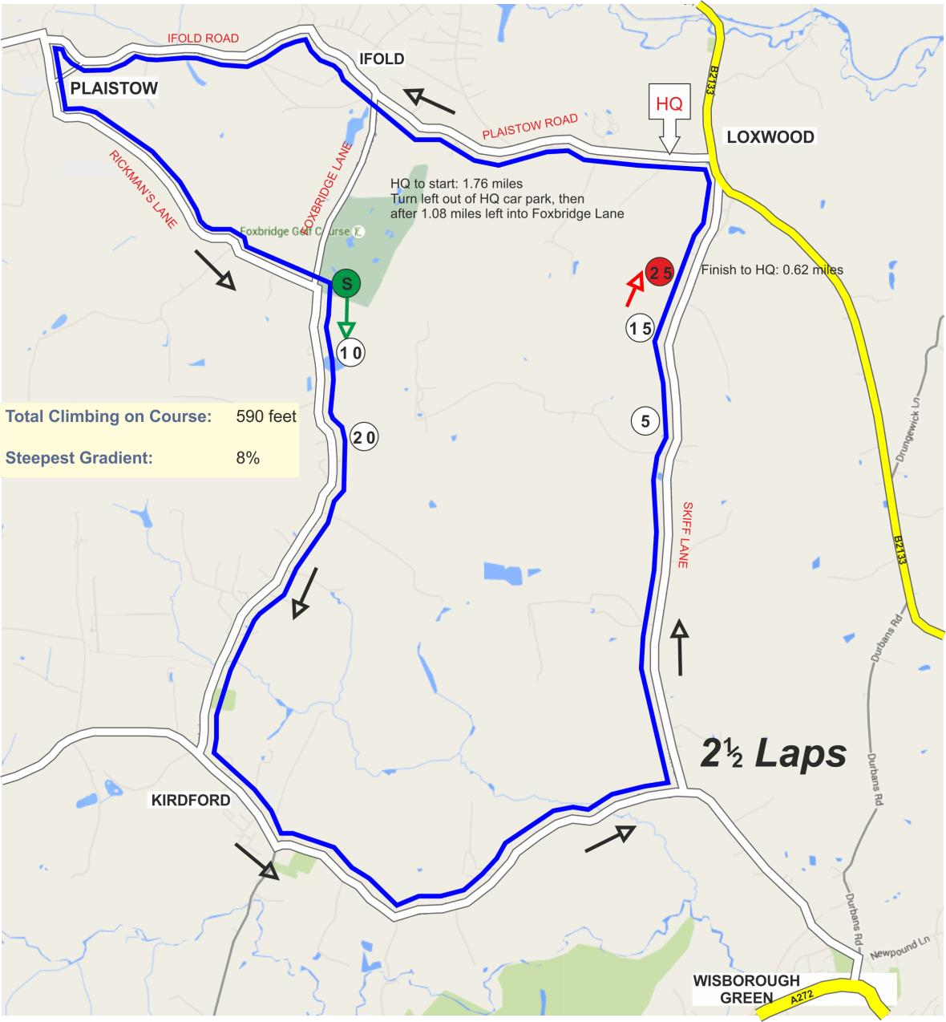
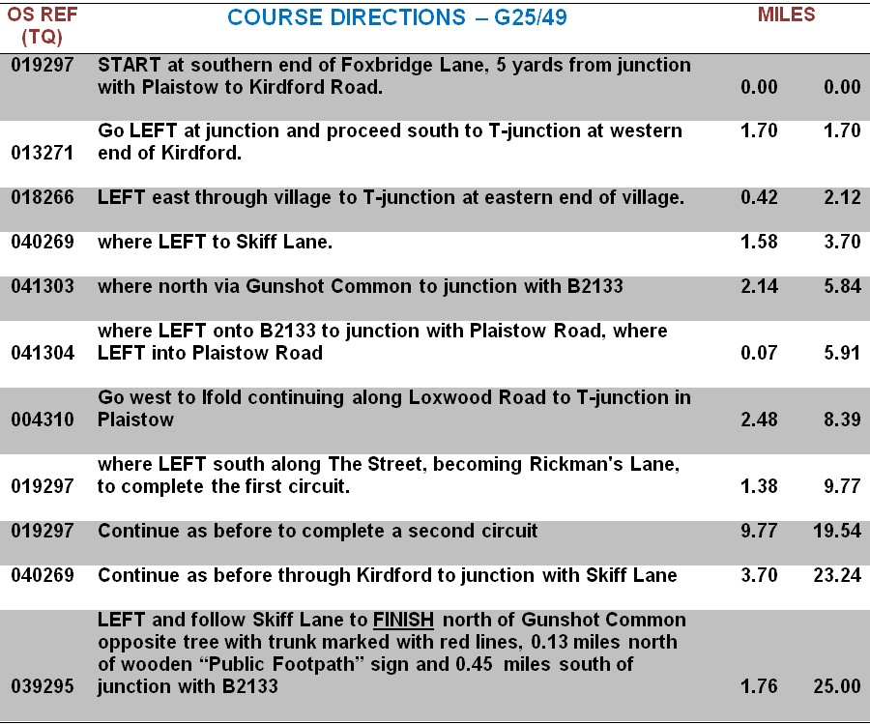

www.sussexca.org.uk
Hub Gears Only

Bib | Start Time | Firstname | Lastname | Club | Gender | Category | Age On Day
1 | 14:31:00 | John | Howells | Corinium Cycle Club | Male | Veteran | 77
2 | 14:32:00 | David | French | Weybridge Wheelers | Male | Veteran | 45
3 | 14:33:00 | David | Eccles | Redmon CC | Male | Veteran | 70
4 | 14:34:00 | Mike | Marchant | Southdown Velo | Male | Veteran | 61
Bib | Start Time | Firstname | Lastname | Club | Gender | Category | Age On Day
5 | 14:35:00 | Robin | Johnson | Brighton Mitre CC | Male | Veteran | 70
6 | 14:36:00 | Lisa | Davis | Lewes Wanderers CC | Female | Veteran | 43
7 | 14:37:00 | Peter | Dyer | Crawley Wheelers | Male | Veteran | 69
8 | 14:38:00 | Danny | Halpin | Bristol CX | Male | Veteran | 45
9 | 14:39:00 | Eoghan | Mchugh | Sussex Nomads CC | Male | Senior | 34
10 | 14:40:00 | Brett | Davis | Lewes Wanderers CC | Male | Veteran | 45
11 | 14:41:00 | James | Cheeseman | Crawley Wheelers | Male | Senior | 32
12 | 14:42:00 | Tim | Holmes | Brighton Excelsior CC | Male | Veteran | 56
13 | 14:43:00 | Barrie | Foster | Anerley BC | Male | Veteran | 69
14 | 14:44:00 | Peter | Marshall | Sussex Nomads CC | Male | Veteran | 43
15 | 14:45:00 | James | Goward | Farnborough & Camberley CC | Male | Veteran | 47
16 | 14:46:00 | Michael | Thyer | Sussex Nomads CC | Male | Veteran | 68
17 | 14:47:00 | Clive | Jarman | trainSharp | Male | Veteran | 60
18 | 14:48:00 | Aidan | Culhane | Kingston Wheelers CC | Male | Veteran | 42
19 | 14:49:00 | Peter | Owen | Norwood Paragon CC | Male | Veteran | 57
20 | 14:50:00 | Damon | Day | CC Sudbury | Male | Veteran | 52
21 | 14:51:00 | Andy | Tedd | South Downs Bikes / Casco Europe | Male | Veteran | 51
22 | 14:52:00 | Peter | Davies | Brighton Mitre CC | Male | Veteran | 61
23 | 14:53:00 | Brian | Jones | Horsham Cycling | Male | Veteran | 67
24 | 14:54:00 | Andrew | Green | Old Portlians CC | Male | Veteran | 52
25 | 14:55:00 | Eddie | Allen | Redmon CC | Male | Senior | 25
26 | 14:56:00 | Jason | Blenkarn | Sussex Nomads CC | Male | Senior | 31
27 | 14:57:00 | Robert | Giles | PMR @ Toachim House | Male | Veteran | 71
28 | 14:58:00 | Ben | Fielden | GS Stella | Male | Veteran | 76
29 | 14:59:00 | Adrian | Bennett | Sussex Nomads CC | Male | Veteran | 53
30 | 15:00:00 | Steve | Dennis | East Grinstead CC | Male | Veteran | 55
31 | 15:01:00 | Kevin | Plummer | South Downs Bikes / Casco Europe | Male | Veteran | 53
32 | 15:02:00 | Matthew | Butler | Charlotteville Cycling Club | Male | Senior | 24
33 | 15:03:00 | Geoff | Smith | Eastbourne Rovers CC | Male | Veteran | 68
34 | 15:04:00 | John | Allen | Redmon CC | Male | Veteran | 58
35 | 15:05:00 | James | Rix | Team Bottrill / Vanguard | Male | Veteran | 42
36 | 15:06:00 | Mark | Duncan | ...a3crg | Male | Veteran | 45

www.sussexca.org.uk

