EPSOM CC 10 Mile Time Trial
4th August 2018 at 14:00 H10/8 Course
Promoted for and on behalf of Cycling Time Trials under their rules and regulations
HQ: Bentley Memorial Hall Hole Lane Bentley GU10 5NB
Organiser: Richard Gill. Email: Open10@epsomcc.co.uk 020 8393 2127 (Mobile on day 07833482119)
Timekeepers: Donald Ashton & Maggie Smith
Please respect the volunteers and the timekeepers who are giving up their time to help out.
Numbers to be collected from the HQ where you must sign on, and later exchanged for a drink when returned. The HQ is in a residential area, please be considerate to the people who live there & keep noise to a minimum. Note areas where you can park on map below
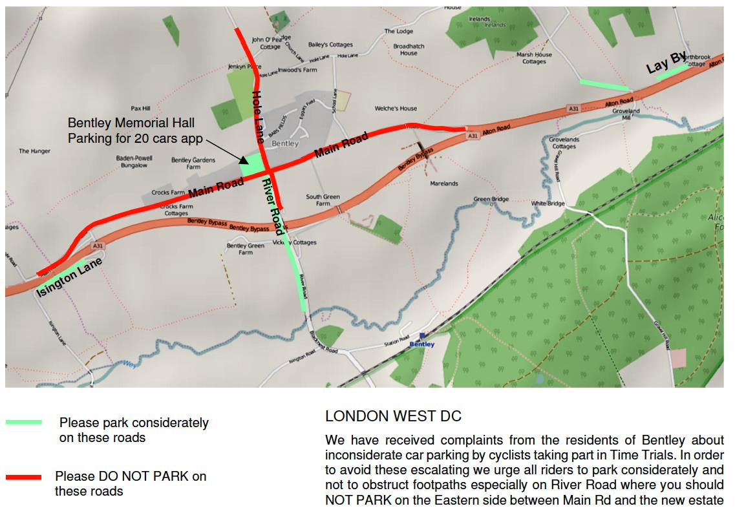
IMPORTANT NOTES AT BENTLEY MEMORIAL HALL HQ
Please respect the local residents of Bentley by parking considerately.
Do not park on the road near the headquarters, even for a short period of time. Please adhere to the guidance on the parking diagram included. If we receive complaints, we may lose Bentley Memorial Hall as an option for the HQ. This could potentially mean the end of up to 20 open events on the course during the year.
Please sign on and collect your numbers from the headquarters and return numbers after & sign out
Position your number below the waist so that it is visible from the rear when in the racing position.
No time may be recorded if number is not correctly positioned. 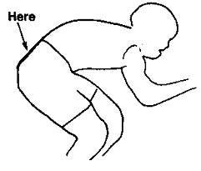
Please return number to the HQ and sign out as soon as possible after you finish.
No cleats or bikes in in the hall.

MAKING YOUR WAY TO THE START
Please allow at least 10 minutes to get to the start
The start is on the opposite side of the carriageway from the HQ. Riders should only use designated crossing points and must not climb over the central reservation. Anyone seen doing so will be disqualified from the event.
No vehicles, except those of the timekeepers, shall be parked at the start or finish
To reach the start from the HQ in Bentley, go eastwards through the village to join the A31, cross to the right hand lane after 850 yards (there are lane markings) and then cross over to the South side of the A31 at the Gravel Hill road junction just short of the ‘Bull’ PH and continue for 760 yards to the lay-by start point.

IN THE INTERESTS OF YOUR OWN SAFETY
CTT regulations require the compulsory use of helmets for the under 18’s. In the interests of your own safety, Cycling Time Trials and the event promoters strongly advise all competitors to wear a hard/soft shell helmet that meets internationally accepted safety standards”
It is recommended that a working rear light, either flashing or constant, is fitted to the machine in a position clearly visible to following road users and is active while the machine is in use.
Head-down riding kills – if dangerous riding is witnessed it will be investigated and reported.

OS Ref | H10/8 Course Description | Dist
796442 | Start at a point in the lead out onto the A31 from the lay-by on the south side at the commencement of the Bentley by-pass, approximately 800 yards west of the Bull Public House on the north side of the A31 and 5 yards beyond the last but one drain grating and 25 yards short of the large road direction sign marked 'Bentley 1⁄2m'. | 00.00
736403 | Proceed (Care) to join the A31 and continue to go westwards along the Bentley by-pass through Froyle to the Holybourne roundabout (Turn) | 4.702
802443 | Circle the roundabout (M2, M3, M4) (Check) and take the third exit back on to the A31 to retrace, going through Froyle and along the Bentley by-pass to a point 10  yards beyond the concrete end of a water culvert on the north side and 63 yards  short of the Gravel Hill Road minor crossroad and 163 yards short of The Bull to finish | 10.00
The normal dual carriageway of the A31 has been reduced to a single lane at a point approximately three miles from the start. The left hand lane has been cross-hatched for a distance of approx 400 yards to finish at a point opposite the Petrol filling station just beyond the Hen & Chicken Public House situated on the north side.
Returning from the Holybourne roundabout on the north side of the A31 the road has been reduced to a single lane by road cross-hatching on the right hand lane commencing approximately 220 yards before the junction to Mill Court on the south side and finishing adjacent to the Hen & Chicken Public House on the north side.
Competitors are to act in a manner appropriate to competing on a single lane road whilst within the restrictions imposed by the road cross-hatching area.
After finishing, riders must not stop but continue to one or other of the central reservation breaks, cross over with great care and go westwards passing the start point lay-by and along the Bentley by- pass to fork left onto the slip road signposted ‘Bentley’. Turn right at the ‘T’ junction to the Bentley Memorial Hall which you can see ahead of you.
Strava Segment: https://www.strava.com/segments/643014
There will be marshals Official Observers and checkers stationed around the course but it is your responsibility to make sure you know the course. If you do have any further questions regarding the course or getting to the start please do not hesitate to ask.
Prizes
All prizes will be awarded on time. – Standards will not be applied for veteran riders
No rider can win more than one award
Fastest Rider £40 2nd £20 3rd £10
Women: 1st £40 2nd £20
Under 30 1st £20
30-39 1st £20
40-49 1st £20
50-59 1st £20
60 plus 1st £20
1st Team of 3 riders £15 each rider 2nd Team of 3 riders £10 each rider

START SHEET
Bib | Start Time | First Name | Last Name | Club | Gender
1 | 14:01:00 | Brian | Hill | Epsom CC
2 | 14:02:00 | John | Froud | Festival Road Club
3 | 14:03:00 | Stuart | Payne | Central Sussex CC
4 | 14:04:00 | Chris | Summers | Sotonia CC
5 | 14:05:00 | Philip | Watts | North Hampshire RC
6 | 14:06:00 | Adam | Stone | North Road CC
7 | 14:07:00 | Adam | Wilkinson | Velo Club Venta
8 | 14:08:00 | Nicholas | Cosgreave | Farnborough & Camberley CC
9 | 14:09:00 | Les | Gardner | Maidenhead & District CC
10 | 14:10:00 | Michael | Davey | Eastbourne Rovers CC
11 | 14:11:00 | James | Cadman | Hounslow & District Whs
12 | 14:12:00 | Chris | Aitken | Thames Valley Triathletes
13 | 14:13:00 | Philip | Mackie | Epsom CC
14 | 14:14:00 | Christopher, | Rosam | Epsom CC
15 | 14:15:00 | Paul | Thompson | Epsom CC
16 | 14:16:00 | Chris | Lord | Brighton Excelsior CC
17 | 14:17:00 | Robert | Waldram | Twickenham CC
18 | 14:18:00 | James | Mahoney | Sigma Sports
19 | 14:19:00 | Brian | James | Brighton Mitre CC
20 | 14:20:00 | Simon | Church | In-Gear Quickvit Italy Bike Tours RT
21 | 14:21:00 | Mel | Wasley | Epsom CC | W
22 | 14:22:00 | Rachel | Green | Cheltenham & County Cycling Club | W
23 | 14:23:00 | Sara | Prisco | De Laune CC | W
24 | 14:24:00 | Anne | Renshaw | PossibiliTTy Race Team | W
25 | 14:25:00 | Richard | Prebble | Cycle Club Basingstoke
26 | 14:26:00 | Mark | Jones | GS Stella
27 | 14:27:00 | Paul | Cannon | Epsom CC
28 | 14:28:00 | Barrie | Foster | Anerley BC
29 | 14:29:00 | Kevin | Bashford | East Grinstead CC
30 | 14:30:00 | Matt J | Smith | Port Talbot Whs CC
31 | 14:31:00 | Malcolm | Davies | Dulwich Paragon CC
32 | 14:32:00 | Jonathan | Thomas | Epsom CC
33 | 14:33:00 | Jorj | James | Maidenhead & District CC
34 | 14:34:00 | Robin | Harris | Clapham Chasers
35 | 14:35:00 | Christian | Yates | East Grinstead CC
36 | 14:36:00 | David | Churchill | Direct Power Cycling Team
37 | 14:37:00 | Matt | Phipps-taylor | VELOSPORT CC
38 | 14:38:00 | Steve | Arscott | VTTA (Surrey & Sussex)
39 | 14:39:00 | Chris | Brewer | Redmon CC
40 | 14:40:00 | Henrik | Persson | Kingston Wheelers CC
41 | 14:41:00 | Sam | Clarke | Team Bottrill / Vanguard
42 | 14:42:00 | Jeffrey | Davis | Farnborough & Camberley CC
43 | 14:43:00 | Martin | Koester | Pure Motion Cycling Club
44 | 14:44:00 | Michael | Valks | Lewes Wanderers CC
45 | 14:45:00 | Pete | Christensen | Alton CC/Owens Cycles
46 | 14:46:00 | Ian | White | Farnham RC
47 | 14:47:00 | James | Horan | South Downs Bikes / Casco Europe
48 | 14:48:00 | Peter | Horsfield | Redmon CC
49 | 14:49:00 | Philip | Burgin | Newbury RC
50 | 14:50:00 | Jon | Hughes | Velo Club Godalming & Haslemere
51 | 14:51:00 | John | Dowling | Hemel Hempstead CC
52 | 14:52:00 | Martin | Beale | Velo Club St Raphael
53 | 14:53:00 | Nick | Marks | CC London
54 | 14:54:00 | Clive | Jackson | Central Sussex CC
55 | 14:55:00 | Dave | Dawkins | Portsmouth North End CC
56 | 14:56:00 | Andrew | Payne | Maidenhead & District CC
57 | 14:57:00 | David | Phillips | Old Portlians CC
58 | 14:58:00 | Richard | Turner | Pearson Cycling Club
59 | 14:59:00 | Paul | Valks | Lewes Wanderers CC
60 | 15:00:00 | Mark | Bashford | East Grinstead CC
61 | 15:01:00 | Mark | Duncan | ...a3crg
62 | 15:02:00 | Tim | Peters | Horsham Cycling
63 | 15:03:00 | Aidan | Culhane | Kingston Wheelers CC
64 | 15:04:00 | Adrian | Bond | De Laune CC
65 | 15:05:00 | Luke | Maguire | Glasgow Green Cycle Club
66 | 15:06:00 | Nolan | Heather | Worthing Excelsior CC
67 | 15:07:00 | Neal | Marrin | Finsbury Park CC
68 | 15:08:00 | John | Mcglashan | Redmon CC
69 | 15:09:00 | Ben | Fielden | GS Stella
70 | 15:10:00 | Andrew | Cooper | Bournemouth Jubilee Whs
71 | 15:11:00 | Jim | Ford | Dorking Cycling Club
72 | 15:12:00 | Caine | Macneil | Islington Cycling Club
73 | 15:13:00 | David | French | Weybridge Wheelers
74 | 15:14:00 | Daniel | Arthur | Epsom CC
75 | 15:15:00 | Tim | Lynch | Aspire Velo Racing Team
76 | 15:16:00 | Robert | Gilmour | Hounslow & District Whs
77 | 15:17:00 | Jon | Wiggins | Frome and District Wheelers
78 | 15:18:00 | Derrick | Thirlwell | Kingston Wheelers CC
79 | 15:19:00 | David | England | Crabwood CC
80 | 15:20:00 | Ryan | Smith | Charlotteville Cycling Club

