The North Downs Hilly 22 Mile Time Trial - Results

Promoted for and on behalf of Cycling Time Trials under their Rules & Regulations

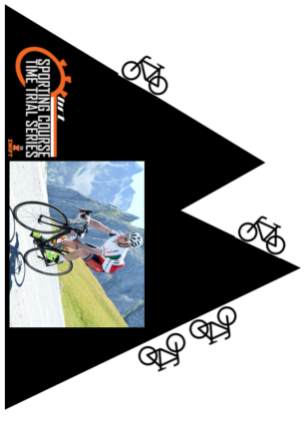

Results sheet

Medway Velo Club – Open 22 Mile Hilly Time Trial

Held on Sunday 22nd July, 2018 starting at 06:30 hrs

On Course QS/7 (Challock- Charing – Challock - Boughton Lees - Chilham - Molash)

(Previous) Men’s course record: 50:08 Pete Tadros
Women’s course record: 56:04 Louise Mason

Awards
1st Fastest £30 | Christopher Fennell* | 1st Woman £30 | Karen Florey | 1st Vet £20 | Andrew Meilak
2nd Fastest £25 | Nicholas Fennell | 2nd Woman £25 | Not Awarded | 2nd Vet £10 | Pete Elms
3rd Fastest £20 | Andrew Meilak | 3rd Woman £20 | Not Awarded | 3rd Vet £5 | Keith Walker

* New course record

All awards will be send out to winners in the post.

Event Secretary/Promoter
Steve Smith
Mobile: 07734 651590
Email: stevesmit140177@yahoo.co.uk

Timekeepers/Recorder – Ernie Mackey, Dave Mackey, Vic Williams
Assistant event organiser - Phil Booth
Event Sign on / Sign out / Numbers - Steve Smith
Tea/cake bar – Gliding Club

Marshal's and locations:
Start & Holder/Pusher off – Phil Booth
Challock rab x3 – Rodney Kennison, Barbara Kennison, Sally Smith
Charing Hill - Spencer Stacey
Charing rab x4 Paul Daniel, Tracey Daniel, Nigel Wharton, x1 Rob Kennison
Boughton Lees, at left turn off A251 x1 – Andrew Collyer
Kemps Corner, at left turn onto A28 x1 – Charles Bruce
Bagham (Chilham fork, left turn onto A252) x2 – Lee Kingston, Steve Melia
Finish – Phil Booth (moved from start to finish after last rider off)

It was fantastic to see the men's course record smashed twice, first by Nicolas, then 3mins or so later by his brother Christopher. With the top twelve riders all under the hour it was certainly a quality field.

Many thanks to the volunteers who gave up their Sunday morning to help, and the riders for supporting. Hope to see you all next year!

Please see the attached flyer for Medway Velo Clubs other open TT events in 2018.

For any Zwift users out there I've also included information on the SCTT series (including Vets standards based events) Zwift TT events which I co-manage with Steven Melia-Chamberlain.

Ride on!

Steve Smith
Event Secretary

Results
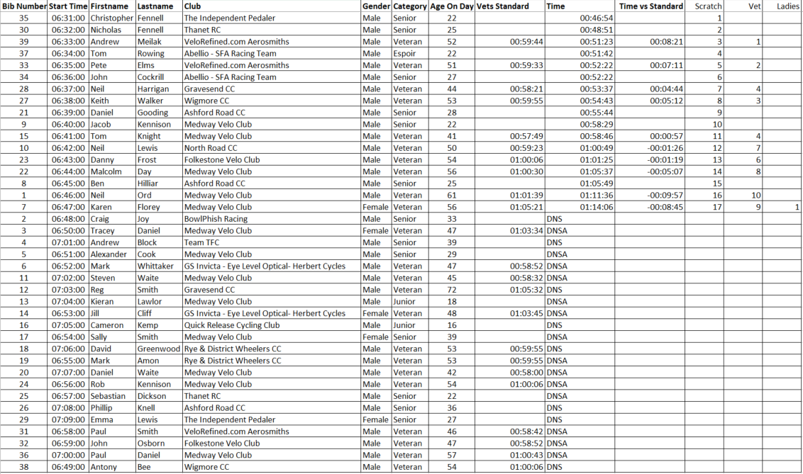
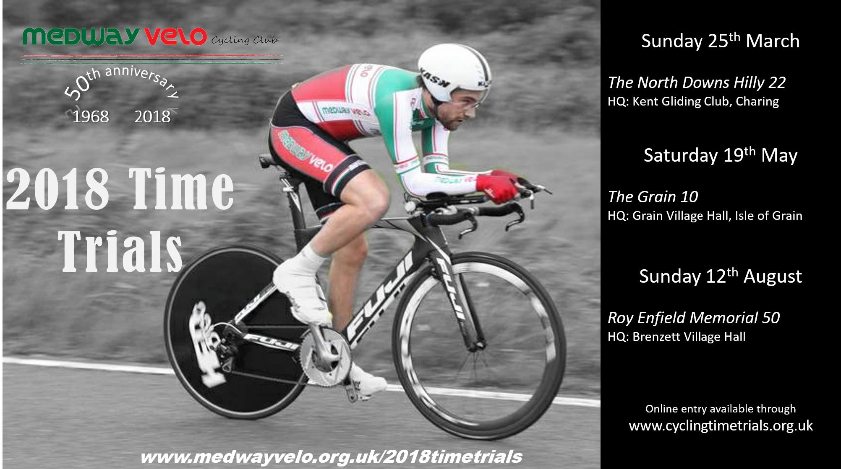
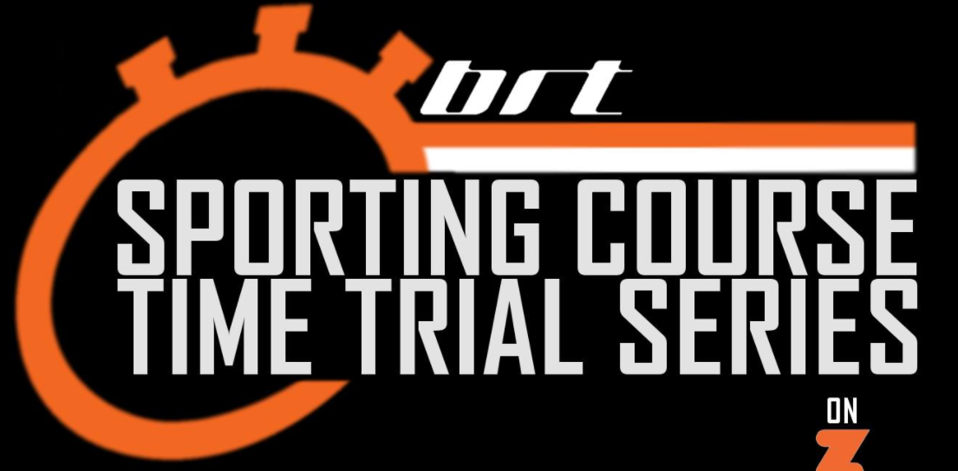
The Sporting Course Time Trial series and Veteran Standard League on Zwift, run in association with BRT (Bolt Race Team) are a series designed to challenge the best all-round time-trial testers. Facebook group: https://www.facebook.com/groups/SCTTonZ/ Website: https://www.brteam.co.uk/sctt

