Barnesbury Cycling Club

Present

The Johnny Rankin Trophy
Open 25 Mile Time Trial
(kindly sponsored by Scott Sports UK)

Promoted for and on behalf of Cycling Time Trials under their Rules and Regulations

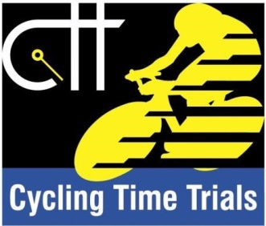

Sunday 22nd July 2018
8.00am Start
Course: M2510
First Rider: 8:01am

Time Keepers: Peter & Frances Schultz
Assistant Timekeeper: Carrie Roberts
Official Handicapper: Peter Manners (Barnesbury CC members only)
Event Secretary: Sharon Dyson, 8 Horton Manor, Blyth, NE24 4SF
Tel: 01670 531993/07837607219

This Open TT event is kindly sponsored by Scott Sports UK. We are very grateful of their continued support.

Scott Sports UK have kindly donated three pairs of Sunglasses and some cycling accessories for three lucky entrants in today’s race: -
- Rider with the most improved times over the 25M course (based on times in the 2017 and 2018 Johnny Rankin Trophy).

- There will be a draw of race numbers of riders competing on the day.

- Highest placed Junior rider.

Are proud to sponsor the 2018 BARNESBURY CC ‘Johnny Rankin Trophy 25’
Event Headquarters (1)
Additional Parking (2)
Start area (3)

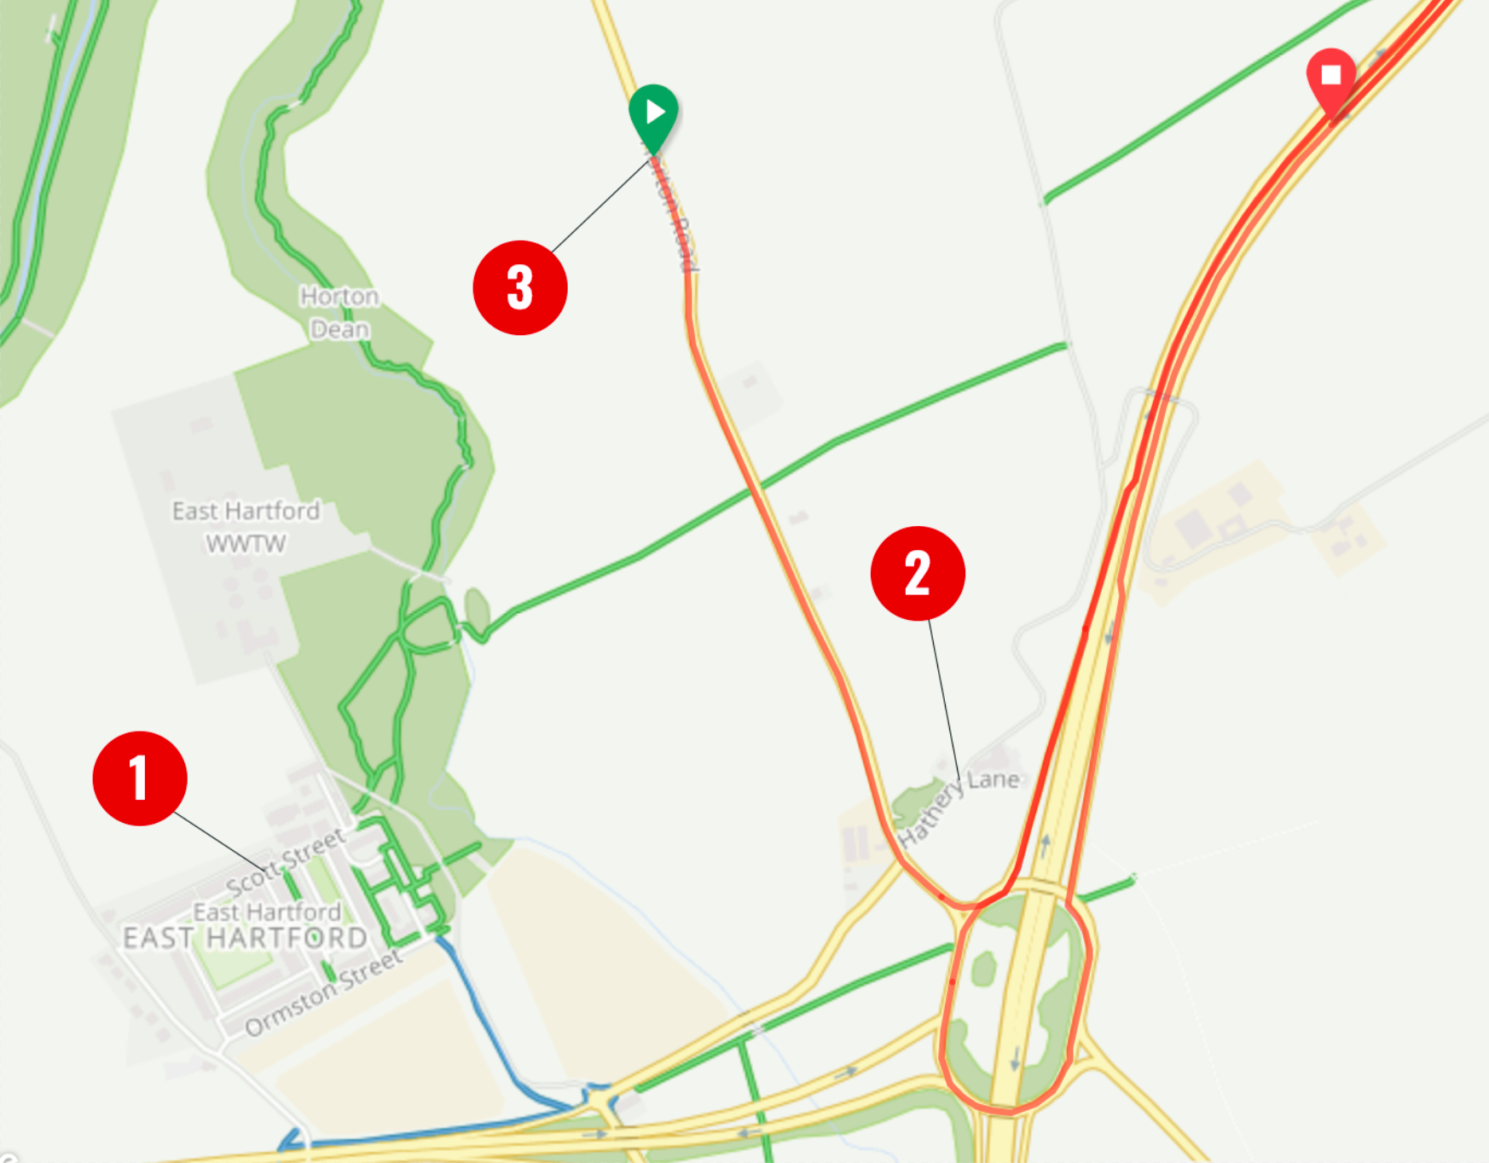
Sign on Headquarters
East Hartford Community Centre, Institute Buildings, Scott Street, Cramlington, NE23 3AP (1 above). Riders will be able to sign on and collect numbers from 7:00am. Refreshments available after the event.
There is parking in the streets around the Community Centre, but we ask that you are respectful of the local residents, particularly at such an early hour as the building is situated on a residential street. Please refrain from using turbos to warm up near the event headquarters – this will save us from getting a right earful! Additional parking is available in the Main Car Park of the Three Horse Shoes Public House, Hathery Lane, Blyth, NE24 4HF (2 above), on the proviso that competitors’ cars are removed by 12pm at the latest. This location can be used for warm-up. We are grateful to the Management of the Three Horse Shoes pub for allowing us this courtesy once again. (Great place for a Sunday lunch to treat the family once your race is out of the way!)
Each rider must sign for themselves and nobody else before collecting their number. Once the course has been completed, remember to sign out and return your number. NOTE: Riders who do not sign-out will be recorded as a “DNF” on the official results sheet. Juvenile and Junior riders must hand in a completed parental consent form to be permitted to race.
Please ensure that the road bike signing-on sheet is completed to be considered for the road bike prize at this event. When entering this category, the rider must not use Tri Bars, TT helmets, Trip Socks or wheels deeper than 60mm. Skin suits are permitted.
PRIZES & TROPHIES**
Results will be available at Headquarters. Full results will be uploaded to the CTT website as soon as they have been signed off by the Timekeepers. They will also be available on the Club website.
Fastest – 1st £30 + The Johnny Rankin Trophy, 2nd £25, 3rd £20
Female – 1st £30, 2nd £25, 3rd £20
Junior/Juvenile – Scott Sports UK Sponsored Prize
V40 – 1st £20
V50 – 1st £20
V60+ – 1st £20

Road Bike – 1st £25
Team Prize (Team of 3 from the same Club) – £30
Barnesbury CC (Only) Handicap (see Start Sheet on the day for details of rider handicap – 1st £20 + The Jack Burnley Trophy, 2nd £15, 3rd £10
The Stan Sadler Trophy will be awarded to the fastest Barnesbury CC Novice.
** One rider – one prize (with the exception of the Team prize)
- Where a rider qualifies for two prizes, the highest value prize will be awarded.
- If the prizes are of equal value, they will be awarded in the order shown above.

Course and Rider Information
Three Horseshoes – Woodhorn – Three Horseshoes.
- Start at the S-bend sign on the B1505 Bedlington road (see 3 on map above).
- Proceed to the Three Horseshoes roundabout and take the first exit slip road on the A189 northbound.
- Proceed to the North Seaton (Sandy Bay) roundabout and continue straight onto the Woodhorn roundabout.
- Encircle the roundabout and retrace to the Three Horseshoes roundabout by taking the A192 exit slip road.
- Encircle the roundabout and take the fifth exit slip road back onto the A189 northbound to repeat the course via the Woodhorn roundabout.
- FINISH at the start of the lay-by on the A189 southbound, shortly before the slip road leading once more to the Three Horseshoes roundabout.

If you’re unfamiliar with the course, please study it!! We had several riders who went completely off course last year.

Safety notes:
- Vehicles of competitors / officials / marshals / helpers to be parked safely and without hindrance to other road users.
- All riders are responsible for their own safety.
Riders:
Take extra care where traffic enters or leaves the course by way of slip roads and in the negotiation of roundabouts.
- No U-turns to be made in the vicinity of the timekeeper.
- Please refrain from warming up on the course once the time trial has commenced.
- No dismounting in the finishing area.
- You must look ahead and not ride with your head down.
- It is your responsibility to ensure that your machine is roadworthy and that you ride safely at all times.
- You must not take pace or shelter from any other vehicle or competitor (no drafting) – failure to comply may lead to disciplinary action being taken.
- In the interests of your own safety, Cycling Time Trials and the event promoters strongly advise you to wear a HARD-SHELL HELMET that meets an internationally accepted safety standard. All competitors under the age of 18 years MUST wear a hard-shell helmet.
- It is strongly recommended that a working rear light, either flashing or constant, is fitted to the machine in a position visible to following road users and is active whilst the machine is in use.

To assist the Timekeepers at the finish line can you please ensure that your number is correctly placed and visible from the rear in line with CTT regulations noted below:
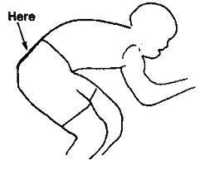
If it’s too high and we can’t see it, this may result in disqualification.

Please shout out your number as you pass the Finish Timekeeper.

Start Sheet - the full start sheet is also available on the CTT website event page (cyclingtimetrials.org.uk).
No | Start Time | Rider | Club | Cat
1 | 08:01 | Dean Madden | Barnesbury CC | V40
2 | 08:02 | Ian Simon | Breeze Bikes RT | V40
3 | 08:03 | Sam Dodd | Barnesbury CC | S
4 | 08:04 | Paul Mitchell | Blaydon CC | V40
5 | 08:05 | David Nearney | South Shields Velo CC | S
6 | 08:06 | Wayne Coates | Derwentside CC | V50
7 | 08:07 | Peter Stokoe | Sunderland Clarion | S
8 | 08:08 | Christopher Beaty | Allen Valley Velo | S
9 | 08:09 | Allen Armstrong | Sunderland Clarion | V65+
10 | 08:10 | Neil Pendrich | SVTTA | V40
11 | 08:11 | Justin Ramel | Blaydon CC | V40
12 | 08:12 | Kevin Hall | Sunderland Clarion | V40
13 | 08:13 | Mark Whaley | Blaydon CC | V40
14 | 08:14 | Paul Barrett | Sunderland Clarion | S
15 | 08:15 | Craig Fenwick | Team Swift | V40
16 | 08:16 | Lee Statham | Houghton CC | V40
17 | 08:17 | Ross Ketteridge | Gala CC | V50
18 | 08:18 | Steven Marks | North Tyneside Riders CC | V40
19 | 08:19 | Ronnie Thompson | Derwentside CC | V65+
20 | 08:20 | Mark Strang | Breeze Bikes RT | V40
21 | 08:21 | Steven Craggs | Blaydon CC | S
22 | 08:22 | Keith Sibbald | Cramlington CC | V40
23 | 08:23 | Neil Parkin | Derwentside CC | V40
24 | 08:24 | Richard Cleathero | North Racing | V40
25 | 08:25 | Lewis Timmins | Team Swift | S
26 | 08:26 | Tom Guy | Sunderland Clarion | V60
27 | 08:27 | Mark Herbert | Derwentside CC | V50
28 | 08:28 | Kyle Spence | Tyneside Vagabonds CC | S
29 | 08:29 | Angela McGurk | Blaydon CC | WS
30 | 08:30 | Collin Humphrey | Derwentside CC | V40
31 | 08:31 | Kerry Gowland | Houghton CC | WV40
32 | 08:32 | Colin Atkinson | Muckle Cycle Club | V50
33 | 08:33 | David Swainson | Derwentside CC | V40
34 | 08:34 | Sara Cummings | Blaydon CC | WV40
35 | 08:35 | Ben Lane | GS Metro | V40
36 | 08:36 | Hedley Fletcher | Blaydon CC | V40
37 | 08:37 | Mark Tully | Sunderland Clarion | S
38 | 08:38 | Joanne Rea | Blaydon CC | WS
39 | 08:39 | Caroline Golightley | Sunderland Clarion | WV40
40 | 08:40 | Nev Martin | GS Metro | V50
41 | 08:41 | Julian Macbride | Blaydon CC | S
42 | 08:42 | Paul Robson | Houghton CC | V50
43 | 08:43 | Peter McEwan | Breeze Bikes RT | V40
44 | 08:44 | Ian McLean | Tyneside Vagabonds CC | V50
45 | 08:45 | David Beattie | Hawick Cycling Club | S
46 | 08:46 | Jamie Johnson | Barnesbury CC | S
47 | 08:47 | Russell Hughes | Tyneside Vagabonds CC | V50
48 | 08:48 | Mick Bradshaw | GS Metro | V65+
49 | 08:49 | Rachel Galler | Blaydon CC | S
50 | 08:50 | Adam Wild | GS Metro | Espoir
51 | 08:51 | Adam Wilson | Cramlington CC | S
52 | 08:52 | Paul Rider | Tyneside Vagabonds CC | V50
53 | 08:53 | Richard Tyson | Rock to Roll CC | V50
54 | 08:54 | Christine Burns | Tyne Tri | WS
55 | 08:55 | Ken Thursby | Tyneside Vagabonds CC | V40
56 | 08:56 | Ali Bailey | GS Metro | S
57 | 08:57 | Mark Ambury | Cramlington CC | V40
58 | 08:58 | Gemma Hutchins | Blaydon CC | WS
59 | 08:59 | Gareth Davies | Barnesbury CC | V50
60 | 09:00 | Adam Jarps | Team Bottrill/Vanguard | Junior
61 | 09:01 | Dan Meggison | GS Metro | S
62 | 09:02 | Philip Kennell | Allen Valley Velo | V50
63 | 09:03 | Sebastian Stockbridge | Blaydon CC | S
64 | 09:04 | Craig Bell | Allen Valley Velo | S
65 | 09:05 | Thomas Hutchinson | Tyneside Vagabonds CC | S
66 | 09:06 | Keith Davison | Hadrian R.T. | V50
67 | 09:07 | Martin Rasmussen | Tyneside Vagabonds CC | V50
68 | 09:08 | James Allen | Barnesbury CC | V65+
69 | 09:09 | Hannah Baker | North Tyneside Riders CC | S
70 | 09:10 | Harry Walker | Revolver Racing | V40
71 | 09:11 | Sam Murray | DRAG2ZERO | Juvenile
72 | 09:12 | Ross Gray | Allen Valley Velo | S
73 | 09:13 | Gemma Frost | Team Swift | WS
74 | 09:14 | Raymond Bell | Derwentside CC | V65+
75 | 09:15 | Phil Hall | Breeze Bikes RT | V40
76 | 09:16 | Ian Norris | Blumilk.com | V50
77 | 09:17 | Simon Emsley | Derwentside CC | V40
78 | 09:18 | Jock Bolam | Breeze Bikes RT | V50
79 | 09:19 | Henning Saelzer | Houghton CC | S
80 | 09:20 | Keith Murray | DRAG2ZERO | V40
81 | 09:21 | Roger Clarke | Tyneside Vagabonds CC | V40
82 | 09:22 | Harry Armstrong | Berwick Wheelers Cycling Club | V40

Trophies and History

The Johnny Rankin Trophy

Awarded to the winner of the Barnesbury Open 25 Time Trial.

In 1950, the Barnesbury promoted its first “Invitation 25” in an attempt to encourage the best riders resident in Tyneside, Teesside, Cumberland and the North of Yorkshire to compete on local courses, and it was this that prompted Johnny Rankin to give to the Club an ornate silver cup for presentation to the winner of the event. After the “hour” had been beaten several times locally, the event was discontinued and the trophy was subsequently awarded to the winner of the Barnesbury Open 25. In 1970, Johnny suggested the trophy be modernised and the present silver trophy was made from the original.

Johnny Rankin joined the Barnesbury in late 1923 and gave many years of dedication to the Club and the sport and continued to do so until his death. Johnny also took an active role in the N&DCA.

Barnesbury CC- The Stan Sadler Trophy

The Stan Sadler Trophy is awarded to the fastest novice in the Club 25 mile time trial. To be classed as a novice you must not have won any championships (for any club) or Barnesbury trophies before. This silver 3 handled bowl was presented to the club by Mr W Stan Sadler in 1939. Stan joined the Barnesbury in 1926. Although Stan’s great cycling love was touring, he also enjoyed racing and bicycle polo. Stan took an active interest in Club affairs and held various positions including Dance Secretary and Vice President. Stan was always interested in encouraging young members and it was this that gave him the idea of presenting to the Club a perpetual trophy for competition among the novices.

Barnesbury CC- The Jack Burnley Trophy

The Jack Burnley trophy is awarded to the fastest Barnesbury rider on handicap time, who completes the Barnesbury Open 25. This trophy was presented to the Club by Mrs Burnley in memory of her husband Jack. Jack was a popular and enthusiastic Club member for many years having joined in 1936. Jack also held several official positions in the Club including Dance Secretary and was a Club Auditor until his death in 1958.

