Darlington Cycling Club

Open 25mile Time Trial
Sunday 15TH July 2018

Promoted for and on behalf of Cycling Time Trials under their Rules and Regulations.

Event Secretary: Timekeeper:
Geoff Watson Dave Oliver
19 Halnaby Avenue Geoff Watson
Darlington
DL3 8UH

Tel – 07914 577038

Start: First Rider off at 09.05 am Course T254

Course Description
Course Description: Start local to bridge over railway line on concrete expansion joint and proceed south over Leeming Services roundabout ( 90 metres ).Proceed over RAF Leeming/ Gatenby roundabout(2.60 miles), encircle the Sinderby roundabout (6.4 miles)and retrace outward journey via RAF Leeming/Gatenby (10.2 miles) to Leeming services roundabout (12.64 miles). Encircle and repeat journey south via RAF Leeming/ Gatenby roundabout (15.08 miles)to the Sinderby roundabout (18.88 miles)encircle and return north via RAF Leeming/Gatenby (22.68 miles)to finish at the start of the kerb (25miles)located 0.35metres past the A1/A1M sign and 100 meters before Leeming Services roundabout).

The Attention of all riders is drawn to the District RTTC guidelines:

- No U-Turns will be permitted in the vicinity of the Start.
- No warming –up by any rider on course once the event has started.
- No Turbo trainers to be used within 100 yards of any inhabited property.
Marshals will be placed at the top and bottom roundabout turns.

HQ address - Leeming Village Hall, Mill Lane, Leeming, Northallerton, DL7 9SS.
No warming up at HQ, suggested area is south of the Village Hall heading towards Londonderry on the roadside
Parking/Warm Up Area – Parking is limited at HQ, please use Roman Road/Dere Street south of HQ.
Prize List One Rider – One Prize

Fastest - 1st £60, 2nd £30, 3rd £15

1st 2nd
Age 40 - 49 £30 £15
Age 50 - 59 £30 £15
Age 60 - 69 £30 £15
Age 70 + £30 £15
Fastest lady £30 £15

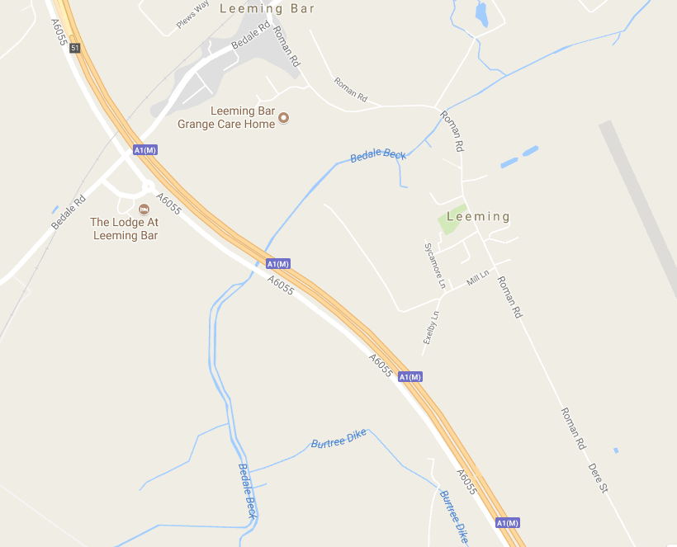
Parking and access to course
In the interest of safety, Cycling Time Trials and Event promoters strongly advise you to wear hard shell helmet that meets an internationally accepted safety standard. All competitors under the age of 18years/or Juniors must wear a properly affixed helmet, which conforms to recognised standards.
Finish
Start
HQ

