Route Maps

Start – Lan-y-Pwll – Prees
http://routebuilder.org/2eek
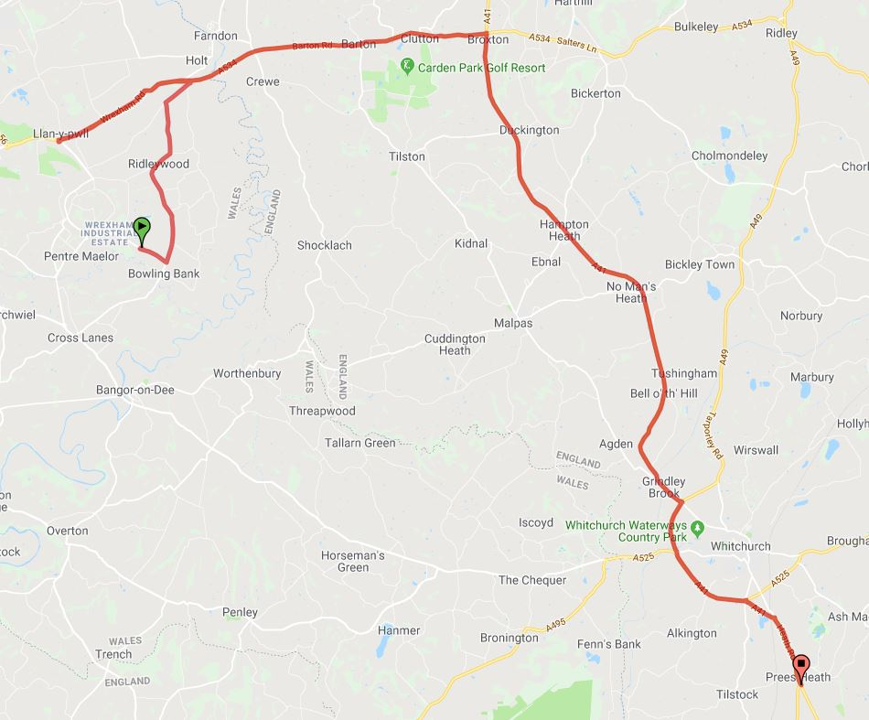

Prees - Espley
http://routebuilder.org/2ef0
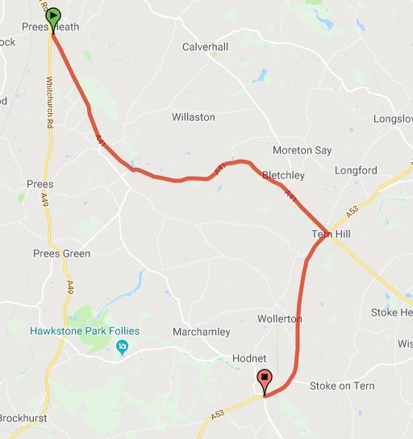

Espley – Shawbirch
http://routebuilder.org/2ef1

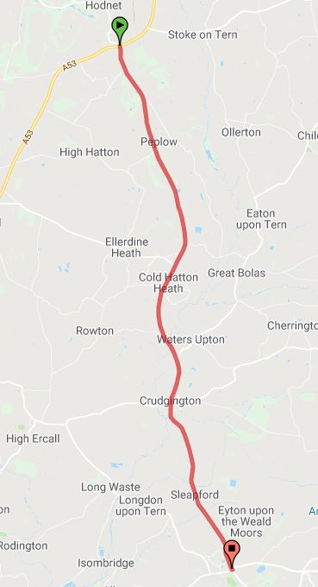

Prees – Battlefield
http://routebuilder.org/2ef2
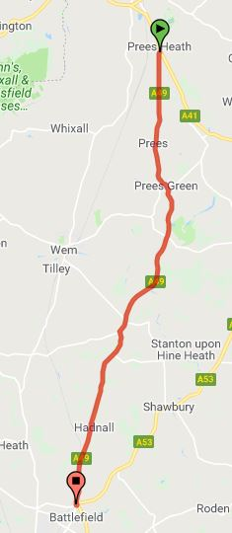

Quina Brook Circuit
http://routebuilder.org/o8t

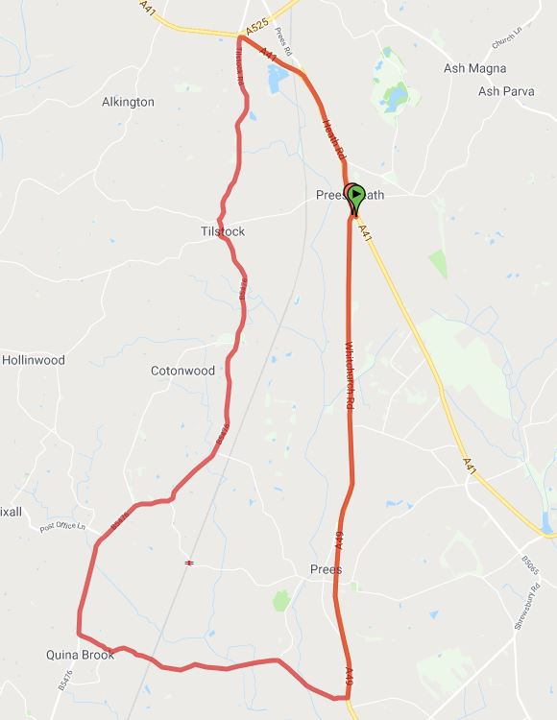

Prees – Finishing Circuit
http://routebuilder.org/2ef3

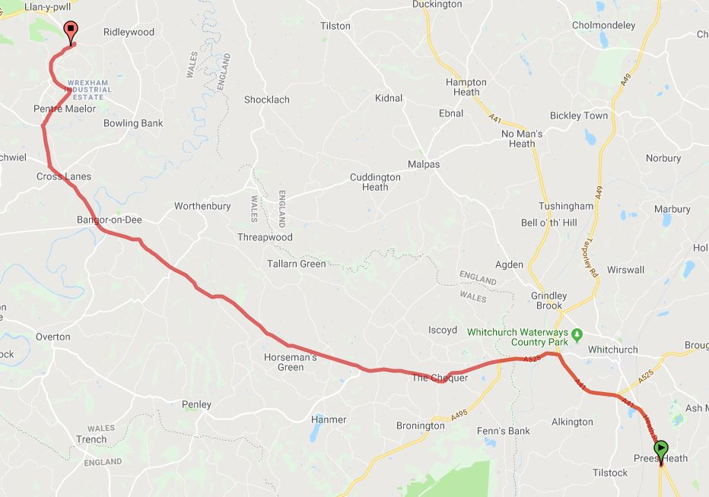

Finishing Circuit
http://routebuilder.org/2ef4

