Dunstable Road Cycling Club

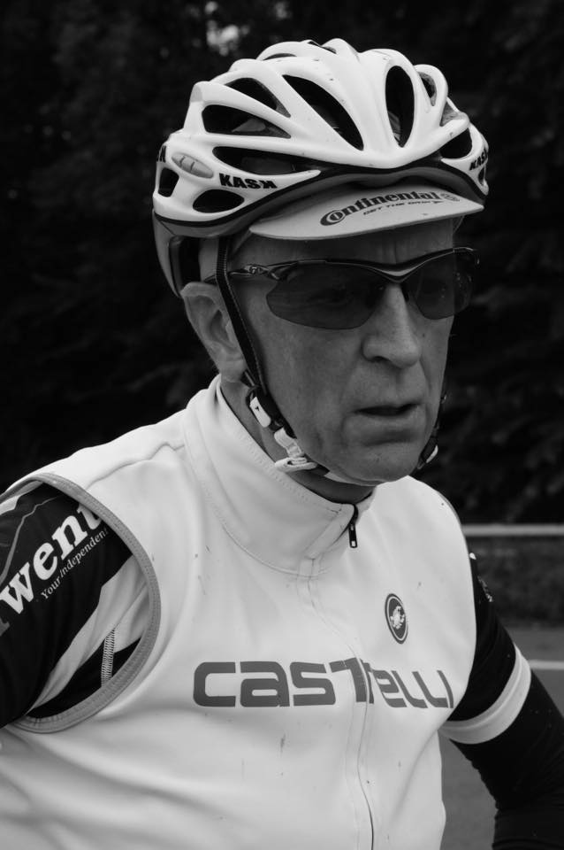

Ian Goodhew Memorial 10 miles Time Trial
Saturday 7th^{th} July 2018

Ian Goodhew 1950-2016
I first met Ian when we both joined the British cycling southern Centre of excellence, me as a young racer & Ian as manager/coach.
From that day to his recent passing Ian has been involved in my cycling career, Ian played a big part in my successes as a rider & then later as a team manager.
His 2nd to none organisational skills & coaching knowledge complemented any team he was involved in, from running his own team "team Energy" through to supporting me in 2013 in UCI team, IG-Sigmasport.
Ian has coached endless riders in that 25 years, far to many to list. They have achieved many great things from finishing a charity event to racing on the big stage.
Ian rarely spoke of his achievements, however in the past few years while he was falling back in love with cycling and riding his own bike we spent many hours talking everything cycling.
We spoke & laughed of the past from fun & not so fun racing trips we had been on together through to dissecting Km by Km tactics of races we had watched on TV.
As I go into another season as a team manager Ian will be sadly missed, I have adopted many of his ideas & suggestions. He is often in my thoughts, particularly when I feel my own performance wasn't up to scratch and what he would off said to me in my debrief.

Simon Howes

Dunstable RCC
Start sheet for the Ian Goodhew Memorial Open 10
Saturday 7th July 2018 on the F11/10 course starting at 14:00 pm

To be held “ For and on behalf of Cycling Time Trials under their rules and regulations”

Event secretary : Debbie Knott, 83 Elm Park Close, Houghton Regis, Beds, LU5 5PW
Tel 07950 193977

Event HQ : Aston Clinton School, Twitchell Lane, Aston Clinton, Bucks, HP22 5JJ ( open from 13:00 )

Time keepers :- Mr Mike Bannister (Chronos RT) and Tony Farmborough (North Bucks RC)

Course Details are: F11/10 (Tring & Aston Clinton by-passes) (Please note course change due to Roadworks on F15/ 10)
Start on southbound sliproad to A41 on the Western Tring junction approx 40 yards from the start of the sliproad. Proceed along A41 to come off at first sliproad (Eastern Tring junction) to
Turn (approx 2.0 miles) by taking 4th exit out of RAB and under the A41, going around 2nd RAB to take 2nd exitback onto the A41 westbound and continue past all junctions to RAB at end of Aston Clinton by-pass to

Turn (7.87 miles) by taking 3rd exit out of RAB back along the by-pass, again ignoring College Road junction to

Finish on Buckland sliproad 9 yards south-east of manhole cover on grass verge, about 91 yards nth-west of (i.e.before) separation of slip road and main carriageway, also about 460 yards nth-west of the B489 over bridge.

Every effort will be made to have marshals at points where there is a change of direction, however the onus is on the rider to know the course. Refreshments available at the HQ, please exchange your number for a Tea/coffee.

Important Notice

The finish of the course is in the slip road. All riders must pass within 2.5 metres of the white line de-marking the left edge of the carriageway of the slip road. Failure to do this will lead to a DNF If you impede a vehicle you risk disqualification

There must be no parking of motor vehicles on any part of the A41 apart from those of the officials. All parking must be in the HQ car park. Do NOT obstruct other road users or driveways outside the school.

You must sign on in advance of your start at the headquarters where you can pick up your number and receive any last minute instructions or warnings. Please return number with all pins after you have ridden. DO NOT fold numbers at all. DO NOT use sticky tape (or other sticking methods) to secure the numbers to your clothing.

Please keep your head up at all times. At roundabouts the traffic coming from the right has priority over you, so please give way. In particular the first one at the bottom of the off sliproad does not have good line of sight for traffic coming from the right so please take great care here. Be prepared to stop if need be.

Local Regulation 1. – No U Turns should be made at any time while riding on the public highway.

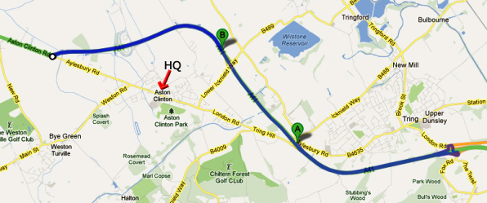

Please be aware that the first 2 miles does have a number of potholes (mainly caused by the older surface expansion joins failing) so look well ahead at all times. There are a few more after the first turn for the next 2 miles. However the remaining 6 miles are very good.

HQ to start route (blue route A to B) – please note that almost half of this is uphill so allow at least 15 minutes to get to the start from the HQ

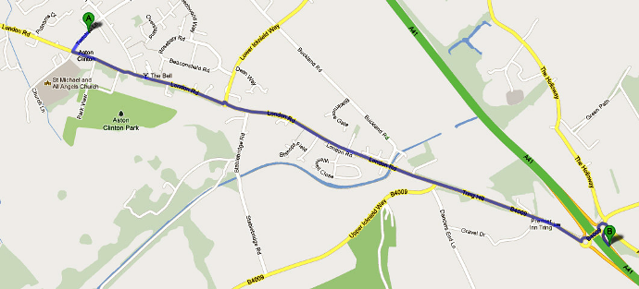

Prizes:
Men (Scratch) Ladies Tandem
1st £50 £50 £20
2nd £40 £40
3rd £30 £30
4th £20 £20
5th £10 £10
Team: 1st team of 3 on total time £30

London North Regulations

LOCAL REGULATION No. 1 No U turns should be made in sight of the start or finish areas while riding on the public highway.

LOCAL REGULATION No. 2 Competitors, their helpers and event officials must use the toilet facilities provided at event headquarters as required. Fields and hedgerows must NOT be used for toilet purposes. Failure to observe this regulation may result in disciplinary action against those concerned.

LOCAL REGULATION No. 3 No cars other than that of the timekeeper(s) and other event officials are to be parked in the vicinity of the start or finish points.

Start Order

Tandem

# | Start Time | FirstName | Surname | Club | Gender | Category
1 | 14:01 | Christopher | York | Maldon & District CC | Male | Veteran
 |  | Joanne | York | Maldon & District CC | Female | Veteran

Open event
# | Start Time |  | FirstName |  | Surname |  | Club |  |  | Gender |  | Category
2 | 14:02 |  | Naomi |  | Holt |  | Welwyn Whs |  |  | Female |  | Junior
3 | 14:03 |  | Gillian |  | Morgan |  | Westerley Cycling Club |  |  | Female |  | Veteran
4 | 14:04 |  | Claire |  | Sharp |  | Verulam Really Moving |  |  | Female |  | Veteran
5 | 14:05 |  | Allison |  | Kaye |  | Verulam CC |  |  | Female |  | Veteran
6 | 14:06 |  | Joanna |  | Spragg |  | Bossard Whs |  |  | Female |  | Veteran
7 | 14:07 |  | Graeme |  | Church |  | Team Milton Keynes |  |  | Male |  | C3
8 | 14:08 |  | Stephanie |  | Cousins |  | North Bucks RC |  |  | Female |  | Veteran
9 | 14:09 |  | Denese |  | Hallahan |  | Wisbech Whs |  |  | Female |  | Veteran
10 | 14:10 |  | Paul |  | Pardoe |  | Peterborough CC |  |  | Male |  | Senior
11 | 14:11 |  | Jim |  | Moffatt |  | CC Luton |  |  | Male |  | Veteran
12 | 14:12 |  | Thomas |  | Weir |  | Hitchin Nomads CC |  |  | Male |  | Senior
13 | 14:13 |  | Andrew |  | Clarke |  | Mid Shropshire Wheelers |  |  | Male |  | Veteran
14 | 14:14 |  | Richard |  | Moule |  | Bossard Whs |  |  | Male |  | Veteran
15 | 14:15 |  | Keith |  | Lea |  | Paceline RT |  |  | Male |  | Veteran
16 | 14:16 |  | Steve |  | Legg |  | ...a3crg |  |  | Male |  | Veteran
17 | 14:17 |  | Tim |  | Kingston |  | GS Invicta - Eye Level Optical- Herbert Cycles |  |  | Male |  | Veteran
18 | 14:18 |  | Danuta |  | Tinn |  | Maidenhead & District CC |  |  | Female |  | Veteran
19 | 14:19 |  | Steph |  | Russell |  | Team Bottrill / Vanguard |  |  | Female |  | Senior
20 | 14:20 |  | Timothy |  | Allen |  | SPIRIT TIFOSI RT |  |  | Male |  | Espoir
21 | 14:21 |  | Simon |  | Bowler |  | AS Test Team |  |  | Male |  | Veteran
22 | 14:22 |  | Martin |  | Winter |  | Twickenham CC |  |  | Male |  | Veteran
23 | 14:23 |  | Harry |  | Kirby |  | Bicester Millennium CC |  |  | Male |  | Junior
24 | 14:24 |  | Julie |  | Chasin |  | Twickenham CC |  |  | Female |  | Veteran
25 | 14:25 |  | B Xavier |  | Disley |  | AeroCoach |  |  | Male |  | Senior
26 | 14:26 |  | Stu |  | Wright |  | Planet X - Carnac |  |  | Male |  | Veteran
27 | 14:27 |  | Gareth |  | Wignall |  | Hertfordshire Whs |  |  | Male |  | Senior
28 | 14:28 |  | Helen |  | Reynolds |  | Hemel Hempstead CC |  |  | Female |  | Veteran
29 | 14:29 |  | Suzy |  | Patience |  | Banbury Star Cyclists' Club |  |  | Female |  | Senior
30 | 14:30 |  | Keith |  | Ainsworth |  | Sheffrec CC |  |  | Male |  | Veteran
31 | 14:31 |  | Martin |  | Reynolds |  | Cambridge CC |  |  | Male |  | Veteran
32 | 14:32 |  | Jon |  | Elliott |  | Maidenhead & District CC |  |  | Male |  | Senior
33 | 14:33 |  | Martin |  | Stanley |  | Didcot Phoenix CC |  |  | Male |  | Veteran
34 | 14:34 |  | Jennifer |  | Millmore |  | Islington Cycling Club |  |  | Female |  | Senior
35 | 14:35 |  | Mark |  | Ellis |  | Team Milton Keynes |  |  | Male |  | Veteran
36 | 14:36 |  | matthew |  | saunders |  | Team Vision Racing - Silverhook |  |  | Male |  | Veteran
37 | 14:37 |  | James |  | Garrett |  | Rugby Velo |  |  | Male |  | Senior
38 | 14:38 |  | Jessica |  | Rhodes-Jones |  | Beacon Roads CC |  |  | Female |  | Senior
39 | 14:39 |  | Karen |  | Dennett |  | Bishop's Stortford CC |  |  | Female |  | Veteran
40 | 14:40 |  | Luke |  | Clarke |  | TMG Horizon Cycling Team |  |  | Male |  | Senior
41 | 14:41 |  | matt |  | steel |  | Shaftesbury CC |  |  | Male |  | Veteran
42 | 14:42 |  | lawrence |  | wintergold |  | Hounslow & District Whs |  |  | Male |  | Veteran
43 | 14:43 |  | Robert |  | Saunders |  | North Bucks RC |  |  | Male |  | Veteran
44 | 14:44 |  | John |  | McCormack |  | Islington CC |  |  | Male |  | Senior
45 | 14:45 |  | Eric |  | Grill |  | AeroCoach |  |  | Male |  | Senior
46 | 14:46 |  | fabos |  | young |  | VeloElite RC |  |  | Male |  | Veteran
47 | 14:47 |  | Anthony |  | Turner |  | Mickey Cranks Cycling Club |  |  | Male |  | Veteran
48 | 14:48 |  | Stuart |  | Morgan |  | MERCEDES AMG PETRONAS CC |  |  | Male |  | Veteran
49 | 14:49 |  | Gillian |  | Reynolds |  | Willesden CC |  |  | Female |  | Veteran
50 | 14:50 |  | Ryan |  | Davies |  | AS Test Team |  |  | Male |  | Senior
51 | 14:51 |  | Michael |  | Bennett |  | Bicester Millennium CC |  |  | Male |  | Veteran
52 | 14:52 |  | Jason |  | Costello |  | Team Swindon Cycles |  |  | Male |  | Veteran
53 | 14:53 |  | Paul |  | French |  | Bedfordshire Road RT |  |  | Male |  | Veteran
54 | 14:54 |  | Katie |  | Crowe |  | Dulwich Paragon CC |  |  | Female |  | Veteran
55 | 14:55 |  | Dave |  | Elliott |  | Rugby Racing Cycling Club |  |  | Male |  | Veteran
56 | 14:56 |  | Andrew |  | Wright |  | High Wycombe CC |  |  | Male |  | Veteran
57 | 14:57 |  | James |  | Barlow |  | Bicester Millennium CC |  |  | Male |  | Senior
58 | 14:58 |  | Joseph |  | Hudson |  | Sharrow CC |  |  | Male |  | Senior
59 | 14:59 |  | Helen |  | Roby |  | Spirit Bikes CC |  |  | Female |  | Veteran
60 | 15:00 |  | Richard |  | Harrison |  | DRAG2ZERO |  |  | Male |  | Veteran
61 | 15:01 |  | Howard |  | Shaw |  | Eastbourne Rovers CC |  |  | Male |  | Senior
62 | 15:02 |  | Phil |  | Wilks |  | Sotonia CC |  |  | Male |  | Senior
63 | 15:03 |  | Abid |  | Hussain |  | Icknield RC |  |  | Male |  | Veteran
64 | 15:04 |  | mike |  | logue |  | Fairly United Cycling Team |  |  | Male |  | Veteran
65 | 15:05 |  | Ian |  | Greenstreet |  | AeroCoach |  |  | Male |  | Veteran
66 | 15:06 |  | Joe |  | Perkins |  | University of Nottingham C C |  |  | Male |  | Senior
67 | 15:07 |  | Colin |  | Ross |  | Lea Valley CC |  |  | Male |  | Senior
68 | 15:08 |  | Daniel |  | Ryan |  | North Road CC |  |  | Male |  | Senior
69 | 15:09 |  | Jo |  | Buckland |  | Bush Healthcare CRT |  |  | Female |  | Veteran
70 | 15:10 |  | Robert |  | Willcocks |  | Royal Air Force Cycling Association |  |  | Male |  | Senior
71 | 15:11 |  | Adam |  | Fisher |  | Cambridge CC |  |  | Male |  | Senior
72 | 15:12 |  | Nick |  | Morgan |  | Hitchin Nomads CC |  |  | Male |  | Senior
73 | 15:13 |  | Geoff |  | Reynolds |  | Hemel Hempstead CC |  |  | Male |  | Veteran
74 | 15:14 |  | Kirsty |  | McSeveney |  | Fareham Wheelers CC |  |  | Female |  | Senior
75 | 15:15 |  | Lawrence |  | Burrows |  | Vive Le Velo |  |  | Male |  | Senior
76 | 15:16 |  | MartinF2:M212 |  | O'Sullivan |  | Teddington and Turing Velo |  |  | Male |  | Veteran
77 | 15:17 |  | Henry |  | Latimer |  | Nuun-Sigma Sport-London RT |  |  | Male |  | Senior
78 | 15:18 |  | Lee |  | Turner |  | Sigma Sports |  |  | Male |  | Veteran
79 | 15:19 |  | Kathryn |  | Innes |  | Dulwich Paragon CC |  |  | Female |  | Senior
80 | 15:20 |  | Nick |  | English |  | AeroCoach |  |  | Male |  | Senior
81 | 15:21 |  | robert |  | watson |  | Cambridge CC |  |  | Male |  | Veteran
82 | 15:22 |  | Andy |  | Proffitt |  | Ipswich BC |  |  | Male |  | Veteran
83 | 15:23 |  | Sam |  | Christy |  | TAAP Cervélo |  |  | Male |  | Senior
84 | 15:24 |  | Claire |  | Emons |  | Newbury RC |  |  | Female |  | Veteran
85 | 15:25 |  | Harry |  | Buxton |  | Andy Moore Autocentres Racing |  |  | Male |  | Junior
86 | 15:26 |  | Murat |  | Ozdenya |  | Team Vision Racing - Silverhook |  |  | Male |  | Veteran
87 | 15:27 |  | Dave |  | Johnson |  | Bicester Millennium CC |  |  | Male |  | Veteran
88 | 15:28 |  | Alex |  | Bradley |  | Oxford University CC |  |  | Male |  | Senior
89 | 15:29 |  | Michelle |  | Walter |  | Bournemouth Arrow CC |  |  | Female |  | Veteran
90 | 15:30 |  | Robert |  | West |  | AeroCoach |  |  | Male |  | Veteran
91 | 15:31 |  | Karl |  | Willis |  | Herts Rouleurs Racing Club |  |  | Male |  | Senior
92 | 15:32 |  | Michael |  | Davey |  | Eastbourne Rovers CC |  |  | Male |  | Veteran
93 | 15:33 |  | antony |  | bee |  | Wigmore CC |  |  | Male |  | Veteran
94 | 15:34 |  | Molly |  | Patch |  | Fusion R T Veloperformance |  |  | Female |  | Senior
95 | 15:35 |  | Nicholas |  | Candy |  | North Road CC |  |  | Male |  | Junior
96 | 15:36 |  | Hefin |  | Jones |  | Didcot Phoenix CC |  |  | Male |  | Veteran
97 | 15:37 |  | Sean |  | Noon |  | Edinburgh Road Club |  |  | Male |  | Espoir
98 | 15:38 |  | Michael |  | Knight |  | Team Bottrill / Vanguard |  |  | Male |  | Senior
99 | 15:39 |  | Anna |  | Woodcock |  | Oxonian CC |  |  | Female |  | Senior
100 | 15:40 |  | Ian |  | Ryves |  | Baines Racing |  |  | Male |  | Senior
101 | 15:41 |  | Toby |  | Hunt |  | Verulam CC |  |  | Male |  | Senior
102 | 15:42 |  | Daniel |  | Burbridge |  | Bristol South Cycling Club |  |  | Male |  | Senior
103 | 15:43 |  | Nick |  | Livermore |  | Bristol South Cycling Club |  |  | Male |  | Senior
104 | 15:44 |  | Emma |  | Angove |  | 73Degrees CC, WestSide Coaching |  |  | Female |  | Senior
105 | 15:45 |  | Tom |  | Thornely |  | Buxton CC/Sett Valley Cycles |  |  | Male |  | Senior
106 | 15:46 |  | Sam |  | Wightman |  | Chelmer CC |  |  | Male |  | Veteran
107 | 15:47 |  | Nic |  | Stevenson |  | Westerley Cycling Club |  |  | Male |  | Senior
108 | 15:48 |  | Peter |  | Lavery |  | Hemel Hempstead CC |  |  | Male |  | Veteran
109 | 15:49 |  | Anastasia |  | Bowler |  | AS Test Team |  |  | Female |  | Espoir
110 | 15:50 |  | John |  | Wingfield |  | Team Milton Keynes |  |  | Male |  | Senior
111 | 15:51 |  | Simon |  | Cannings |  | JCA Equipe Velo |  |  | Male |  | Veteran
112 | 15:52 |  | Tim |  | Davies |  | Icknield RC |  |  | Male |  | Veteran
113 | 15:53 |  | Michael |  | Martin |  | CC Ashwell |  |  | Male |  | Veteran
114 | 15:54 |  | Faye |  | Faber |  | Bike Jockey CC |  |  | Female |  | Senior
115 | 15:55 |  | Jonathan |  | Gates |  | Royal Air Force Cycling Association |  |  | Male |  | Veteran
116 | 15:56 |  | Gavin |  | Tillson |  | cyclisme du loup solitaire |  |  | Male |  | Veteran
117 | 15:57 |  | Jonathan |  | Williams |  | Amersham Road Cycling Club |  |  | Male |  | Veteran
118 | 15:58 |  | Andrew |  | Halliday |  | Westerley Cycling Club |  |  | Male |  | Veteran
119 | 15:59 |  | Marianne |  | Holt |  | Team Bottrill / Vanguard |  |  | Female |  | Senior
120 | 16:00 |  | Gavin |  | Hinxman |  | DRAG2ZERO |  |  | Male |  | Veteran
121 | 16:01 |  | Angus |  | MacInnes |  | Royal Air Force Cycling Association |  |  | Male |  | Veteran
122 | 16:02 |  | James |  | Cook |  | Radeon-Cycology RT |  |  | Male |  | Senior
123 | 16:03 |  | Pierre |  | Scrase |  | Baines Racing |  |  | Male |  | Senior
124 | 16:04 |  | liam |  | somerville |  | Bike Jockey CC |  |  | Male |  | Senior
125 | 16:05 |  | Chris |  | Manko |  | Team Milton Keynes |  |  | Male |  | Senior
126 | 16:06 |  | rob |  | fletcher |  | JCA Equipe Velo |  |  | Male |  | Veteran
127 | 16:07 |  | Mark |  | Baker |  | Abellio - SFA Racing Team |  |  | Male |  | Veteran
128 | 16:08 |  | Simon |  | Drewett |  | Fairly United Cycling Team |  |  | Male |  | Veteran
129 | 16:09 |  | Christie |  | Jones |  | Hereford & Dist Whs CC |  |  | Female |  | Senior
130 | 16:10 |  | Chris |  | Boddy |  | Didcot Phoenix CC |  |  | Male |  | Senior
131 | 16:11 |  | Michael |  | Hill |  | Chester RC |  |  | Male |  | Senior
132 | 16:12 |  | Harri |  | James |  | Didcot Phoenix CC |  |  | Male |  | Senior
133 | 16:13 |  | stuart |  | stow |  | Twickenham CC |  |  | Male |  | Veteran
134 | 16:14 |  | Linda |  | Dewhurst |  | Team Milton Keynes |  |  | Female |  | Veteran
135 | 16:15 |  | Tom |  | Temple |  | Primera-Teamjobs |  |  | Male |  | Junior
136 | 16:16 |  | Nik |  | Allen |  | Worthing Excelsior CC |  |  | Male |  | Veteran
137 | 16:17 |  | Darren |  | Heath |  | Charlotteville Cycling Club |  |  | Male |  | Veteran
138 | 16:18 |  | Tim |  | Childs |  | Westerley Cycling Club |  |  | Male |  | Veteran
139 | 16:19 |  | Jill |  | Bartlett |  | Hounslow & District Whs |  |  | Female |  | Veteran
140 | 16:20 |  | MARK |  | JONES |  | DRAG2ZERO |  |  | Male |  | Veteran
141 | 16:21 |  | Will |  | Bevan |  | Ross on Wye & Dist CC |  |  | Male |  | Senior
142 | 16:22 |  | Matt J |  | Smith |  | Port Talbot Whs CC |  |  | Male |  | Veteran
143 | 16:23 |  | Eddie |  | Humphreys |  | Loughborough Phoenix CC |  |  | Male |  | Veteran
144 | 16:24 |  | Ian |  | Markham |  | Chronos RT |  |  | Male |  | Veteran
145 | 16:25 |  | David |  | Rumm |  | Southborough & Dist. Whs |  |  | Male |  | Veteran
146 | 16:26 |  | Greg |  | Brookes |  | Team Jewson - MI Racing ~Poly Pipe~McCann |  |  | Male |  | Senior
147 | 16:27 |  | Charlie |  | Walters |  | Primera-Teamjobs |  |  | Male |  | Junior
148 | 16:28 |  | Dean |  | Chiddention |  | Abellio - SFA Racing Team |  |  | Male |  | Veteran
149 | 16:29 |  | Alan |  | Crane |  | Chronos RT |  |  | Male |  | Veteran
150 | 16:30 |  | Hamish |  | Bond |  | AeroCoach |  |  | Male |  | Senior

Reserve Riders

R1 |  | Kevin | Stokes | Born To Bike | Male | Veteran
R2 |  | Mark | Wise | Islington CC | Male | Veteran
R3 |  | Joe | Schvartz | Team Swift | Male | Veteran
R4 |  | Martin | Headon | Dulwich Paragon | Male | Veteran
R5 |  | Jon | Talbot | Wisbech Wheelers | Male | Veteran
R6 |  | Matt | Donovan | Beds Road CC | Male | Veteran
R7 |  | Roger | Porter | Verulum CC | Male | Veteran
R8 |  | Michael | Cope | Kettering CC | Male | Veteran
R9 |  | Simon | Elkington | St Neots CC | Male | Veteran
R10 |  | Mattew | Smith | Port Talbot Whs CC | Male | Senior
R11 |  | Daniel | Homer | London Pheonix CC | Male | Veteran
R12 |  | Kevin | Creese | Chronos RT | Male | Veteran
R13 |  | David | Creese | Chronos RT | Male | Veteran
R14 |  | John | Iszatt | Team Vision | Male | Veteran
R15 |  | Carmelo | Luggeri | CC Ashwell | Male | Veteran

If you have been accepted to ride and are not planning to start, please inform Debbie Knott
ASAP on 07950 193977, so an opportunity can be given to a reserve rider

Other Notices
Please bring a few extra pennies, we are running a charity cake stall. The charity is Glanfield Childrens group. The Glanfield Group provides children and adults with Learning Disabilities with a holiday in Lourdes in August, More details of the group can be http://www.glanfield.org/

We are also being supported in today’s event by Total Balance with Sports Massage. So get booked in or have a chat, regarding Sports Massage, Sports Rehabilitation and Chiropractic services. Recently I have used Total Balance Clinic for a Grade 2 Ankle sprain and their services have helped me back on the road to recovery with their expert Knowledge. Total Balance Clinic is based near Hemel Hempstead. More Details can be found on their Website - http://www.totalbalanceclinic.co.uk

