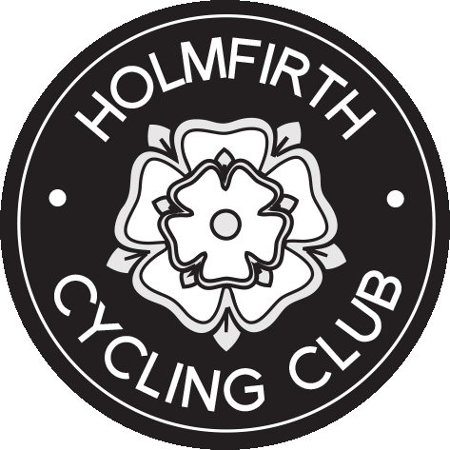
FINAL RESULT SHEET
SPOCO EVENT
10 mile TT V915 on SATURDAY 23RD JUNE 2018
Promoted for and on behalf of Cycling Time Trials,
under their Rules and Regulations.
Yorkshire Cycling Federation

Event Secretary  Rachael Mellor  35 The Cutting, Brockholes, Holmfirth, HD9 7HL  Mob. 07969663881 | Timekeepers  Start – Phil Hurt – Yorkshire RC  Finish -George Barker - Pennine CC  Assisted by –Rebecca Breakey - HCC

1st fastest Male –  Christophe Demoulin –  York Cycleworks | 22:06 | 1st Vet 40 Male - Glen Turnbull  Harrogate Nova CC | 23:27
2nd fastest Male – Richard Sharp  Team Swift | 22:28 | 1st Vet 50 Male - Michael Schofield | 23:23
3rd fastest Male – Jack Brown  Cambridge University | 22:44 | 1st Vet 60 - Chris Harris  Holmfirth CC | 26:15
1st fastest Female –  Sarah Lewthwaite  Team Sportslab | 26:13 | 1st Female Vet 40 – Helen Goldthorpe  Otley CC | 29:12
2nd fastest Female – Hannah Benson  Ilkley CC | 27:17 | 1st Female Vet 50 - 59 – Tracey Coldwell Holmfirth CC | 33:03
3rd fastest Female – Nicola Forwood  Alba Rosa CC | 28:28 | 1st Female Vet 60+ | NONE
This event is part of the YCF SPOCO Competition 2018 | CONGRATULATIONS TO ALL THE PRIZE WINNERS
NO EVENT CAN BE RUN WITHOUT THE NUMEROUS VOLUNTEERS SO THANK YOU TO ALL - HOLMFIRTH CC YOU DID US PROUD!
Special mentions to Jan & Bronwyn for all the baking & to Tracey for organizing all the many wonderful volunteers who came to marshal - you are amazing!

