National Youth TT Championship (NYC)

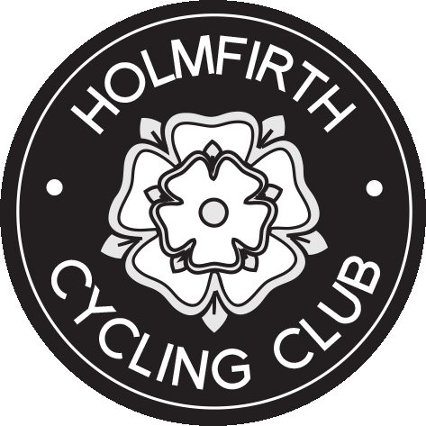
(Yorkshire DC/Holmfirth CC)
Promoted for and on behalf of Cycling Time Trials,
under their Rules and Regulations.

10 mile TT on V915

Event Secretary - Rachael Mellor  35 The Cutting, Brockholes, Holmfirth, HD9 7HL  rachaelmellor@hotmail.com  Mob: 07969663881 | Timekeepers  George Barker - Pennine CC  Phil Hurt - Yorkshire RC  Assistant – Rebecca Breakey

RESULTS

NATIONAL YOUTH CHAMPIONSHIP (Yorkshire District)

1st Fastest boy HARRY BUTTERWORTH Scarborough Paragon CC 24:16
2nd Fastest boy Liam Bavison Team JRC 24:50
3rd Fastest boy Matthew Dixon Scarborough Paragon CC 25:33

1st Fastest girl Rebecca Dawes Clifton CC 29:03
2nd Fastest girl Ella Jamieson Clifton CC 29:07
3rd Fastest girl Rachel Earnshaw Team JRC 29:38

AGE GROUP WINNERS (Age as at 31st Aug 2018)

12 boy Alex Belon Ilkely CC 26:45
12 girl ------
13 boy Oli Akers Holmfirth CC 26:35
13 girl Ella Jamieson Clifton CC 29:07
14 boy -----
14 girl Harriet Breakey Holmfirth CC 29:54
15 boy Harry Butterworth Scarborough Paragon 24:16
15 girl Rebecca Dawes Clifton CC 29:03
16 boy -------
16 girl Rachel Earnshaw Team JRC 29:38
Team of 3 Riders from Holmfirth CC - Akers, Dodd & Breakey

THANK YOU TO ALL THE PARENTS WHO BROUGHT THE CHILDREN TO THIS VERY SUCCESSFUL RACE.

THANK YOU TO ALL OUR WONDERFUL VOLUNTEERS FROM HOLMFIRTH CC WHO CAME OUT TO MARSHAL, SERVE WONDERFUL CAKE, PUSH OFF, PUT UP SIGNS, DO RISK ASSESSMENTS AND SO MUCH MORE – WE COULD HAVE NOT DONE IT WITHOUT YOUR SUPPORT. YOUR CLUB IS PROUD OF YOU! And finally thank you to Phil Hurt and George Barker for their expertise and Timekeeping.

And finally…

All the Prize winners will be automatically entered into the GHS/National Final on Saturday September 8th. We wish you lots of luck, train well and do your county proud!

