N&DCA HQ is at Walgrave Village hall -
Please be aware that a Cricket match will be playing so please park in the main car park and if this is filled then park at the top end of the playing fields. The side gate will be open which is just beyond the main entrance.

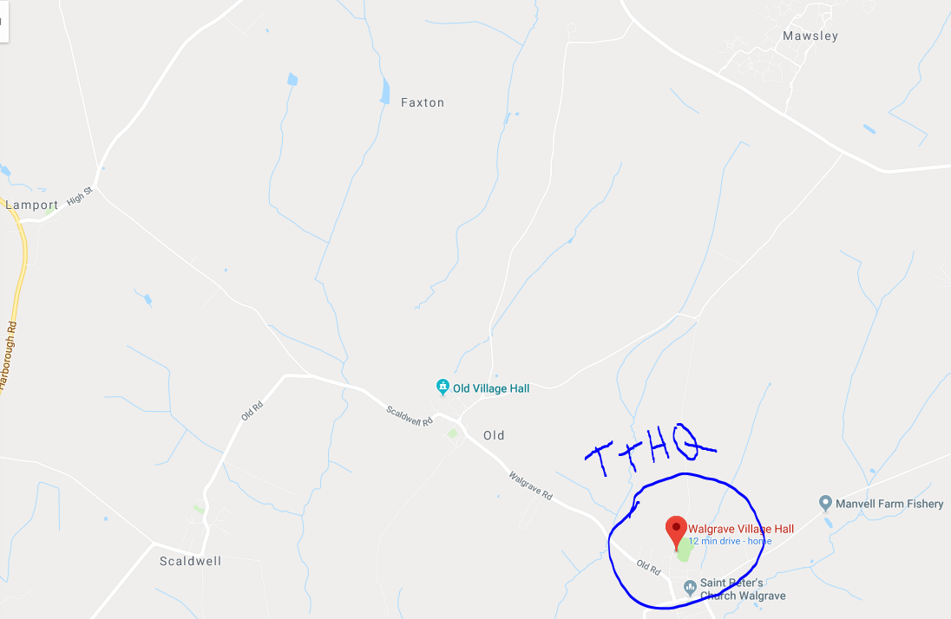
There will be parking available at Venue HQ and limited changing facilities. You can also leave your bags here if needed.
Please leave plenty of time to get to HQ.
Registration will be from 12:30pm with the first rider off at 14.01pm.
HQ is approximately 15 – 20 min cycle to the start
Timings
Riders will be set off at 1 minute intervals from 14.01pm as per the start list.
Please make sure you arrive at the start in good time so as not to miss your time slot!
There will be a 30 second count down before you start and there will be a ‘push-off’ available if anyone wants this and so please inform the marshal if you do not want this at the start.
Note: All Juvenile and Junior entrants must ensure that a completed and signed Parental form is presented and available at the signing on area prior to race numbers being released.

Course Details: NC15B – 20.8 miles

Start | On the Lamport to Rothwell Road, in line with the tree at junction to Draughton
Proceed | North east towards Rothwell, past junction to Foxhall. Bearing right at junction to Harrington and continue to roundabout south side of bridge over A14 (4.83 miles) (M)
Encircle | Roundabout and retrace towards Lamport passing start to
Turn left | At Manor Farm on entering Lamport (9.8 miles) (M) proceed towards Old to
Turn left | At the junction opposite the White Horse Pub (11.7 miles) (M) continue to the junction with the Foxhall/Broughton Road (13.77 miles) (M) where
Turn left | And proceed westwards passing Mawsley and Foxhall Cottages to
Turn left | At junction (16.72 miles) (M) and proceed towards Lamport
Turn left | At Manor Farm on entering Lamport (19.11 miles) (M) proceed towards Old to
Finish | In line with drain cover in the road near to the “S-Bend” sign approx 30 yards before the sign for Old Village (20.8 miles)
Note | This Finish enables riders to continue back to the HQ in Walgrave without having to U-turn causing danger and inconvenience to those riders just completing the first lap.

SAFETY:

- Hard-shell Helmets are recommended (Compulsory for under 18 year olds). In the interests of your own safety, Cycling Time Trials and the event promoters strongly advise you to wear a hard-shell Helmet that meets an internationally accepted standard.
- Any rider performing a “U” turn within sight of the start or finish may be disqualified
- Promoted for and on behalf of Cycling Time Trials under their Rules & Regulations. A list of these is available on request.
All riders will need to sign the start sheet at the venue HQ prior to setting off and will be given a number to affix to your jersey top.
The start sheet will also have a disclaimer attached which must be read and accepted prior to riding.
Please note that marshals cannot stop traffic or advise you whether it is safe to ride. You must observe the Highway Code at all times.
No sleeveless jersey tops/tri tops are allowed and the tops must cover your shoulders.
The approved timekeepers for the event will be Michael Church (Start) and Richard Daniells (Finish).
Refreshments • Tea, coffee, and cakes will be available at the Venue HQ – Donations appreciated.
Questions • Any questions, please call Simon Frost on 07884497150

