GHS North East District Youth Championship 2018
10 Mile Time Trial – Wednesday 27th June, 2018 – M102B Course

Promoted for and on behalf of Cycling Time Trials under their rules and regulations.

Event Secretary: Sharon Dyson, 8 Horton Manor, Front Street,
BLYTH, Northumberland, NE24 4SF
Tel: 01670 531993/07837607219
Email: sharonmdyson@gmail.com

Timekeepers: Peter & Frances Schultz

Event HQ: East Hartford Community Centre, Scott Street,
CRAMLINGTON, Northumberland, NE23 3AW

Car-parking: In the residential streets in the vicinity of Event HQ. Please park with respect to local residents.

Numbers & Results All riders must sign the “signing-on” sheet before collecting their number and must sign the sheet again when returning their race number. All participants must hand in a completed parental consent form to be permitted to race. Event HQ will be open from 5.30pm.

Refreshments will be available at Event HQ after the event.

A medallion and certificate will be presented to each finisher at Event HQ once all competitors have returned.

Start Time: First rider 18:31

Course Details:

Bassington - Three Horseshoes – Plessey Checks

10 Miles
Start at the north end of bus stop lay-by just north of the Bassington Roundabout on the A1068. Proceed north to Plessey Checks roundabout to start the first circuit. Take the third exit onto the A192 to Crowhall Lane roundabout. Continue straight on to the Three Horseshoes roundabout. Encircle the roundabout and take the fifth exit to rejoin the A192 westbound. Proceed to Crowhall roundabout and continue straight on to Plessey Checks roundabout to complete the first circuit. Encircle the roundabout and take the fourth exit to start the second circuit. At the end of the second circuit finish at the road sign approx 0.1 miles before Plessey Checks roundabout.

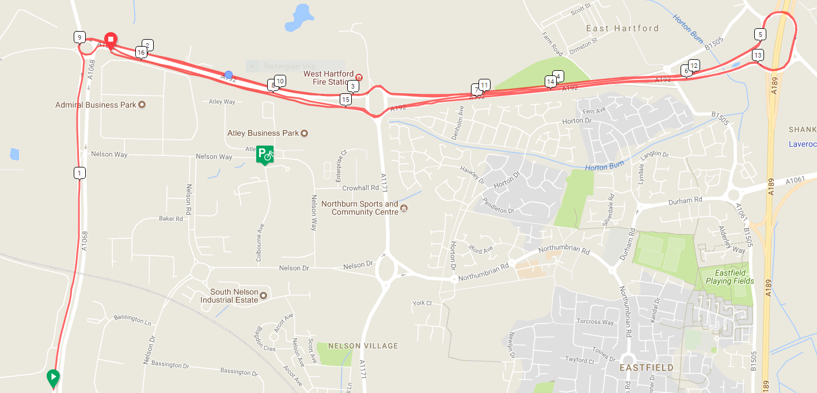

To access the start, it will be necessary to cross and ride a short section of the course. We ask all competitors heading to the start to be mindful of other competitors racing and neither impede nor assist them, whilst also being aware of other road users. We suggest that all riders heading to the start turn off at Crowhall roundabout and ride through the industrial estate (Crowhall Road and Nelson Way – for those that ride the Barnesbury Club 10’s, this is the normal route you would use to access the start). Please also note that once the last competitor has been set off for this District Heat, the normal Barnesbury Club 10 event will commence.
Notes to Riders
- All riders are responsible for their own safety.
- You must obey the rules of the road and obey all traffic signs, signage and direction indicators.
- It is your responsibility to ensure that your machine is roadworthy and that you ride safely at all times.
- You must look ahead and not ride with your head down.
- You must not take pace or shelter from any other vehicle or competitor (no drafting).
- No warming up on the course once the race has started.
- No dismounting by riders in the finishing area.
- No U turns to be made by riders in the vicinity of the timekeeper at the start.
- All competitors in this event MUST wear a hard-shell helmet that meets an internationally accepted safety standard.
- It is strongly recommended that a working rear light, either flashing or constant, is fitted to the machine in a position visible to following road users and is active whilst the machine is in use.
- In the interests of rider safety, on approach to The Three Horse Shoes roundabout, riders should remain in the near-side (left hand) lane. Once safe to enter the roundabout, riders should check behind before moving into the inside (right hand) lane on the roundabout. This is a large roundabout with five exit points – it will be heavily marshalled on the night to ensure safety and support for all competitors.
Qualifiers
The fastest three riders, the fastest girl, the fastest girl and boy in each age category, and the fastest team of 3 will automatically have a place in the National Final on Saturday 8th September, 2018, to be held near Norwich.

Number Placing

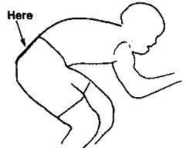

If it’s too high and we can’t see it, this may result in disqualification.

Please shout your number clearly as you pass the finishing Timekeeper.

Bib | Start | Rider | Club | Gender | Cat
1 | 18:31:00 | Grace Courtney | Ryton Tri Club | Female | Juvenile
6 | 18:36:00 | Ciaran Lally | Derwentside CC | Male | Juvenile
7 | 18:37:00 | Rebecca Wren | Racing Metro 15 | Female | Juvenile
8 | 18:38:00 | Harry Riches | North Tyneside Riders | Male | Junior
9 | 18:39:00 | Harry Courtney | Racing Metro 15 | Male | Juvenile
10 | 18:40:00 | Josh Charlton | Hetton Hawks CC | Male | Juvenile
11 | 18:41:00 | Jay Dixon | Racing Metro 15 | Male | Junior
12 | 18:42:00 | Roisin Lally | Derwentside CC | Female | Juvenile
13 | 18:43:00 | Joe Dixon | Gosforth RC | Male | Juvenile
14 | 18:44:00 | Freja Smith | Hetton Hawks CC | Female | Juvenile
15 | 18:45:00 | Matthew Wells | Tyneside Vagabonds CC | Male | Juvenile
16 | 18:46:00 | Kieron Mutch | Racing Metro 15 | Male | Juvenile
17 | 18:47:00 | Pete Watson | Barnesbury CC | Male | Juvenile
18 | 18:48:00 | Maddy Hal | Breeze Bikes RT | Female | Juvenile
19 | 18:49:00 | Connor Prior | South Shields Velo Cycling Club | Male | Juvenile
20 | 18:50:00 | Daniel Dixon | Gosforth RC | Male | Junior

