NOTES FOR COMPETITORS
Sign-on is at the Fairweather Halls, Newton Mearns (Barrhead Rd, G77 6BB) and will be open from 8:30, with the first rider off at 10:01.

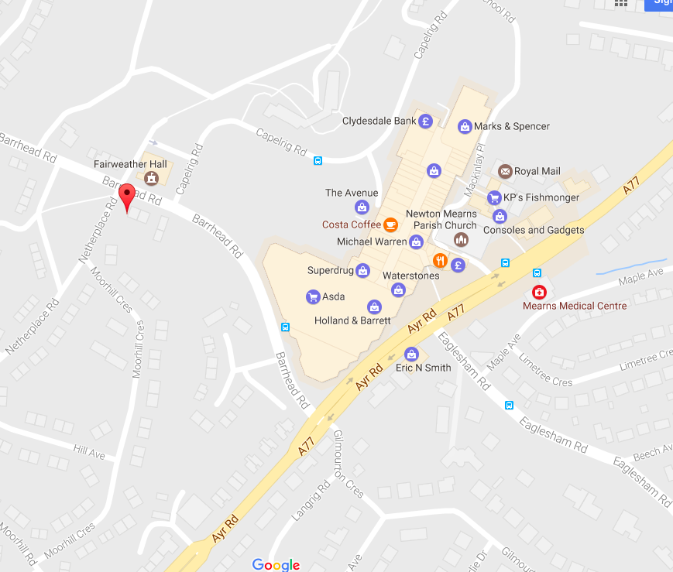

Please note parking at the halls is limited, and riders may wish to park nearer the start line, next to the India Platform Restaurant car park (340 Ayr Rd, Newton Mearns, Glasgow G77 6RT).

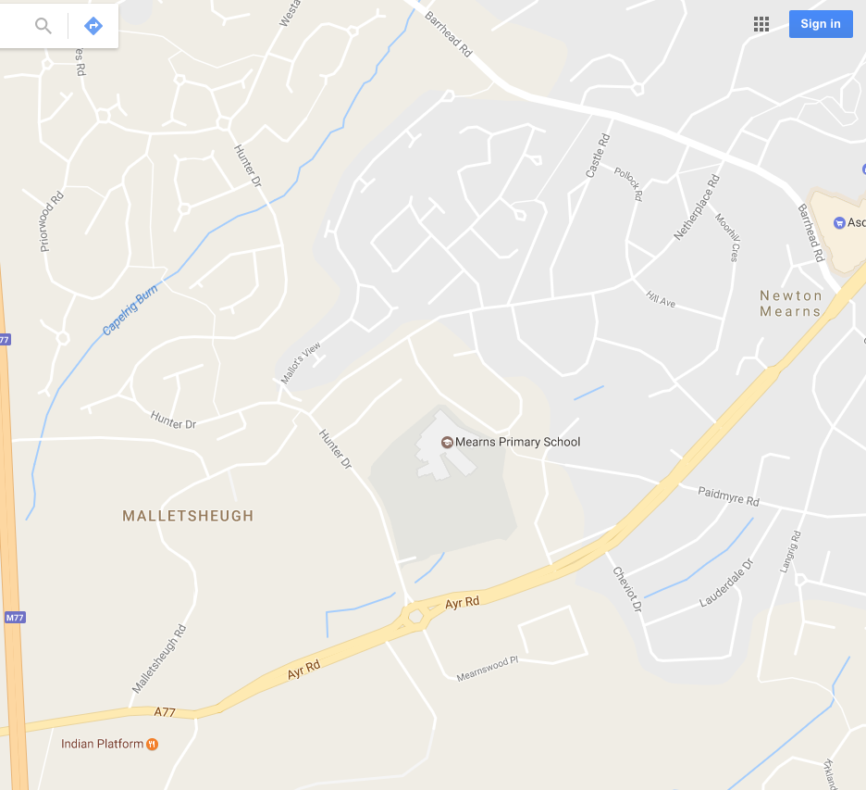
Please bring along ID to prove who you are and to leave as deposit for your number (i.e. British Cycling/ TLI / CTC or similar).

Time Keepers: Linda Smith and Another

Organiser: Chris Watters
Contact details: 07821 678771 chriswatters@btconnect.com

PRIZE LIST
1st fastest: £50 + VCGS TT Trophy
2nd fastest: £30
3rd fastest: £20
First Vet: £30
First +60: £30
1st Lady: £50
1st Lady Vet: £30
1st Tandem: £50

Prize giving around 12:00.

Note: Only one prize per person.

ROUTE
The route is an out and back, along the A77, as shown. Note the start is 1.5-mile from the sign-on, on the northside of the Greenhags recycling center (the dump). Riders should allow sufficient time to get to the start.
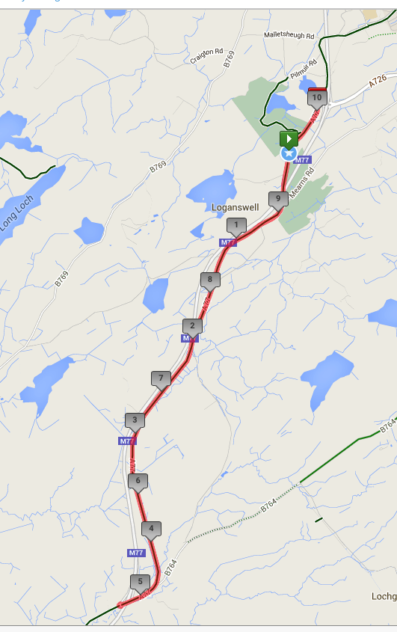

START LIST
Please find below the start list.
Race No | Start Time | First Name | Surname | Club
1 | 10:01 | Steven | Horne | Airdrie cycle club
2 | 10:02 | Iona | MacDougall | Glasgow Riderz
3 | 10:03 | Robert | Smith | Coatbridge Clarion CC
4 | 10:04 | Lewis | Keoghan | Royal Albert CC
5 | 10:05 | Michael | Semple | VC Glasgow South
6 | 10:06 | SIMON | PORTER | Walkers Cycling Club
7 | 10:07 | Janette | Hazlett | Glasgow Ivy CC
8 | 10:08 | Stephen | Stewart | Loudoun Road Club
9 | 10:09 | Joe | Hands | Velo Club Vitesse
10 | 10:10
11 | 10:11 | Sheena  Warren | Crombie Crombie | Musselburgh RCC
12 | 10:12 | Alison  Jack | Patrick  Peasgood | Walden Tri
13 | 10:13 | Gordon | Raleigh | Fullarton Wheelers
14 | 10:14 | Mike | Wood | Edinburgh Road Club
15 | 10:15 | Ruairidh | Brown | St Christopher's CC
16 | 10:16 | Deirdre | O'Reilly | Glasgow Wheelers
17 | 10:17 | Calum | Doyle | VC Glasgow South
18 | 10:18 | Matthew | Mccullagh | Edinburgh Road Club
19 | 10:19 | Jim | Sutherland | Loudoun Road Club
20 | 10:20
21 | 10:21 | Grant | Johnstone | Falkirk B C
22 | 10:22 | Scott | Gourlay | Fullarton Wheelers
23 | 10:23 | George | Skinner | Royal Albert CC
24 | 10:24 | harry | tweed | Glasgow Wheelers
25 | 10:25 | Lindsay | Foster | Hitchin Nomads CC
26 | 10:26 | Graeme | Brown | St Christopher's CC
27 | 10:27 | John | Shelley | Perth United CC
28 | 10:28 | James | Brown | Carrick CC
29 | 10:29 | hugh | wardrope | Arria Wheelers Cycling Club
30 | 10:30
31 | 10:31 | John | McKie | Ayr Roads CC
32 | 10:32 | Steven | McLean | Born to Bike - Bridgtown Cycles
33 | 10:33 | Murray | Lawson | East Kilbride Road Club
34 | 10:34 | Martin | Gordon | Coatbridge Clarion CC
35 | 10:35 | Iain | Cowden | Garstang CC
36 | 10:36 | Luke | Johnstone | Falkirk B C
37 | 10:37 | Graeme | Muir | Glasgow Wheelers
38 | 10:38 | Brian | Morrell | Dumfries CC
39 | 10:39 | Martin | Shields | Fullarton Wheelers
40 | 10:40 | Mike | Ferguson | Johnstone Wheelers
41 | 10:41 | John | Russell | Law Wheelers
42 | 10:42 | JAMES | MUIR | SVTTA
43 | 10:43 | Catherine | Logan | Fullarton Wheelers
44 | 10:44 | Steven | Grier | Loudoun Road Club
45 | 10:45 | George | Donnelly | Johnstone Wheelers
46 | 10:46
47 | 10:47 | Stephen | Dickson | Falkirk B C
48 | 10:48 | john | leonard | Velopreda
49 | 10:49 | james | truswell | Fruin Road Club
50 | 10:50 | David | Morrison | VC Glasgow South
51 | 10:51 | Stuart | Garner | Dumfries CC
52 | 10:52 | Owen | Ross | Carrick CC
53 | 10:53 | Stevie | Watters | Fullarton Wheelers
54 | 10:54 | john | johnstone | Icarus Racing
55 | 10:55
56 | 10:56 | Brian | Cameron | Lomond Roads CC
57 | 10:57 | Frazer | Bell | Fullarton Wheelers
58 | 10:58 | Stephen | Makin | Falkirk B C
59 | 10:59 | Oscar | Marletta | VC Glasgow South
60 | 11:00 | alex | mcphee | Dooleys RT
61 | 11:01 | David | Blockley | RT 23
62 | 11:02 | Jim | Barr | VC Glasgow South
63 | 11:03 | Paul | Robinson | Loudoun Road Club
64 | 11:04 | David | Pritchard | Kennoway Road Club
65 | 11:05 | Derek | Skinner | Fullarton Wheelers
66 | 11:06 | Allan | Duncan
67 | 11:07 | Timothy | Clark | Team Blanco Enduro
68 | 11:08 | Robert | Simpson | Lea Valley CC
69 | 11:09 | Brian | Nicol | Velo Club Vitesse
70 | 11:10 | Ian | King | Velocity 44
71 | 11:11 | ALAN | HOLMS | Inverclyde Velo
72 | 11:12 | Gary | Jamieson | Fechan flyers
73 | 11:13 | Kevin | Jamieson | Fechan flyers
74 | 11:14 | Gordon | Graham | Fullarton Wheelers
75 | 11:15 | Michael | Robb | Carrick CC
76 | 11:16 | Gordon | Murdoch
77 | 11:17 | William | Bonar | Velo Club Vitesse
78 | 11:18 | Paul | McLafferty | Dooleys RT
79 | 11:19 | Karl | Farmer | VC Glasgow South
80 | 11:20 | Martin | Lonie | Nuun-Sigma Sport-London RT
81 | 11:21 | David | Griffiths | Bioracer-Project GO
82 | 11:22 | Douglas | Watson | GTR - Return To Life
83 | 11:23 | John | Archibald | Ribble Pro Cycling

DOPING CONTROL
This event may be subject to a Doping Control. It is your responsibility to check.
As soon as you have finished you should return to the event HQ as it is your responsibility to check if you are required for Doping Control.
Race numbers required for Doping Control will be displayed at the HQ adjacent to the result board.
If your number is displayed, you should report immediately to Doping Control which will be nearby.
Remember, it is up to you to check and ensure that you comply. If required you must report to Doping Control after finishing without delay.

