SCCU

50 MILE TIME TRIAL

Promoted for and on behalf of Cycling Time Trials under their Rules & Regulations

Sunday 3rd June 2018
Course G50/10

Official Time Keeper:

Mike Irons, Worthing Excelsior CC

Start 06:06 am

Headquarters:
Dial Post Village Hall, Worthing Road,
Dial Post, West Sussex, RH13 8NS

Handicapped using Cycling Time Trials official tables
Veterans target times from CTT tables

Event Organiser:

Paul Tunnell, Addiscombe Cycling Club
10 Uppark Gardens, Horsham, West Sussex RH12 5JN

Home: 01403 250 847

Mobile: 07714 339 575

Email: paul.tunnell@yahoo.co.uk

General Instructions
IN CONSIDERATION OF LOCAL
RESIDENTS, NO TURBO TRAINERS ARE TO BE USED
Please park with consideration at the HQ. There is a small car park which will mainly be reserved for officials. Please park on the lane to the South of the hall on the same side of the road, as you will be finishing along this lane. Numbers will be issued at the HQ. Please sign on before collecting your number. Body numbers should be placed as low down as possible so that they face to the rear at all times, they should be pinned slightly to the left of centre. Numbers may be exchanged for a drink after the event.

Details of any additional hazards not listed on the start sheet will be displayed or advised at the Signing On point. All competitors must take note of these details when they sign on. Please don’t forget to SIGN OUT or you will be DNF.

We suggest that you allow approximately 20 minutes to ride to the start from the HQ.

No times will be given at the finish. On finishing riders should continue along the lane and take great care before returning to the Hall. No U-turns are to be made within sight of the timekeeper

In the interests of your own safety, Cycling Time Trials and the event promoters strongly advise all competitors to wear a hard shell helmet that meets internationally accepted safety standards. CTT regulations require the compulsory use of helmets for riders under 18 years old.

Competitors Machines:
It is recommended that a working rear light, either flashing or constant, is fitted to the machine in a position clearly visible to following road users and is active while the machine is in use.

This event carries a handicap competition and any improvements to times shown on entry forms, including first rides at the distance entered, (within 3 days prior to the event) must be notified to the organiser prior to the event, in accordance with CTT Regulation 13(a).

The Village Hall will be open for riders changing and toilet facilities. We have previously had complaints from local people who have witnessed sights that they shouldn’t have to – no names mentioned……..Anyone who fails to make use of the appropriate facility, and causes offence will risk disqualification.

Although we do our best to ensure the course is fully marshaled, you are reminded that the onus is on the rider to know the course, so please familiarize yourself with the course details.

2017 Winner – Mark Smith, Crawley Wheelers 1:48:24

Open awards – all riders eligible:

1st Fastest Rider £20
1st Fastest Lady £20
1st Fastest Veteran £20

SCCU Association awards:
Awarded to members of affiliated clubs and SCCU private members only

Fastest SCCU rider to hold the Vice President’s Tankard for one year and £20
2nd Fastest £15
3rd Fastest £10
Fastest SCCU Lady £20
Fastest SCCU Junior £20

Fastest SCCU team of 3 to hold the Roberts Shield for one year and £10 each

1st Handicap £20
2nd Handicap £15
3rd Handicap £10
Please contact the organiser with any improvements in your times up to 3 days prior to the event.

1st Veteran on Standard £20
2nd Veteran on Standard £15
3rd Veteran on Standard £10

Fastest qualifying SCCU rider (N) will hold the Tacagni Cup for one year and £20.

# To qualify for the Tacagni Cup, riders must not have ridden a 50-mile time trial during the current or past three seasons.

Eligible riders - using available information are marked with * in the rider listings. Please contact the organiser if you were eligible but have subsequently ridden a 50-mile time trial prior to the event.

Riders without a handicap (N/A) did not have any previous times on their entry forms, or are ineligible because their club is not affiliated to the SCCU.
START ORDER
Start Time | No | N  # | Name | MF | Cat | Club | Vet Target Time | H’cap  Allowance | Time
06:06 | 6 |  | Robert Royle-Evatt | Male | V | Addiscombe CC | 02:14:30 | 00:30:47
06:07 | 7 | N | Alexandra Dix | Female | S | Crystal Palace  Triathletes |  | N/A
06:08 | 8 | # | Elliott Dickenson | Male | V | Kingston Phoenix RC | 02:12:33 | N/A
06:09 | 9 |  | Robin Johnson | Male | V | Brighton Mitre CC | 02:35:43 | 00:52:14
06:10 | 10 |  | Adrian Blacker | Male | V | Norwood Paragon CC | 02:18:30 | 00:14:10
06:11 | 11 | N | Leena Peltonen | Female | S | Crystal Palace  Triathletes |  | N/A
06:12 | 12 | # | Jonathan Mayne | Male | V | Twickenham CC | 02:08:43 | 00:28:00
06:13 | 13 |  | Mike Morley | Male | V | Kingston Phoenix RC | 02:42:42 | 00:37:20
06:14 | 14 |  | Helen Webb | Female | V | Sussex Nomads CC | 02:08:43 | 00:35:28
06:15 | 15 |  | Robert Rollings | Male | S | Lewes Wanderers CC |  | 00:13:27
06:16 | 16 | N | Lizzy Brama | Female | S | Crystal Palace  Triathletes |  | 00:23:20
06:17 | 17 | N | Jane Wiley | Female | V | 7 Oaks Tri | 02:24:43 | 00:31:03
06:18 | 18 |  | Daniel Arthur | Male | V | Epsom CC | 02:15:29 | 00:28:00
06:19 | 19 | N | Matt Lawes | Male | S | Crystal Palace  Triathletes |  | N/A
06:20 | 20 |  | Dale Lush | Male | S | Kingston Phoenix RC | 02:14:30 | 00:10:35

N in the 3rd column indicates non-SCCU riders, target time in red, and # indicates eligibility for the Tacagni Cup.

Start Time | No | N  # | Name | MF | Cat | Club | Vet Target Time | H’cap  Allowance | Time
06:21 | 21 | N | Daniel Sharp | Male | V | Charlotteville  Cycling Club | 02:09:40 | 00:28:00
06:22 | 22 |  | Keith Butler | Male | V | Bec CC | 02:20:32 | 00:20:32
06:23 | 23 |  | John Marinko | Male | V | Brighton Mitre CC | 02:17:29 | 00:19:38
06:24 | 24 | # | Lorenzo Casasanta | Male | S | Crawley Wheelers |  | 00:23:20
06:25 | 25 | N | Steven Kane | Male | S | Team ASL |  | 00:10:20
06:26 | 26 |  | James Cheeseman | Male | S | Crawley Wheelers |  | 00:29:46
06:27 | 27 | N | Ian Neville | Male | V | Clarence Wheelers CC | 02:20:32 | 00:20:35
06:28 | 28 |  | Simon Trehearn | Male | V | Kingston Phoenix RC | 02:08:43 | 00:20:08
06:29 | 29 | N | Michael Sanderson | Male | S | Clapham Chasers |  | N/A
06:30 | 30 |  | Mark Emsley | Male | S | Crawley Wheelers |  | 00:09:35
06:31 | 31 |  | Andrew R Green | Male | V | Bec CC | 02:07:47 | 00:20:42
06:32 | 32 |  | Jason Blenkarn | Male | S | Sussex Nomads CC |  | 00:23:26
06:33 | 33 | # | Phil Gall | Male | V | Epsom CC | 02:12:33 | 00:28:00
06:34 | 34 | N | Martin Shoesmith | Male | V | Mid Sussex Triathlon Club | 02:17:29 | 00:29:24
06:35 | 35 |  | Dominic Hill | Male | V | Bec CC | 02:08:43 | 00:09:34

N in the 3rd column indicates non-SCCU riders, target times in red and # indicates eligibility for the Tacagni Cup.

Start Time | No | N  # | Name | MF | Cat | Club | Vet  Target Time | H’cap  Allowance | Time
06:36 | 36 |  | Mark Gower | Male | V | South Downs Bikes / Casco Europe | 02:06:51 | 00:20:54
06:37 | 37 |  | James Stone | Male | V | Brighton Excelsior CC | 02:13:31 | 00:11:29
06:38 | 38 |  | Ben Fielden | Male | V | GS Stella | 02:42:42 | 00:24:31
06:39 | 39 |  | Mark Penfold | Male | V | Crawley Wheelers | 02:16:29 | 00:30:04
06:40 | 40 | N | David Shepherd | Male | V | ...a3crg | 02:21:34 | 00:07:30
06:41 | 41 | N | Jamie Freeland | Male | V | South London Harriers | 02:09:40 | 00:28:56
06:42 | 42 | # | Iain Duncan | Male | V | Crawley Wheelers | 02:10:37 | 00:20:32
06:43 | 43 |  | Gavin Hughes | Male | V | Kingston Phoenix RC | 02:15:29 | 00:25:52
06:44 | 44 |  | Peter Davies | Male | V | Brighton Mitre CC | 02:25:47 | 00:24:16
06:45 | 45 | N | Pete Morris | Male | S | Team ASL |  | 00:03:51
06:46 | 46 | # | Tony Truepenny-Phillipson | Male | S | Bec CC |  | 00:20:32
06:47 | 47 |  | Andy Tedd | Male | V | South Downs Bikes / Casco Europe | 02:14:30 | 00:17:58
06:48 | 48 |  | Shaun Marlor | Male | V | Bec CC | 02:09:40 | 00:25:08
06:49 | 49 | N | John Glaysher | Male | V | ...a3crg | 02:05:00 | 00:17:54
06:50 | 50 |  | Matt Peel | Male | S | C and N Cycles RT |  | 00:03:34

N in the 3rd column indicates non-SCCU riders, target times in red and # indicates eligibility for the Tacagni Cup.

Start Time | No | N  # | Name | MF | Cat | Club | Vet  Target Time | H’cap  Allowance | Time
06:51 | 51 |  | Chris Jones | Male | V | Elite Cycling | 02:08:43 | 00:17:29
06:52 | 52 | N | Michael Parker | Male | V | TMG Horizon  Cycling Team | 02:17:29 | 00:14:00
06:53 | 53 |  | Kevin Plummer | Male | V | South Downs Bikes / Casco Europe | 02:16:29 | 00:17:14
06:54 | 54 |  | Tom Houghton | Male | V | Brighton Excelsior CC | 02:10:37 | 00:20:32
06:55 | 55 | N | Alex Napier | Male | V | Racing Club Ravenna | 02:08:43 | 0:01:47
06:56 | 56 |  | Paul Batten | Male | S | Crawley Wheelers |  | 00:14:56
06:57 | 57 |  | Ian Cheesman | Male | V | Worthing Excelsior CC | 02:13:31 | 00:16:34
06:58 | 58 |  | Donald Parker | Male | V | Brighton Mitre CC | 02:34:35 | 00:19:22
06:59 | 59 |  | Jim Burdett | Male | V | Addiscombe CC | 02:13:31 | 00:17:35
07:00 | 60 |  | Mark Smith | Male | V | Crawley Wheelers | 02:08:43 | 00:02:19

N in the 3rd column indicates non-SCCU riders, and # indicates eligibility for the Tacagni Cup.

Competitors are requested not to warm up on the course after the first competitor has started.

IMPORTANT NOTE:
There are 2 sets of pedestrian crossing lights in Cowfold, which MUST be obeyed.

Competitors must exercise extra care when negotiating all roundabouts.

The course will be signed and marshalled, but the onus is on the rider to
know where the course goes, especially at the two mini roundabouts
at Cowfold.

Please note London South District regulations: No vehicles except the timekeeper shall be parked on the highway within sight of the starting or finishing points.

Course Map : G50/10
HQ: Dial Post Village Hall, Worthing Road, Dial Post West Sussex RH13 8NS

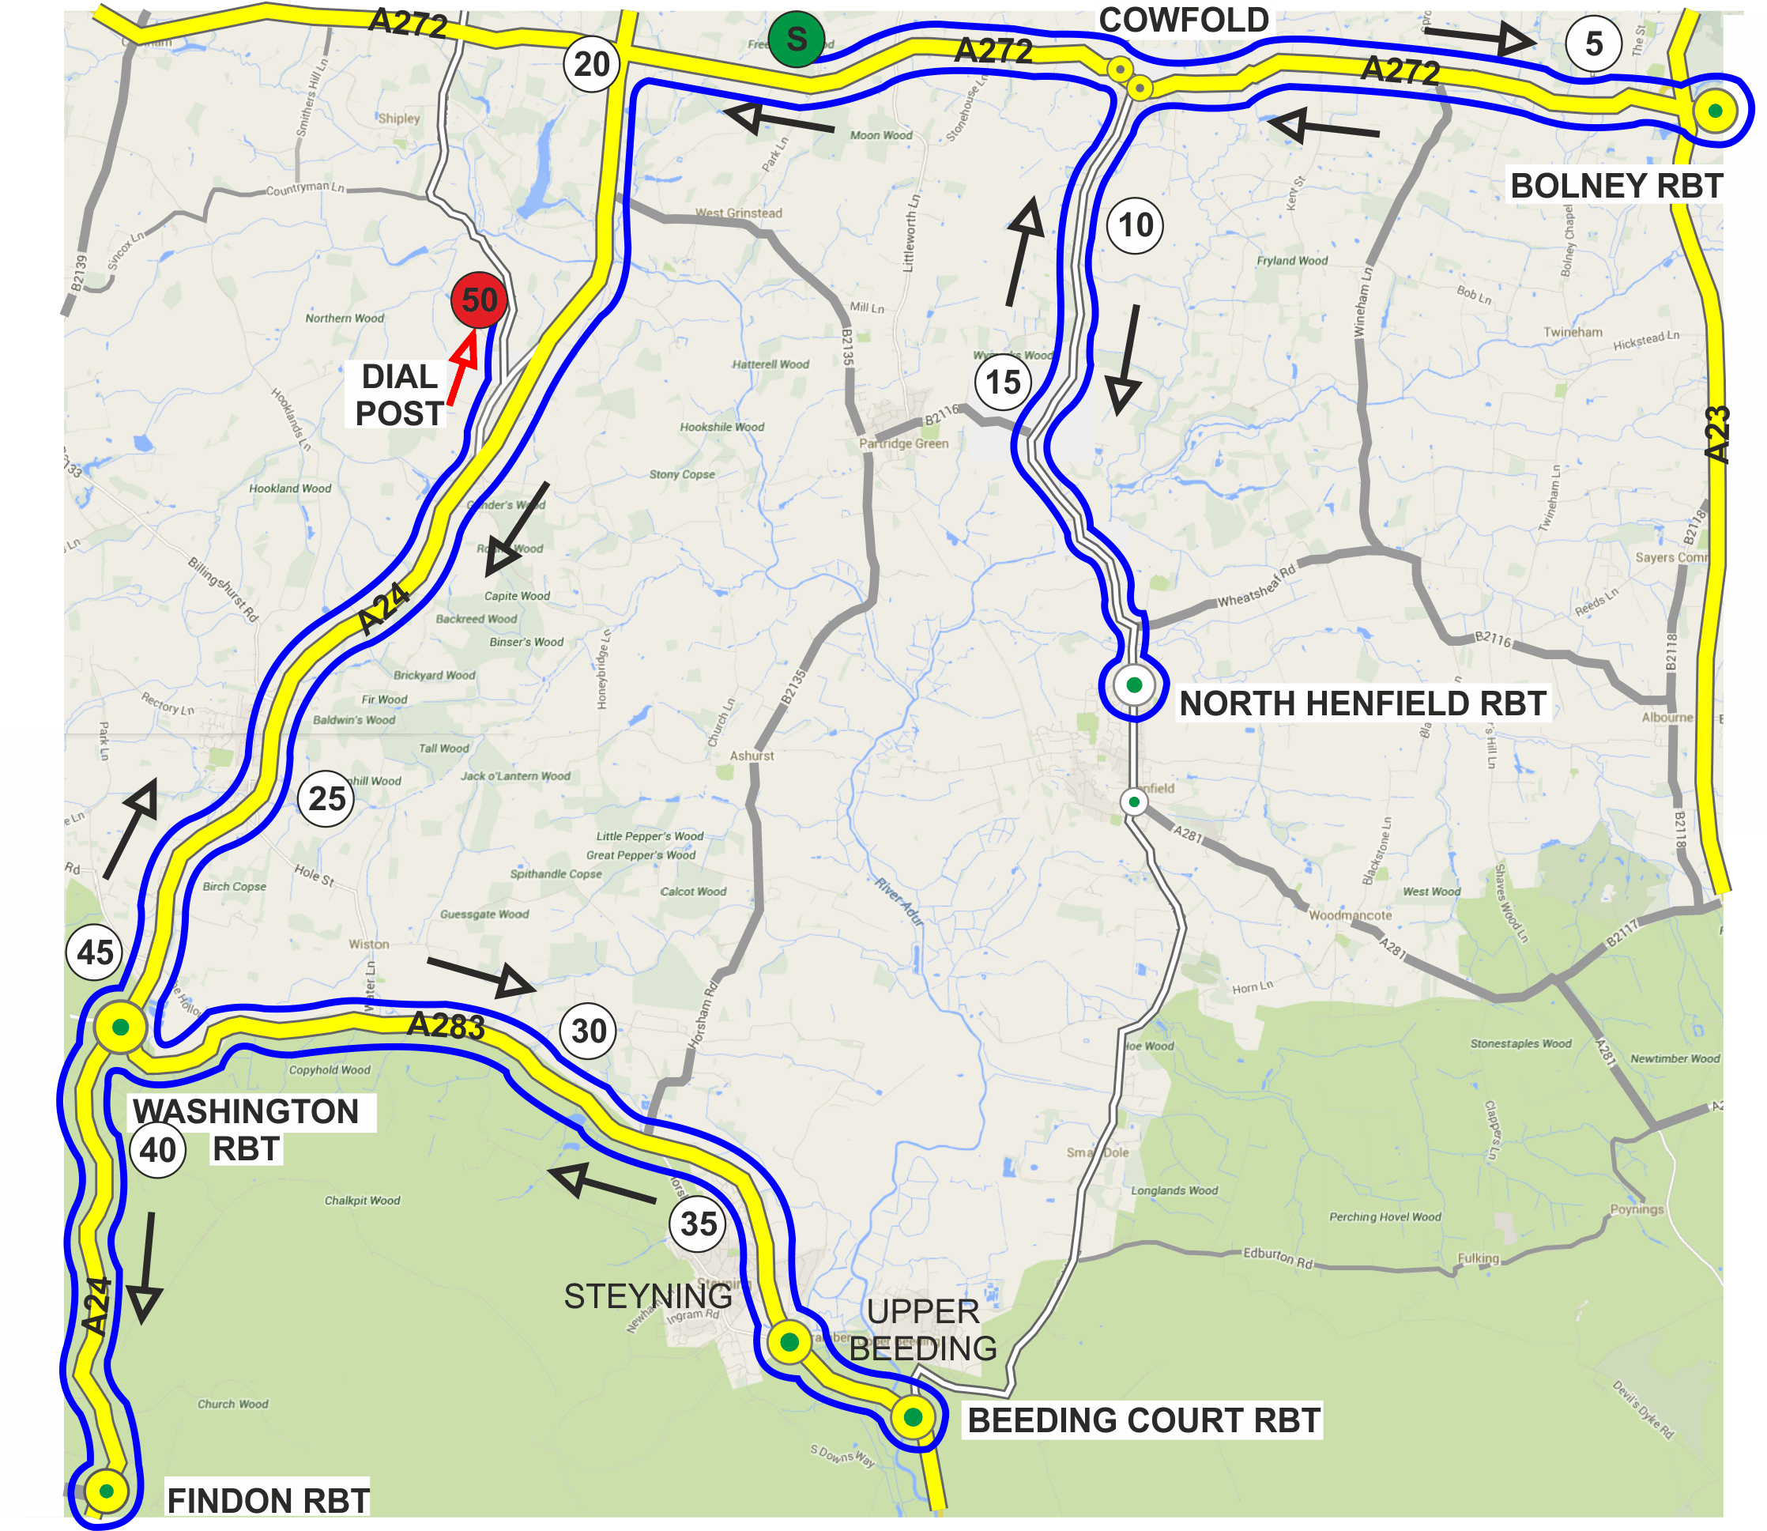
HQ

- Please do not warm up on the course once the first rider has started.
- Please take care at all roundabouts

Heads up, accidents down. Ride safely and enjoy the event.

Course Details

CTT LONDON SOUTH DC - 50 MILE COURSE - G50/10

West Grinstead / Bolney / North Henfield / West Grinstead /Washington / Beeding Court / Washington / Findon / Washington / Dial Post – A272/A281/A24/A283

Ordnance Survey Grid Reference # | DETAILS | Distances  Interim Cumulative
182225 | START on A272 at raised manhole cover on grass verge approximately 50 yards West of entrance to the Orchard at West Grinstead. | 0.00 | 0.00
267224 | Proceed East to twin roundabouts (RBTs) at Cowfold. RIGHT 2nd exit at first LEFT 1st exit at second. Continue on A272 to Bolney RBT where TURN (CHECK) 3rd exit to retrace to twin RBTs at Cowfold. | 5.49 | 5.49
215167 | LEFT 1st exit at first RBT and follow A281 to North Henfield RBT where TURN (CHECK) 3rd exit to retrace to twin RBTs at Cowfold. | 7.44 | 12.93
165227 | Straight on 1st exit at first RBT LEFT 1st exit at second and follow A272 to West Grinstead crossroads | 7.14 | 20.07
120134 | LEFT in filter lane to join A24 and proceed South to Washington RBT | 6.69 | 26.76
197098 | LEFT 1st exit and follow A283 to Bramber Castle RBT. Straight on 3rd exit to Beeding Court RBT where TURN (CHECK) 3rd exit to retrace to Bramber Castle RBT | 6.09 | 32.85
120134 | 3rd exit and continue on A283 to Washington RBT | 6.14 | 38.99
119089 | LEFT 1st exit and follow A24 to Findon RBT where TURN (CHECK) 4th exit to retrace to Washington RBT. Straight on 2nd exit and follow A24 to turn LEFT at Southern entrance to Dial Post Village. LEFT into Swallows Lane to | 2.95 | 41.94
155202 | FINISH at tree on Western side of farm gate opposite PP12150 past entrance to Swallows Farm | 8.06 | 50.00

# Use OS Landranger Map 198 Brighton and Lewes

SOUTHERN COUNTIES CYCLING UNION

Riders are reminded that sleeveless cycling tops are not allowed under CTT rules, but are acceptable when worn with an undervest that does have short sleeves.

Riders without a handicap allowance did not supply a time on their entry forms to calculate from, or are not SCCU members.

N in the 3rd column indicates non-SCCU riders

# indicates eligibility for the Tacagni Cup
(not previously ridden a 50 mile time trial during current and past 3 seasons)

Good Luck to everyone for a safe and enjoyable ride.

Paul

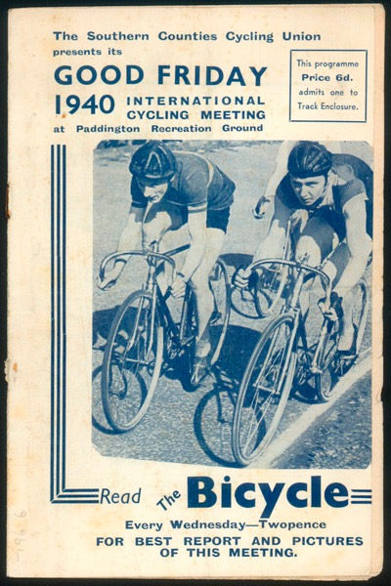

Heads Up, Accidents Down!
V1.1 24 May 2018

