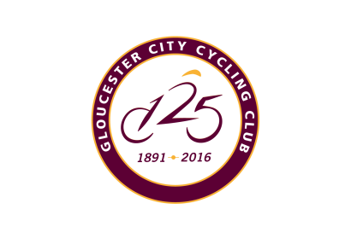
Gloucester City Cycling Club
Open 10 TT – U7B
Sat June 9th 2018 start time 9:01am
Dear Friends/Colleagues/Racers
Thank you for all your help on Saturday June 9th, I hope the event is a success. I would like to thank you all in advance for your help, without your support, these events cannot go ahead so I appreciate everyone for taking part.
There is a field of 31 riders this year, which is good, 7 of these are Glos City riders.
I will be at the HQ Falfield Village Hall from around 7:30am
It is on the A38, the address is Falfield, Wotton-under-Edge GL12 8DH
If you decide to bring a cake donation please pass it on to Medina Witts at the HQ. Listed below are the names of all the helpers, if I have missed anyone off, please let me know.
Many thanks
Simon Witts
simonwitts@blueyonder.co.uk Home: 01452540187 Mobile: 07795200117

Timekeepers: Mike & Shelia Edwards, Malcom Grainger
Traffic count Marshal: Mike Clements
Pusher Off & Results Phone in: Jamie Woodward
Slimbridge Roundabout: Ted Tedaldi and Roy Hook
Falfield Village Hall Results Board : Alastair Goldie
Kitchen : Medina & Jessica Witts

