Northampton & District CA (TT series 4 of 10) Litchborough NC19 19 Mile Time Trial

Organised on behalf of the N&DCA by Baines Racing

To take place on 19th May 2018. First rider off at 14:00
Promoted for and on behalf of Cycling Time Trials under their rules and regulations.
This is a counting event for all categories of the Time Trial Series Championships.

Event Secretary: Race Head Quarters:
Pierre Scrase Litchborough Village Hall
The Old Latin House 9 Towcester Road
Market Hill Litchborough
Buckingham Towcester
MK18 1JX NN12 8JA
Approved time Keepers
Sue Holliday (A5 Rangers CC) – sue_isis@yahoo.com
Gordon Hart - glhart34@gmail.com
CTT Observer
Joe Gardias

The full description of the course
Course Identification: NC19
19 Miles – Litchborough/Canons Ashby/Culworth/Canons Ashby/Litchborough
START At east end farm gateway approx. 100 yards west of junction of Banbury lane and Litchborough Road, Grimscote (Grid Ref SP659534)
Proceed westwards to
TURN Left, sign posted ‘Maidford, Adstone’. (1.5 miles) after 0.4 miles
TURN Left, also signposted ‘Maidford, Adstone’. (1.9 miles) Continue through Maidford, Adstone, Canons Ashby, and, Morton Pinkney to junction at Magpie Farm between Sulgrave and Thorpe Mandeville. (10.5 miles)
TURN Clockwise round first green triangle at junction and retrace through Morton Pinkney, Canons Ashby, Adstone, and, Maidford to
FINISH Approx 10 yards before ‘Reduce Speed’ sign approaching sharp left hand bend just prior to Litchborough village sign (19 Miles)

Course Record: Matthew Bottrill drag2zero.com 40.12

No parking on any part of the course.

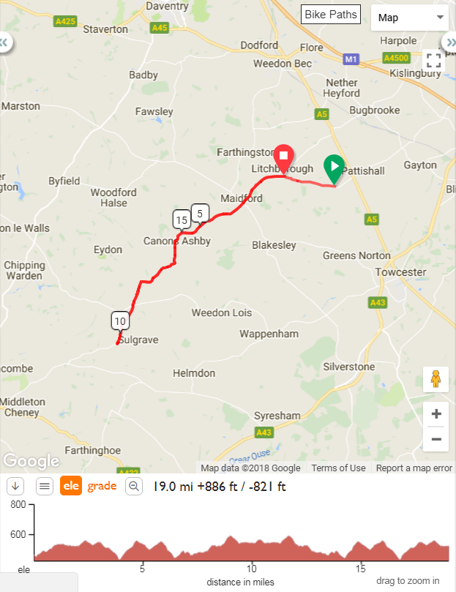
Any applicable local regulations
Sign On:
Race numbers as well as sign on and sign in will be open from 12:30 at the race HQ Litchborough Village Hall
Prizes
Prize  Values | Fastest | Lady | Junior / Juvenile | Masters X  (born 1959-1968) | Masters Y  (born 1949-1958) | Masters Z  (born 1948 or earlier) | Team  of 3
1st | £15 | £9 | £9 | £9 | £9 | £9 | £18
2nd | £12 | £7 | £7 | £7 | £7 | £7 | £15
3rd | £10 | £6 | £6 | £6 | £6 | £6 | -
4th | £9 | - | - | - | - | - | -
5th | £8 | - | - | - | - | - | -
6th | £7

Northampton & District Cycling Association affiliated clubs

45 Road Club  A5 Rangers Cycling Club  Bedfordshire Road Cycling Club  Bonito Squadra Corse  Cycle Club Ashwell  Fenland Clarion Cycling Club  I Cycle  Icknield Road Club  Kettering Cycling Club | Kings Cliffe Flyers  Lutterworth Cycle Centre RT  North Bucks Road Club  Peterborough Cycling Club  Ratae Road Club  Rockingham Forest Wheelers  St Ives Cycling Club  Team Milton Keynes  Team Salesengine.co.uk
St Neots Cycling Club Baines Racing Silverstone Cycles
Welland Valley CC JCA Equipe Velo
VeloElite RC

N&DCA Category Allocation

All N&DCA categories used in competitions are based on the year a competitor was born. The following table should enable you to determine the correct category to allocate to each rider.

Category Allocation Table for 2018

Year Born | Category | Indicator | Additional Indicator
2002 or later | Juvenile (must be at least 12 on day of event) | Juv
2000 to 2001 | Junior | Jun
1969 to 1999 | Senior | S
1959 to 1968 | Masters X | X | Year of birth
1949 to 1958 | Masters Y | Y | Year of birth
1948 & earlier | Masters Z | Z | Year of birth
 | All Female Riders (Women) |  | W
 | Association Club |  | (A)

For up to date N&DCA news, including the latest points tables, visit our web site http://www.northamptondca.org.uk
“IN THE INTERESTS OF YOUR OWN SAFETY Cycling Time Trials and the event promoters strongly advise you to wear a HARD SHELL HELMET that meets an internationally accepted safety standard. In accordance with Regulation 15, ALL JUNIOR and JUVENILE competitors must wear Protective Hard Shell Helmets. It is recommended that a working rear light either flashing or constant, is fitted to the machine in a position visible to following road users and is active while the machine is in use.”
The names, numbers and clubs of the competitors in their starting order.
Please use the first name and surname of each rider and Indicate if the Club is affiliated to the N&DCA using the letter “A” against the club name. For info a list of N&DCA clubs is shown below
The riders Category - see info below to determine correct category
Competitors:
Bib | Start Time | Firstname | Lastname | Club | Category | Indicator | Age On Day
1 | 14:01:00 | Edward | Smith | Baines Racing | Veteran | X | 54
2 | 14:02:00 | Richard | Pratt | Icknield RC | Veteran | X | 59
3 | 14:03:00 | Peter | Nix | Rockingham Forest Whs | Veteran | Y | 65
4 | 14:04:00 | Simon | Hunt | 45 RC | Veteran |  | 47
5 | 14:05:00 | Phil | Rayner | Welland Valley CC | Veteran | X | 53
6 | 14:06:00 | David | Cook | Bedfordshire Road RT | Veteran | Y | 62
7 | 14:07:00 | Emma | Koppe | CC Ashwell | Veteran |  | 40
8 | 14:08:00 | andrew | vaughan | Bonito Squadra Corse | Veteran |  | 48
9 | 14:09:00 | Michael | Harvey | Rockingham Forest Whs | Veteran | Z | 71
10 | 14:10:00 | Jon | Simpkins | DRAG2ZERO | Veteran |  | 47
11 | 14:11:00 | Paul | Welsby | DRAG2ZERO | Veteran | X | 51
12 | 14:12:00 | Warren | Drew | Rapha Cycling Club | Veteran |  | 48
13 | 14:13:00 | stuart | Field | CC Ashwell | Veteran | X | 53
14 | 14:14:00 | simon | pidduck | Peterborough CC | Veteran | X | 52
15 | 14:15:00 | Malcolm | Smith | Peterborough CC | Veteran | X | 54
16 | 14:16:00 | James | Stewart | QN Coaching | Veteran | X | 58
17 | 14:17:00 | Richard | Glover | CC Ashwell | Veteran | Z | 78
18 | 14:18:00 | Dave | Bailey | QN Coaching | Veteran |  | 45
19 | 14:19:00 | David | Battersby | VTTA (Surrey & Sussex) | Veteran | Z | 71
20 | 14:20:00 | James | Richardson | North Bucks RC | Senior |  | 25
21 | 14:21:00 | Mark | Greenhow | St Neots CC | Veteran | X | 50
22 | 14:22:00 | James | McKenzie | CC Ashwell | Veteran | Y | 64
23 | 14:23:00 | Trevor | Parrish | A5 Rangers CC | Veteran | Z | 73
24 | 14:24:00 | Martin | Webb | Icknield RC | Veteran | Y | 62
25 | 14:25:00 | Jamie | Murray | Velo Club Rutland | Senior |  | 39
26 | 14:26:00 | stuart | short | QN Coaching | Veteran | X | 52
27 | 14:27:00 | pete | trotman | A5 Rangers CC | Veteran | Y | 64
28 | 14:28:00 | julius | reeeves | CC London | Veteran | X | 49
29 | 14:29:00 | Graham | Bickle | Kings Cliffe Flyers | Veteran | Y | 60
30 | 14:30:00 | Andrew | Green | Team Jewson - MI Racing ~Poly Pipe~McCann | Veteran |  | 40
31 | 14:31:00 | Jackie | Field | CC Ashwell | Veteran | X | 53
32 | 14:32:00 | Dave | Wentworth | Team Salesengine.co.uk | Veteran | Y | 64
33 | 14:33:00 | Linda | Hubbard | Welland Valley CC | Veteran | X | 52
34 | 14:34:00 | iain | macfarlane | Bonito Squadra Corse | Veteran | X | 53
35 | 14:35:00 | Simon | Pitchford | Fenland Clarion CC | Veteran | X | 52
36 | 14:36:00 | Sam | McDonald | St Neots CC | Senior |  | 28
37 | 14:37:00 | Bill | Barrie | Welland Valley CC | Veteran | Z | 72
38 | 14:38:00 | james | BILLINGHAM | Kings Cliffe Flyers | Veteran | X | 55
39 | 14:39:00 | Philip | Jones | Peterborough CC | Veteran | Y | 59
40 | 14:40:00 | Paul | Pardoe | Peterborough CC | Senior |  | 37
41 | 14:41:00 | Paul | Beattie | Rockingham Forest Whs | Veteran |  | 41
42 | 14:42:00 | Ali | Moult | Lutterworth Cycle Centre Racing Team | Senior |  | 31
43 | 14:43:00 | Steve | Maile | Fenland Clarion CC | Senior |  | 33
44 | 14:44:00 | Elaine | Maitland | Bonito Squadra Corse | Veteran |  | 47
45 | 14:45:00 | James | Beechey | Shutt Ridley RT | Senior |  | 28
46 | 14:46:00 | Graham | Martin | A5 Rangers CC | Veteran |  | 44
47 | 14:47:00 | Ian | Waddilove | Fenland Clarion CC | Veteran | Y | 62
48 | 14:48:00 | jack | Pinchin | QN Coaching | Junior |  | 16
49 | 14:49:00 | JOHN | DAINTY | Rockingham Forest Whs | Veteran | Y | 66
50 | 14:50:00 | David | Langlands | Team Bottrill / Vanguard | Veteran | X | 52
51 | 14:51:00 | Richard | Moys | Fenland Clarion CC | Senior |  | 30
52 | 14:52:00 | Ian | Ellis | A5 Rangers CC | Veteran | X | 51
53 | 14:53:00 | Stewart | Wilson | QN Coaching | Veteran | X | 50
54 | 14:54:00 | Trystan | Barnett | 45 RC | Juvenile |  | 15
55 | 14:55:00 | Mark | Avil | QN Coaching | Veteran | X | 57
56 | 14:56:00 | David | Lindsay | St Neots CC | Senior |  | 37
57 | 14:57:00 | Sarah | Short | QN Coaching | Veteran | X | 54
58 | 14:58:00 | David | Morgan | Icknield RC | Veteran |  | 42
59 | 14:59:00 | Maria | Gent | Kettering CC | Espoir |  | 19
60 | 15:00:00 | Brett | Harwood | Team Bottrill / Vanguard | Veteran |  | 41

Notes to Riders:
- The start is approx. 2 miles from the event headquarters by the most direct route. Riders are advised to allow enough time to reach the start.

- Riders are reminded to ride at all times safely and in accordance with the Highway Code. The onus is on the rider to stay on course. Please read the course description carefully. Take care through Moreton Pinkney, there are a series of sharp bends through the village and the possibility of parked cars. Please be aware of the sharp left hand bend shortly after the finish. Northampton Police stress that all competitors are made aware of the need for good behaviour and consideration towards other road users and local residents in order to avoid any complaints being received.

- In the interests of your own safety, Cycling Time Trials & the event promoters strongly advise you to wear a hard shell helmet which meets International safety standards. In accordance with Regulation 15 all junior & juvenile competitors must wear Protective Hard Shell Helmets. It is recommended that a working rear light, either flashing or constant, is fitted to your machine in a position visible to following road users and is active while the machine is in use.

- Numbers will be available at the event headquarters where you should remember to sign on.

- Toilet facilities are provided in the event headquarters and should be used. The event headquarters will be open from 12.30 pm.

- Parking: There is limited parking at the headquarters. Please park considerately on Northampton Road. DO NOT park in Manor Farm Close. If parking close to the start area, please park sensibly on the road between Cold Higham and the Foxley crossroads.

- Any rider performing a U-turn within sight of the start or finish may be disqualified. (Regulation 38)

- Etiquette: Please do not warm up on the course after the event has started. Please avoid riding past the timekeeper unless racing.

