VTTA South Wales “The Gordon Butler Memorial 10 Mile Time Trial”
Promoted for and on behalf of Cycling Time Trials under their Rules and Regulations
2pm, Saturday 12th of May 2018
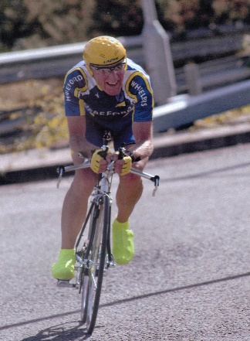 | “In memory of Gordon Butler 1935 – 2012.  A great competitor and diligent official for VTTA South Wales, who was sadly killed while on a training ride near his home in Hay on Wye, by a hit and run motorist.”

Promoter – Barry Williams, Hon Secretary VTTA South Wales
Address: 34 Millbrook Road, Dinas Powys, Vale of Glam, CF64 4DA
Email:- bazspeed@gmail.com :- Mobile 07833786132
Time keepers: Finishing, Robin Field, Assistant, Frances Field, starting, Phillys Harradine
Tea, Coffee & Cakes – Reg Pharaoh
Event Headquarters: Llanarth Village Hall, Raglan NP15 2AU
Situated I mile north of the old Abergavenny/Raglan road to the west of Clytha Hill.
Signing on sheets together with BIB numbers will be available from 1.00pm. Any competitor not returning BIB number or not signing off, will be recorded as DNF
Complimentary drinks, result board and prize presentation, all to be conducted at this venue.
To avoid a late start, competitors should allow at least 35 minutes between leaving the headquarters and reaching the start point on the A40.

The Course R10/17
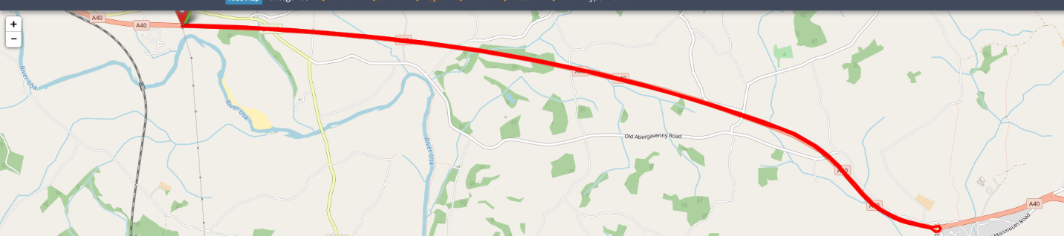
R10/17 OS References: Sheet 161 - Start and finish 333100 Start at 1st drain cover in 3rd lay-by east of Hardwick rbt, Abergavenny, on A40, 25 yards east of Kilo post 97 and 400 yards east of bridge over road. Proceed on A40 to Raglan rbt (4.94 miles) and turn by circling rbt and retrace on A40 to finish at road joint 136 at western end of lay-by opposite start. District Regulation: No cars connected with riders are to travel on the A40 during the event. Competitors observed crossing the dual carriageway will be disqualified.
Safe Riding.
Competitors under the age of 18 and juniors must wear an international standard protective hard or soft shell helmet, other competitors are also recommended to use an international standard hard shell helmet. For additional safety, it is recommended that all competitors fit a rear flashing light. Take extra care at the Raglan roundabout turn – no accidents – please!

Any Accidents or Complaints must be reported to the organiser within 72 hours of the event

Awards and Prizes

The Two –Up Event – 2pm

- Fastest two man team £25 each
- Fastest male/female team £15 each
- Fastest male/junior team £15 each
- Fastest male/juvenile £15 each

The Solo Event - 2.30pm

Veterans & Senior Male 1st £30, 2nd £20 3rd £15
Espoirs 1st £20 (under 23 years on the day)
Juniors 1st £20 (under 18 years on the day)
Female 1st £20

Age Standard prizes open to men and women (VTTA members only)

1st £35 2nd £25 3rd £20 4th £15

Non-Aero Event

Fastest Male £15, Fastest Female, £15

At the conclusion, we will endeavour to present these prizes as soon as possible.

VTTA South Wales Start Times for The 2UP Team Event
2:00pm Saturday May 12th 2018
Number, Start, Team, Club

1 | 2:01:00 | Thomas | Harrington | Abergavenny RC
2 |  | Sam | Hay | Cwmcarn Paragon Road Club
3 | 2:03:00 | Paul | Hayward | Pontypool Road Cycling Club
4 |  | Carwyn | Davies | Cwmcarn Paragon Road Club
5 | 2:05:00 | Louis | Hay | Newport Phoenix CC
6 |  | Aled | Roberts | Newport Phoenix CC
7 | 2:07:00 | Andy | Davies | Cardiff Jif
8 |  | Andy | Hoskins | Cardiff Jif
9 | 2:09:00 | Justin | Harrington | Abergavenny RC
10 |  | Edward | Hay | Newport Phoenix CC
11 | 2:11:00 | Laura | Airey | Ross on Wye & Dist CC
12 |  | Jon | Airey | Ross on Wye & Dist CC
13 | 2:13:00 | Jeremy | Pile | Team Echelon
14 |  | Jon | Howard | Team Echelon
15 | 2:15:00 | Calum | Cheshire | Cardiff Ajax CC
16 |  | David | Regan | Cardiff Ajax CC
17 | 2:17:00 | Paul | Rees | Bynea Cycling Club
18 |  | Brad | Davies | Bynea Cycling Club
19 | 2:19:00 | Philip | Sims | Newport Phoenix CC
20 |  | Robbie | Morgan | Newport Phoenix CC

