THE WELLAND TROPHY OPEN TIME TRIAL

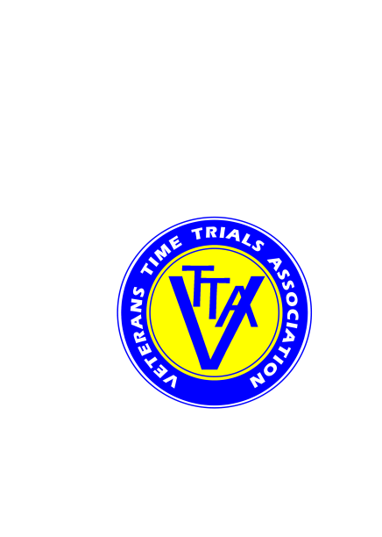

Supported by *ECHELON* Cycles, 124 High St, Pershore  WR10 1EA  01386 550606

(PROMOTED FOR AND ON BEHALF OF CYCLING TIME TRIALS UNDER THEIR RULES AND REGULATIONS)

SATURDAY 7 APRIL 2018, COURSE K47/16, WELLAND

RESULTS / PRIZES

EVENT ORGANISERS:

Michael Amery, 18 Giffard Drive, Welland, Worcestershire WR13 6SE Tel: 01684 310168 mike[amery58@gmail.](mailto:amery58@gmail.)com

Alan Colburn, The Willows, Jury Lane, Martley  WR6 6PE Tel: 01886 888575 / 0755 428 4607 alan.colburn@martley.org

TIMEKEEPERS:

Mrs Susan Kelly and Mr Charlie Barnett

PRIZES: NB These are the prizes as awarded, following the ‘one prize per rider, except team’ rule. Full results are on the pdf file.

Fastest Men on Actual Time:

Richard Oakes, Team Jewson MI Racing 35:18

Timothy Ashton, Royal Sutton CC 35:20

Mark Corbett, Worcester St Johns CC 35:25

Fastest Women on Actual Time:

Emma Bexson, Stratford CC 42:56

Jennifer Doyle, Kenilworth Whls 43:21

Veterans on VTTA Standard:

Jon Howard, Team Echelon 7:11

John Simpkins, Drag2Zero 7:08

Chris Davis, Giant CC Halo Films 7:01

Leon Field, CC Giro 6:41

Jonathan Griffin, Radeon Cycology RT 6:06

Road Bikes on Actual Time:

Andrew Legge, Bristol South CC 41:18

Mark Wise, Team Jewson MI Racing 41:33

Fastest 2-up on VTTA Standard:

Richard Shimmel, CC Giro ) 36:59

Carl Bullingham, B’ham Run & Tri Club )

TEAM PRIZE - THE WELLAND TROPHY - LVRC

Richard Oakes

Chris Davis

Mark Corbett

Leon Field

Jonathan Griffin

Steven Buckley, Ride 24/7

Thanks to all rides who took part, to our timekeepers, marshals, and other helpers, and our sponsor Echelon Cycles.

We hope you enjoyed this fourth joint LVRC–VTTA event in the Worcestershire countryside.

Congratulations to the winning LVRC team members (the aggregated team times are at the foot of the pdf).