
Promoted for and on behalf of Cycling Time Trials under their rules and regulations

Ogmore Valley Wheelers

Present the Carl Roach Memorial 25 Mile Time Trial

Sunday 22nd April 2018 starting at 08:41hrs on the R25/3H (Revised) course

Headquarters – Hirwaun Village Hall
High Street, Hirwaun, CF44 9SL
The headquarters will be open from 07:00hrs.

This event is subject to doping control.
Parking is limited, so please park considerately.
Please note that no turbo is to be used within 100 meters of nearby houses; there are
several lay-by's between the Hirwaun roundabout and the A4061 Rhigos Road.
Please be mindful that this course may be under threat due to riders urinating in public.

Awards List
Men | Women | Veteran
Fastest rider - £50 | Fastest rider - £50 | Fastest Vet on Std - £30
2nd Fastest - £30 | 2nd Fastest - £30 | 2nd Vet on Std - £20
3rd Fastest - £20 | 3rd Fastest - £20 | 3rd Vet on Std - £10
Fastest Junior - £20 | Fastest Tandem - £20 | Team of 3 Riders - £20 each

Strictly one prize per rider (except team)

Start Timekeeper
Tudor Thomas – Bynea CC

Finish Timekeepers
Robin Field – Cardiff Byways CC
Norman James – Ogmore Valley Wheelers

Event Secretary:
Terry Anthony, 15 Parklands, Corntown, Bridgend, Vale of Glamorgan, CF35 5BE
Tel: 01656 656955 or 07432 618535
Any complaints regarding the event must be made in writing to the Event Secretary with 72 hours.

Contact Numbers on the day:
Terry Anthony – 07432 618535
Steven Madeley – 07834 431258
Andy Harries – 07504 436270
Course Description - R25/3H (Revised)

START on access road to Hirwaun Industrial Estate (E 293120/ N206180 OS Sheets 170/160) 8 yards north of lamp column No.1 and 30 yards north of junction with unclassified road (old A465) Hirwaun to Cefn Rhigos. | 0.000
Proceed south to junction with unclassified road (on to the old route) and bear left to roundabout with A4061 (Rhigos mountain road) where take second exit(straight on) to Hirwaun roundabout A465 to take first exit | 1.306
Continue along A465 to Blaengwrach roundabout (McDonalds) to take second exit (straight on). | 7.169
Continue on A465 to Resolven roundabout to take third exit (straight on) | 10.183
Continue on A465 to exit at next junction (signpost Seven Sisters), climbing to the Tonna roundabout, where take first exit to Aberdulais Interchange where circle roundabout and take fourth exit down slip road to re-join the A465 eastward. | 15.063
Continue along A465 to Resolven roundabout to take second exit (straight on) | 19.719
Continue on A465 to Blaengwrach roundabout (McDonalds). | 22.764
Take second exit continuing on A465, passing over river bridge and the Glynneath interchange to REMAIN ON A465 to FINISH in the SECOND layby on the left at a point 25 yards west of the ‘Take Litter Home’ sign and opposite the emergency telephone point | 25.014
Note - From the finish continue on the A465 up the Neath bank to return to the HQ

THE TURN
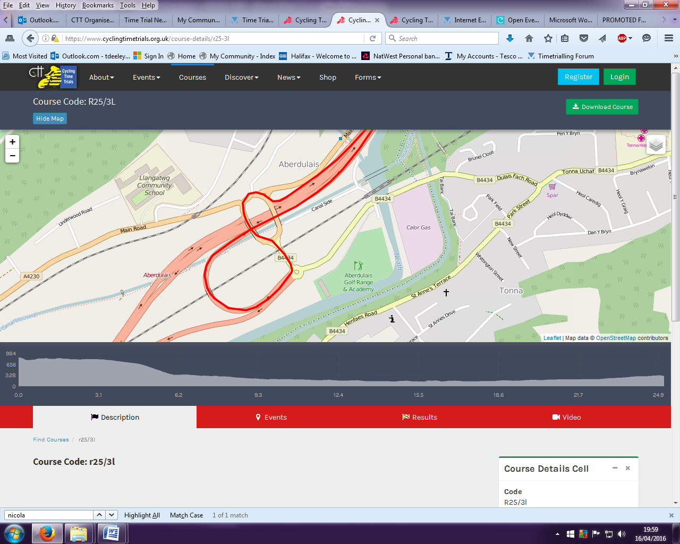
All riders are asked to comply with the following requests.
- Please remember to sign on and look for any updated safety information.
- All competitors must at all times obey the rules of the road and the rules of our sport.
- Please do not take unnecessary risks.
- In the interests of your own safety, Cycling Time Trials and the event promoters strongly advise you to wear a Hard Shell Helmet that meets an internationally accepted standard. All competitors under the age of 18 and/or JUNIORS must wear a HELMET of HARD/SOFT SHELL that conforms to a recognised standard (see Regulation 15).
- It is strongly recommended that a working rear light, either flashing or constant, is fitted to the machine, in a position visible to following road users and is active whilst the machine is in use.
- Prior to starting, competitors must not ride past the finish timekeeper during the duration of the event.
- Riders must not warm up on the course once the event has started
- Any competitor making a U-turn in the vicinity of the start or finish will be disqualified from the event.
- Do call your number to the finishing timekeeper.
- After completing their ride, all riders please return their event number and must sign the Signing-out sheet.
- Do keep your head up, be aware of your surroundings and HAVE A SAFE RIDE.

Please return your event number in exchange for a free cuppa after you finish.

