Addiscombe Cycling Club
Open 25 mile Time Trial
For the E.V. Mills Trophy
(Promoted for and on behalf of Cycling Time Trials under their Rules and Regulations)
Also forming round 3 of the London Womens Racing TT League
Sunday April 22nd April – Course G25/46
HQ: Beare Green Village Hall, Merebank, Beare Green, Surrey, RH5 4RD
Promoter: Jonathan Pontin, 6 Hurst Way, South Croydon, CR2 7AP
Tel: 07732674317
email: jonathanpontin@hotmail.co.uk
Timekeepers: Mick Irons, Paul Tunnell
Please Note:
- The HQ is in a residential area, please keep noise to a minimum
- It is each competitors responsibility to know the course, marshals are on hand to direct you where possible but as this is a resurrection of a rarely used course we may have some teething problems.
Remember: You must now sign out of the race when you hand your number back at the HQ. Failure to do so will result in disqualification.

Course Details:
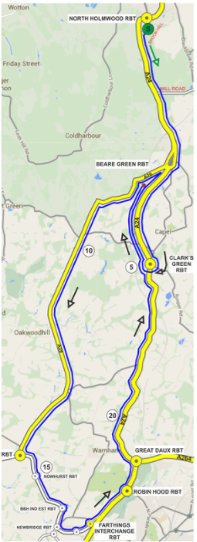
G25/54 Start in spooks hill, north holmwood, 25 yds north of po telephone cover and 55yds from junction with a24 0.00 0.00 left and follow a24 south to beare green rbt 2.67 2.67 straight on 2nd exit and follow a24 to clark’s green rbt where turn 2.24 4.91 5 th exit to retrace on a24 to beare green rbt 2.24 7.15 left 1st exit and follow a29 through ockley to clemsford rbt 7.38 14.53 left 1st exit and follow a281 via nowhurst rbt to broadbridge heath ind est.rbt right 2nd exit on a281 to newbridge rbt. straight on 2nd exit and follow a264 via leisure centre rbt to farthings hill interchange 2.69 17.22 left 2nd exit follow a24 via robin hood rbt to great daux rbt 1.58 18.80 left 1st exit and follow a24 via kingsfold to clark’s green rbt 4.39 23.19 straight on to finish on capel by-pass at a paint mark 20 yards before end of continuous white finishing just before southern edge of entrance to wigmore lane 1.81 25.00

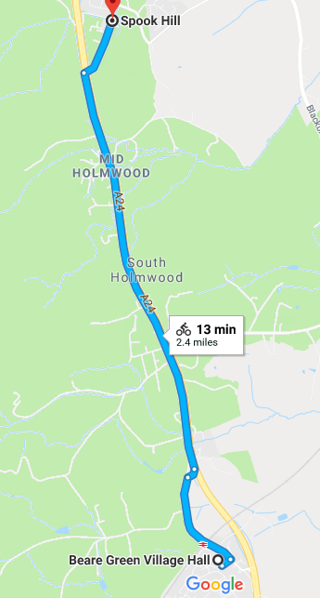
Route from HQ to Start

It is just under 3 miles from the HQ to the start, please leave plenty of time to complete this journey

Local Regulations

(1) It is a London South District Regulation that no vehicles, except those of the timekeepers and event officials, shall be parked in the vicinity of the start and finish areas.

Safety Instructions
- Competitors are requested not to warm up on the course after the first competitor has started.
- Details of any additional hazards not listed on the start sheet will be displayed or advised at the Signing On point. All competitors must take note of these details when they sign on.
- Competitors must exercise extra care when negotiating all roundabouts.
- No times will be given at the finish.
- CTT regulations require the compulsory use of helmets for the under 18’s. In the interests of your own safety, Cycling Time Trials and the event promoters strongly advise all competitors to wear a hard/soft shell helmet that meets internationally accepted safety standards.
- Competitor’s machines: it is recommended that a working rear light, either flashing or constant, is fitted to the machine in a position clearly visible to following road users and is active while the machine is in use.
HEADS UP, RIDE SAFELY!
Prizes
Scratch: 1st £40 2nd £20 3rd £10
Women: 1st £40 2nd £20 3rd £10
Team £10 each
- The scratch winner will also receive two tickets to the club dinner where the trophy will be awarded.
Notes on prizes:
- One prize per rider except for the Team prize the highest value prize being paid.
- A Team is the fastest 3 riders from a single club / team.
- Any prizes not awarded on the day will be sent out with the results sheet.

Startsheet:
Bib Number | Name | Club | Category | Start Time
10 | Katrina Murphy | Dulwich Paragon CC | SW29 | 00:07:10
11 | Reinet Maas | London Women's Racing CC | SW39 | 00:07:11
12 | Katia Hadaschik | Dulwich Paragon CC | VW46 | 00:07:12
13 | MJ (gosia) Cyganowska | Rapha Cycling Club | SW39 | 00:07:13
14 | Lucy Francis | London Dynamo | VW49 | 00:07:14
15 | Rebecca Waters | Vision Innovative Leisure Racing Team | SW22 | 00:07:15
16 | Fiona Inskip | Boot Out Breast Cancer Cycling Club | VW42 | 00:07:16
17 | Caroline Reuter | London Phoenix CC | VW42 | 00:07:17
18 | Lisa Price | London Women's Racing CC | VW48 | 00:07:18
19 | Rosamund Bradbury | Sigma Sports | SW29 | 00:07:19
20 | Robyn Yates | Addiscombe CC | VW55 | 00:07:20
21 | Angela Radden-Rutt | The Cycleroom | SW38 | 00:07:21
22 | Anna Harborow | Brixton Cycles Club | SW30 | 00:07:22
23 | Kathryn Innes | Dulwich Paragon CC | SW39 | 00:07:23
24 | Elise Sherwell | Look Mum No Hands! | VW42 | 00:07:24
25 | Jacintha Hamilton-Love | Dulwich Paragon CC | SW33 | 00:07:25
26 | Damien Breen | Brixton Cycles Club | S37 | 00:07:26
27 | Paul Hunter | Addiscombe CC | S27 | 00:07:27
28 | Jan Schnitker | Charlotteville Cycling Club | S25 | 00:07:28
29 | Simon Pontin | Addiscombe CC | S21 | 00:07:29
30 | Ben Elliott | Paceline RT | S35 | 00:07:30
31 | Peter Owen | Norwood Paragon CC | V57 | 00:07:31
32 | Jamie Freeland | South London Harriers | V45 | 00:07:32
33 | Phil Gall | Epsom CC | V47 | 00:07:33
34 | Richard Allan | South Western Road Club/Evans Cycles | V58 | 00:07:34
35 | Martin Winter | Twickenham CC | V53 | 00:07:35
36 | Tim Moody | Addiscombe CC | S24 | 00:07:36
37 | michael gates | Maison du Velo - Storck Bikes UK | S34 | 00:07:37
38 | ANTHONY BROWN | Horsham Cycling | V62 | 00:07:38
39 | Mark Ellis | Addiscombe CC | S31 | 00:07:39
40 | Philip Murrell | Finsbury Park CC | V48 | 00:07:40
41 | Jonathan Pontin | Addiscombe CC | S27 | 00:07:41
42 | Andrew R Green | Bec CC | V43 | 00:07:42
43 | Daniel Sharp | Charlotteville Cycling Club | V45 | 00:07:43
44 | Neal Marrin | Finsbury Park CC | V48 | 00:07:44
45 | Mark Valios | Bigfoot CC | V44 | 00:07:45
46 | Greg Hunt | RT 316 | V52 | 00:07:46
47 | Matthew Hammond | Dulwich Paragon CC | V41 | 00:07:47
48 | Neil Crowther | Worthing Excelsior CC | V44 | 00:07:48
49 | Jon Fry | Horsham Cycling | V47 | 00:07:49
50 | James Wright | Charlotteville Cycling Club | V45 | 00:07:50
51 | Paolo NISTRI | Albarosa CC | V43 | 00:07:51
52 | Paul Sewell | Bigfoot CC | V40 | 00:07:52
53 | Martin Headon | Dulwich Paragon CC | S39 | 00:07:53
54 | Adam Stone | North Road CC | S37 | 00:07:54
55 | Jon Puleston-Jones | Dulwich Paragon CC | V46 | 00:07:55
56 | malcolm davies | Dulwich Paragon CC | V43 | 00:07:56
57 | David Churchill | Bigfoot CC | V59 | 00:07:57
58 | Robert Taylor | Army Cycling Union | S36 | 00:07:58
59 | Paul Haywood | Epsom CC | V43 | 00:07:59
60 | stephen williamson | ...a3crg | V46 | 00:08:00

