VC10 – 10 mile Time Trial

Start Sheet Under C.T.T. Regulations

Monday 29th August 2016 Start time 12:00 Course F11/10

A promotion by London North District Committee

Contacts: Vince Freeley Richard Moule
13 The Orchard 59 Old Farm
Winchmore Hill Pitstone
London Beds
020 8340 9780 01296 662657

Timekeepers:- Mr G.A.Hart, Icknield RC. And ano

Event HQ : Aston Clinton School, Twitchell Lane, Aston Clinton, Bucks, HP22 5JJ ( open from 11am.

Course Details are: F11/10 (Tring & Aston Clinton by-passes)
Start on southbound sliproad to A41 on the Western Tring junction approx 40 yards from the start of the sliproad. Proceed along A41 to come off at first sliproad (Eastern Tring junction) to
Turn (approx 2.0 miles) by taking 4th exit out of RAB and under the A41, going around 2nd RAB to take 2nd exit back onto the A41 westbound and continue past all junctions to RAB at end of Aston Clinton by-pass to
Turn (7.87 miles) by taking 3rd exit out of RAB back along the by-pass, again ignoring College Road junction to
Finish on Buckland sliproad 9 yards south-east of manhole cover on grass verge, about 91 yards nth-west of (i.e. before) separation of slip road and main carriageway, also about 460 yards nth-west of the B489 overbridge.
Every effort will be made to have marshals at points where there is a change of direction, however the onus is on the rider to know the course. There may not be any refreshments at the HQ, but within 500 metres of the HQ there are two coffee shops/Cafes, should you need a drink.

The finish of the course is in the slip road. All riders must pass within 2.5 metres of the white line de-marking the left edge of the carriageway of the slip road. Failure to do this will lead to a DNF. If you impede a vehicle you risk disqualification

There must be no parking of motor vehicles on any part of the A41 apart from those of the officials. All parking must be in the HQ car park. Do NOT obstruct other road users or driveways outside the school.

You must sign on in advance of your start at the headquarters where you can pick up your number and receive any last minute instructions or warnings. Please return number with all pins after you have ridden. DO NOT fold numbers at all. DO NOT use sticky tape (or other sticking methods) to secure the numbers to your clothing.

Please keep your head up at all times. At roundabouts the traffic coming from the right has priority over you, so please give way. In particular the first one at the bottom of the off sliproad does not have good line of sight for traffic coming from the right so please take great care here. Be prepared to stop if need be.

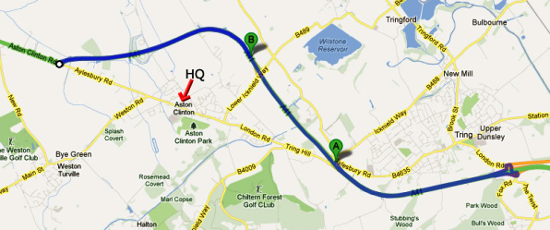

Please be aware that the first 2 miles does have a number of potholes (mainly caused by the older surface expansion joins failing) so look well ahead at all times. There are a few more after the first turn for the next 2 miles. However the remaining 6 miles are very good.

HQ to start route (blue route A to B) – please note that almost half of this is uphill so allow at least 15 minutes to get to the start from the HQ

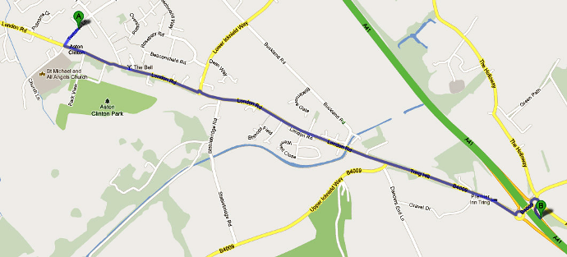

Awards to be confirmed.

London North Regulations
LOCAL REGULATION No. 1.
No U turns should be made in sight of the start or finish areas while riding on the public highway.

LOCAL REGULATION No. 2.
Competitors, their helpers and event officials must use the toilet facilities provided at event headquarters as required. Fields and hedgerows must NOT be used for toilet purposes. Failure to observe this regulation may result in disciplinary action against those concerned.

LOCAL REGULATION No. 3.
No cars other than that of the timekeeper(s) and other event officials are to be parked in the vicinity of the start or finish points.

