Promoted for and on behalf of Cycling Time Trials under their Rules and Regulations

Birdwell Wheelers

Founded 1949

3rd Wentworth Castle Gardens Hill Climb

Sunday 4th Sept 2016

Event Secretary – Paul Heggie 10 Wellfield Road S75 2AL
Mobile on day of event: 07960 704822
Timekeepers: Philip Minto , John Clarke

Course – OHC13

Course description: Start on the private access entrance road to Wentworth Castle visitor

car-park in Stainborough village at line

of stones across the road at the side of the

Strafford Arms PH. Proceed up the hill,

crossing two cattle grids, to finish at the

line of stones across the road 20 metres

below car-park ‘controlled’ entrance. 670yds

Headquarters: The headquarters is the visitors centre Postcode S75 3EN

Directions can be found here http://www.wentworthcastle.org/directions/

Parking, numbers and signing on at the HQ

Awards Fastest overall £30 2nd £20 3rd £10
Fastest woman £30 2nd £20 3rd £10

The fastest overall to hold the Upperthorpe Rose Bowl for one year.

Local Regulations
No Warming up on the course once the event has started
No Parking by anyone connected with the event or turbo trainers in the car park of the Stainborough Arms. Clamping is in operation. There is plenty of parking at the visitors centre after the finish line.

In the interest of your own safety, the CTT and the event promoters strongly advise you to wear a hard shell Helmet that meets an internationally accepted safety Standard.
Regulation 15 requires all riders of 18 years and under to wear a suitable Helmet.
All riders under 18 must submit a signed parental consent form

Cyclists that have registered to ride in either of the hill climbs can present their start sheet/number at the admissions desk to get discounted garden admission on the day of the hill climb. The cafe and Garden will be open till 7.30pm.
Presentation of prizes will be at Long Barn Visitor Centre after the Climbs have finished.
This event is one of the qualifying rounds of the JE James Hill Climb series for North Midlands District clubs’ riders

The website is a home for all the series event details, as well as updates on the current standings as the events progress. http://northmidlandstimetrialseries.org/
Birdwell Wheelers website: www.birdwellwheelers.org

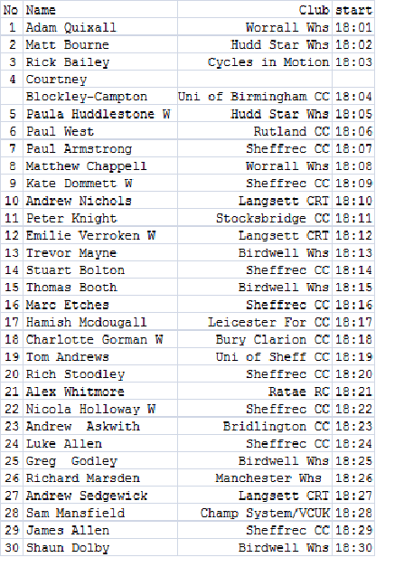

NB The Gardens are offering a year’s season pass to the first rider who records a time under 1 minute !!

