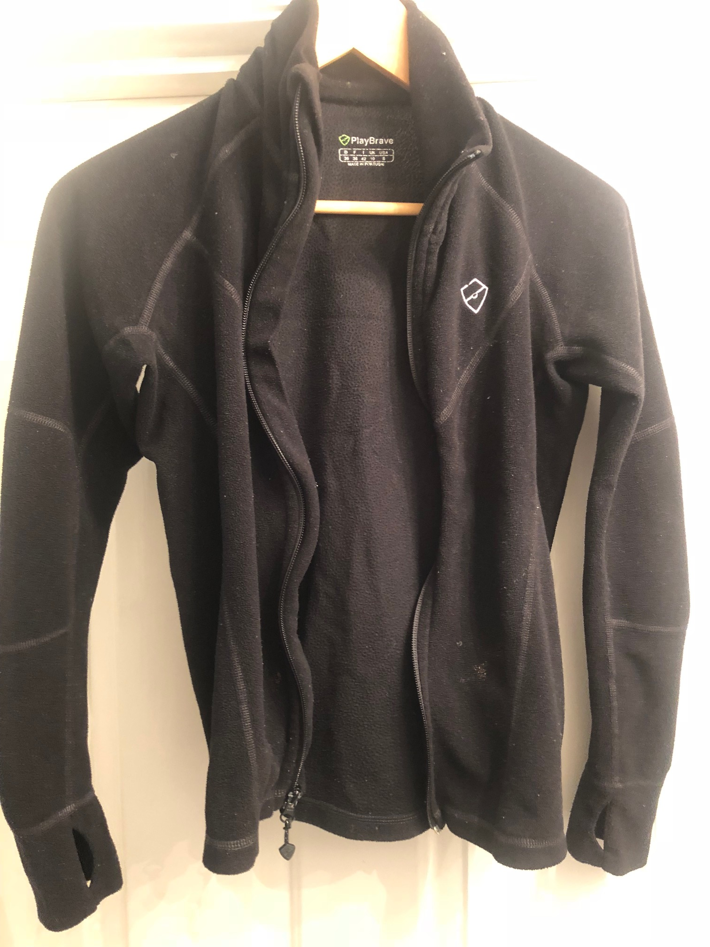 | 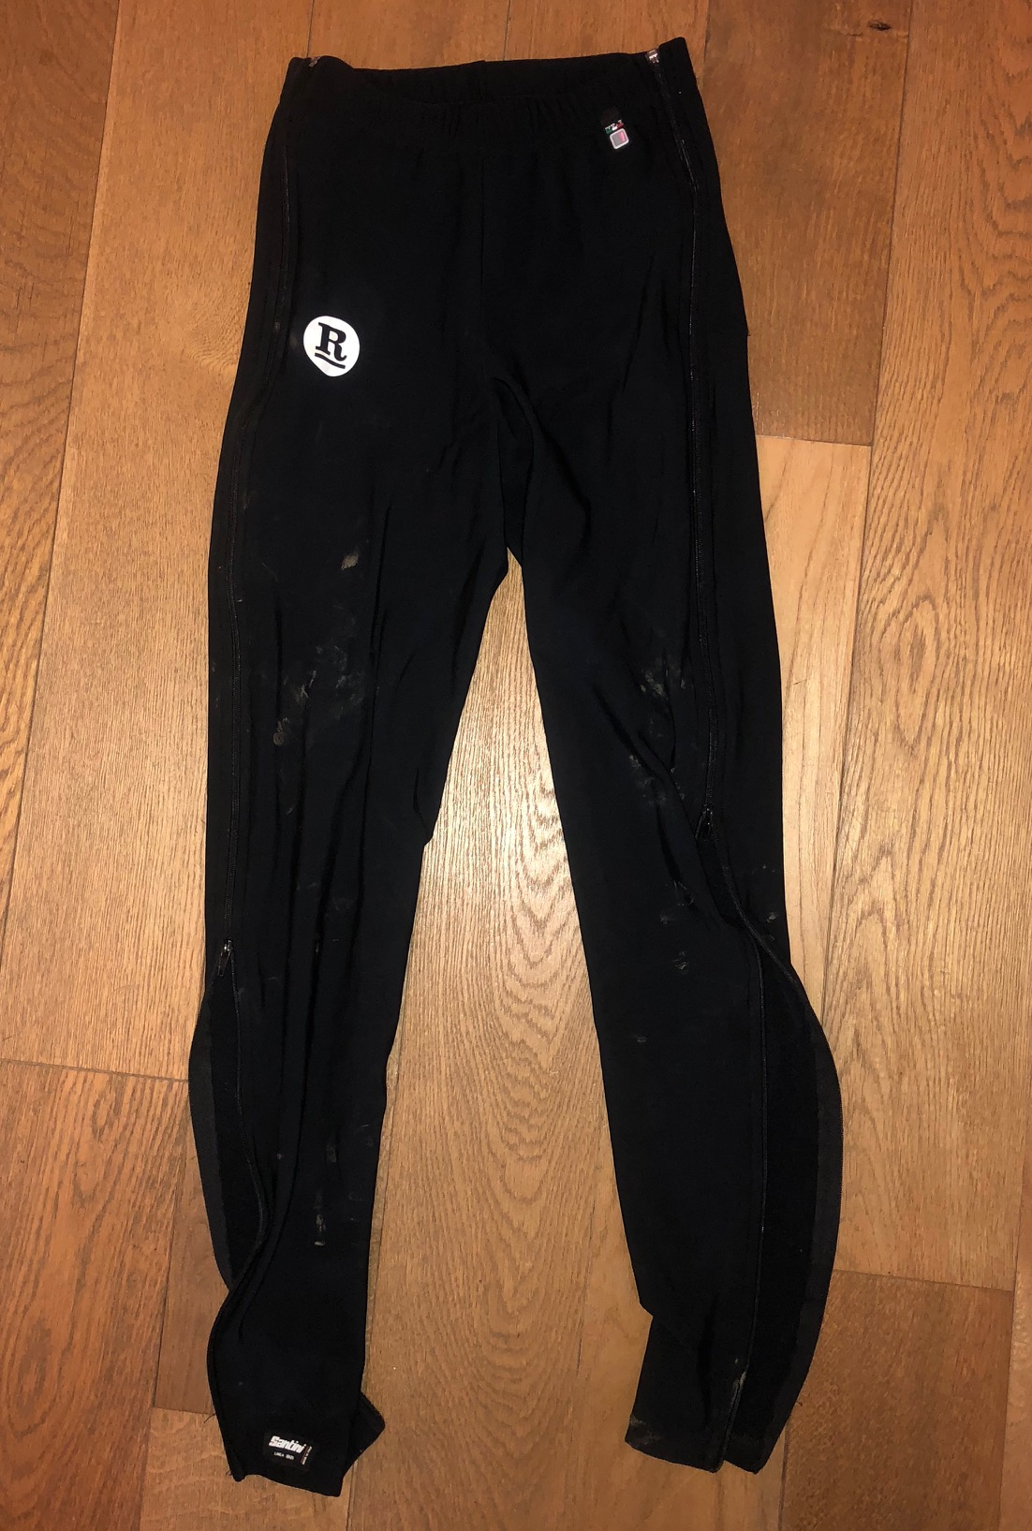
PlayBrave Ladies, Size 10 Runner’s Fleece | Santini Size Small warm up bottoms (fully zipped sides)
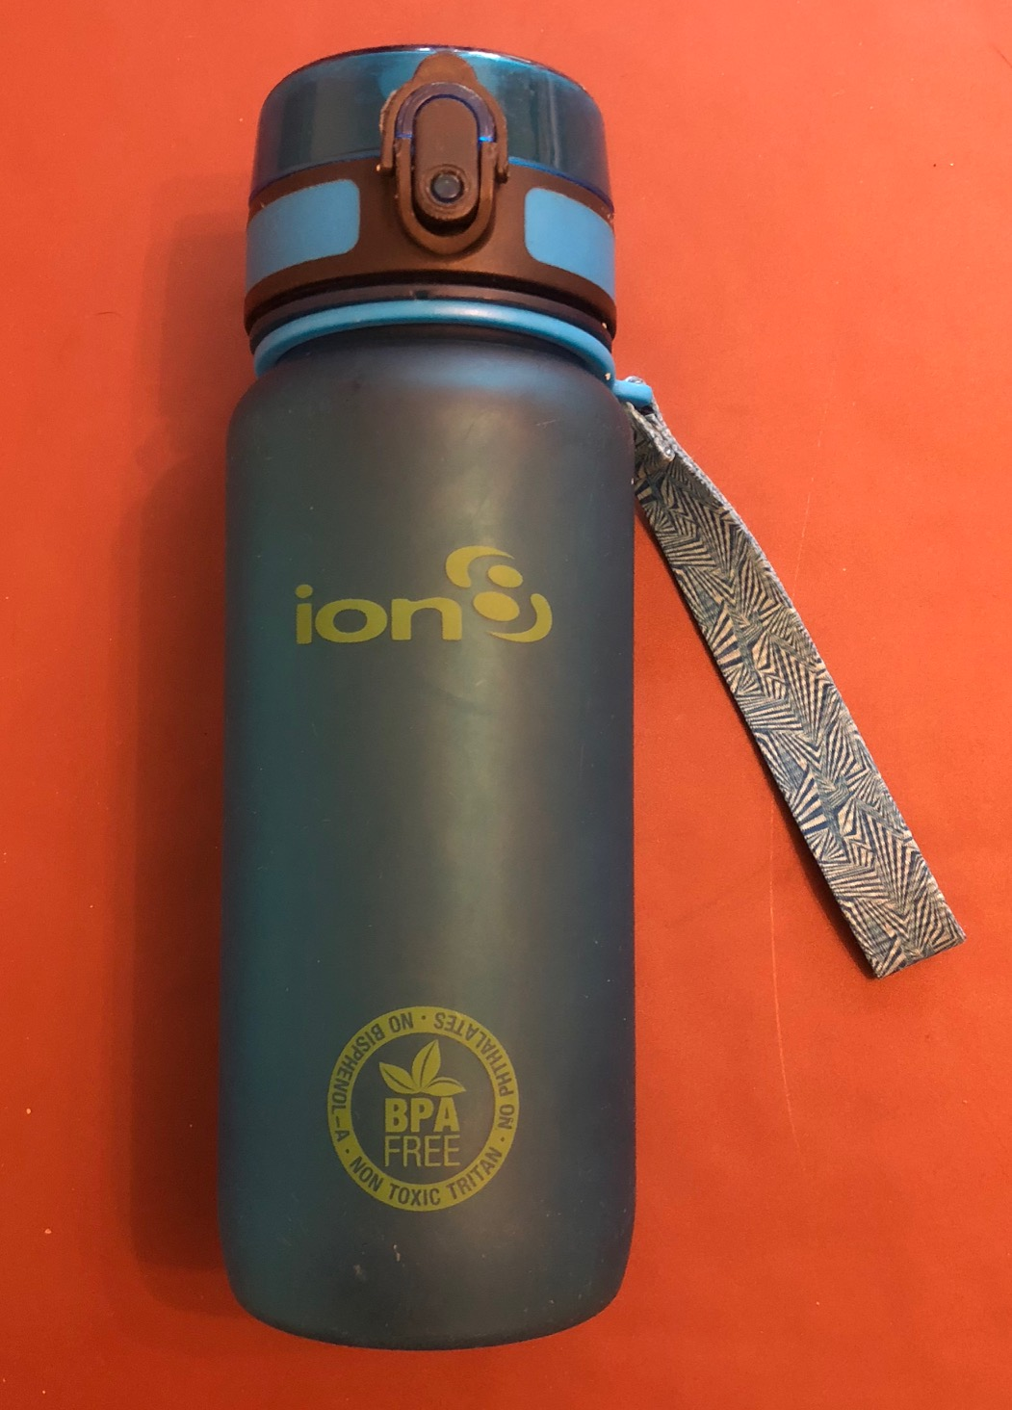 | 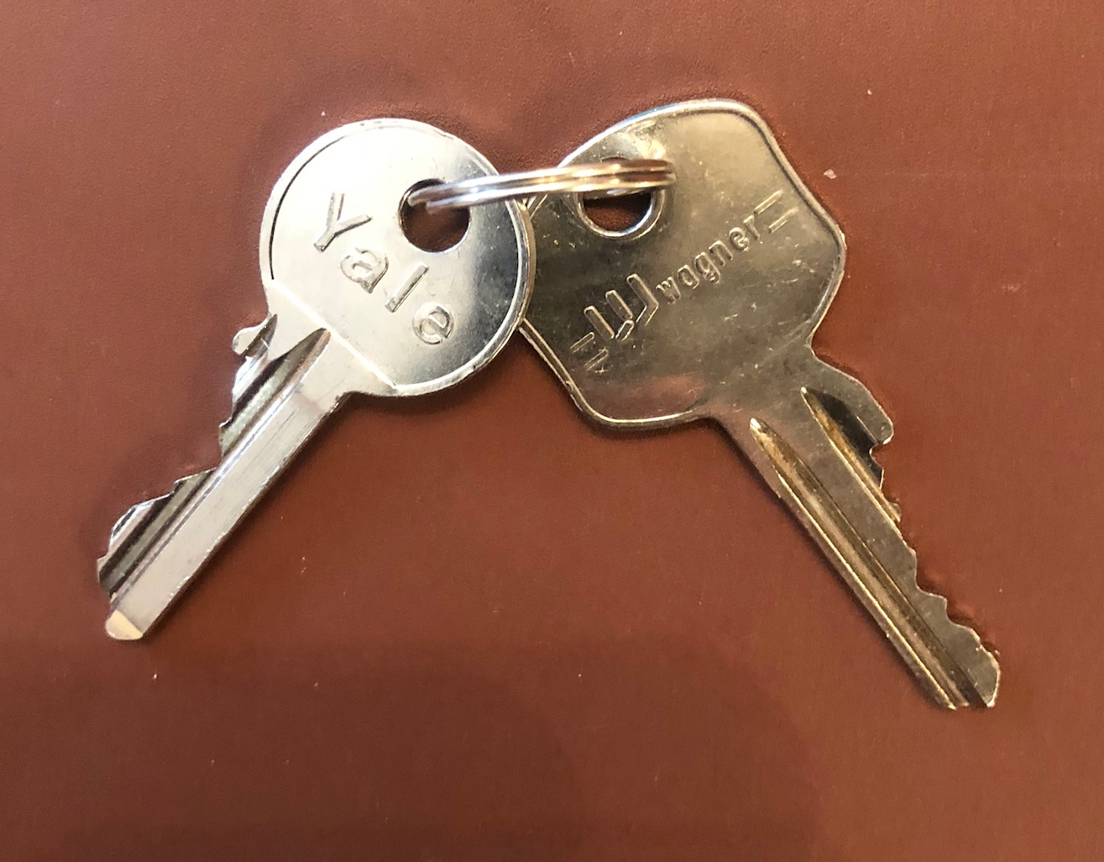
Ion Water Bottle | Door Keys
High Wycombe CC 10 Mile Time Trial 30/03/18 – Lost Property

