THE WELLAND TROPHY OPEN TIME TRIAL

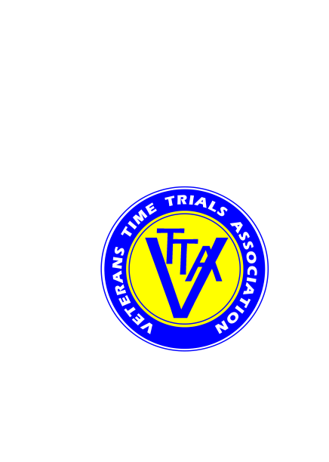

Supported by *ECHELON* Cycles, 124 High St, Pershore  WR10 1EA  01386 550606

(PROMOTED FOR AND ON BEHALF OF CYCLING TIME TRIALS UNDER THEIR RULES AND REGULATIONS)

SATURDAY 7 APRIL 2018, STARTING AT 14:00 HRS

COURSE K47/16, CASTLEMORTON

EVENT ORGANISERS:

Mike Amery, 18 Giffard Drive, Welland, Worcestershire WR13 6SE Tel: 01684 310168 [mikeamery58@gmail.c](mailto:mikeamery58@gmail.c)om

Alan Colburn, The Willows, Jury Lane, Martley  WR6 6PE Tel: 01886 888575 / 0755 428 4607 alan.colburn@martley.org

TIMEKEEPERS: Mrs Susan Kelly and Mr Charlie Barnett

EVENT HEADQUARTERS: Welland Village Hall WR13 6NE, at the crossroads of the A4104 and the B4208. Hall open from 12:30 hrs.

COURSE DETAILS:

Start on B4208 north at white line at entrance to Broatch Farm approx 400 yards north of Welland. **[Keep off the road while waiting to start]**

Proceed south on B4208 through Welland village.**[Take care through staggered crossroads and past parked cars]**

Turn left at Rye Cross junction onto A438 towards Tewkesbury (3.43 miles).

Turn left at junction with B4211 towards Upton upon Severn (8.58 miles).

Proceed through Longdon and turn left at Tunnel Hill junction with A4104 **[take care]** (13.03 miles) and proceed to Welland.

Finish at white line on drain cover immediately opposite a metalled field entrance approx 400 yards before staggered crossroads in centre of Welland village (16.07 miles).

NOTES:

* When you sign on, please indicate whether you are riding for the LVRC or VTTA for the team prize (if you are a member of both, you can choose which you ride for), and whether you are riding a road bike*.
* In the interests of your own safety, Cycling Time Trials and the event promoters strongly advise you to wear a hard shell helmet which meets an internationally accepted safety standard. This is mandatory for riders under age 18.
* Please do not use the course to warm up once the event has started. No U-turns in sight of the start or finish.
* Give way to traffic at junctions if you do not have right of way. Marshals have no authority to stop traffic.
* Results will be posted at the event HQ. Do not ask the timekeeper at the finish area.
* Please return your number to the event HQ in exchange for a free drink, and sign out.
* Results will be posted on the CTT, LVRC and VTTA websites.

PRIZES: 1st 2nd 3rd 4th 5th

Solo men on actual times £30 £20 £10

Solo women on actual times £20 £10

Solo vets on VTTA standards £30 £25 £20 £15 £10

Solo road bike* on actual times £20 Voucher £10 Voucher

2-up on VTTA standards (each) £15 Voucher

Team Prize (The Welland Trophy) based on best 6 results on vets standard from VTTA and LVRC - £10 per rider. This will comprise the best 5 solo results and the best 2-up team result (this formula may be changed on the day depending on numbers riding).

*Road bike is defined as: no wheels more than 50mm section, no aero bars, no pointy hat.

There will be a short prize presentation ceremony at the event HQ approximately 15 minutes after the last rider finishes. Please stay for this presentation if you can. One prize per rider, except for team prize.

The **Veterans Time Trials Association** was founded in 1943 and **is for anyone 40 years of age and over who has an interest in cycle racing, and specifically in time trialling.** For administration the Association is divided into 16 groups, based around geographical areas. Through these groups the VTTA organises time trials at all distances across the country. There are Individual Challenges, National Competitions, Local Competitions, and Social Events.

The **League of Veteran Racing Cyclists** was founded in 1986 to provide a programme of competitive and social cycling events for male and female members of 40 years and over. Most of its events are road and circuit races where riders compete against others in their own age group. Other events include time trials, track competitions and cyclo-cross races. National Championships are held in all these disciplines, as well as a national and regional season-long series of road races.

The Welland Trophy time trial was first run in 2015 and was the first event run jointly by the LVRC and VTTA in order to bring our members together in a competitive event, and to understand better each other’s organisations and activities.