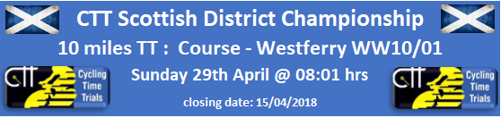
https://www.cyclingtimetrials.org.uk/race-details/16533
Gender Equality in Prize Awards - £100 to winner

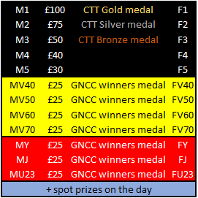

Event HQ: Bishopton Community Hall, Gledstane Rd, Bishopton, PA7 5AU
Event Sign On from 7:00 am
Event Organiser: Graeme Cockburn

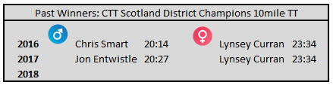
Can Lynsey make it a triple 23:34 this year !!

Notes for Competitors

- Sign on will be open from 7:00 am
- Please bring along a license/membership card to leave as deposit for your number- i.e. BC/TLI/CTC or similar.
- Please read the enclosed anti-doping notice.
- Under 18s must complete a parental consent form (attached at end of this document) and hand it in at sign on.
- The distance from Race HQ is approximately 2.5miles, heading west – please allow plenty of time to reach the start area before allocated time.
- Course Marshals have no legal authority to stop traffic on the course, and as such will only provide course directional information. It is a rider’s responsibility to abide by the rules of the Highway Code at all times. Police observers may be present on the course during the competition.
- Limited shower facilities are available at Race HQ, beyond the kitchen area - although these may be seconded for any anti-doping controls.
- Ideally all presentation awards will be at end of race – however we appreciate that the Ladies event, being at the front-end of the race, means the possibility of a lengthy wait until all results are in. Please let yourself be known to race organiser (Graeme Cockburn) should you need to leave before end. If circumstances dictate, then it may be prudent to bring the Ladies presentation forward.

** SPECIAL NOTICE FOR ALL COMPETITORS: PLEASE READ **

- We would like to draw everyone’s attention to competitor riding standards and the mechanical worthiness of their bicycle.
- We ask that all riders mitigate any risk to themselves; the promoting organisations; other road users; and the reputation of our sport by adhering to the following checklist
  - Please ensure that your bicycle is mechanically fit-for-purpose (steering; brakes; drive-chain; contact points etc).
  - Please adhere to the rules and regulations of the Highway code – once again I’ll emphasise that the event marshals are there for directional purposes only and have no authority to stop other road users at any point.
- Any rider that is reported by either event marshals or the Police as having posed a risk to themselves and/or other road users WILL incur sanctions - this may include disqualification.

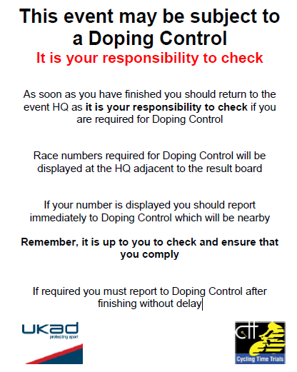

Course Details: Westferry WW10/01

1. Start under railway bridge on Greenock Rd heading West… approx. 2.5miles from RaceHQ
2. … Immediate LEFT on slip-road to A8 at Westferry roundabout…
3. …. Proceed westbound on A8…
4. …. Straight through first roundabout at Langbank….
5. …. Take 2nd exit at second roundabout at Woodhall…
6. …. Continue on A8 to TURN at Newark Roundabout… PLEASE OBSERVE EXTREME CAUTION.
7. …. Retrace to finish at slip-road to Westferry roundabout.

- Race HQ -> Start holding area
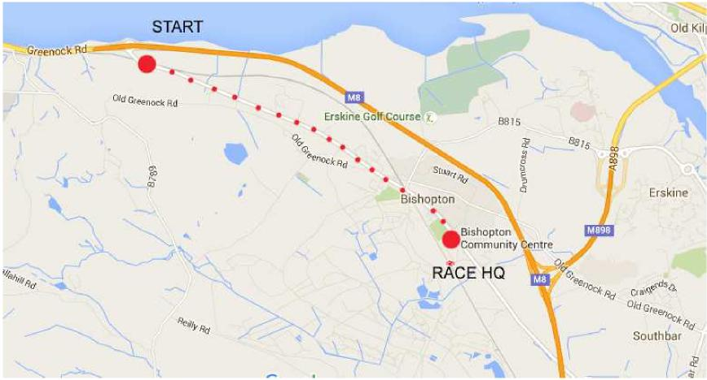

- Route Map with reference points 1-7 as above
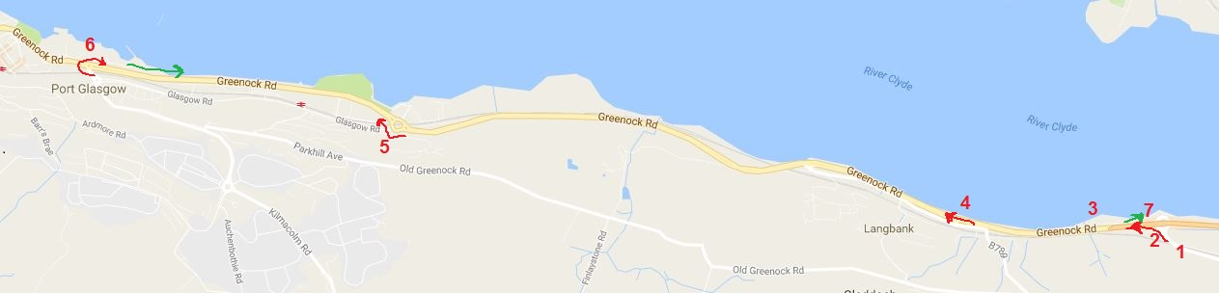
- Start and Finish points with Langbank roundabout (points 1,2,3,4,7)
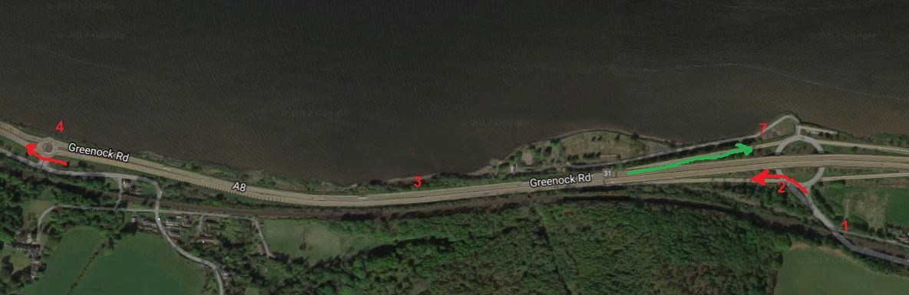

- Woodhall roundabout – exit 2nd left out and return legs (point 5)
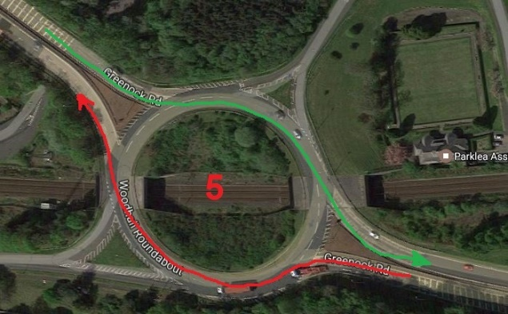
- TURN roundabout – PLEASE EXERCISE EXTREME CAUTION with approaching traffic (point 6)
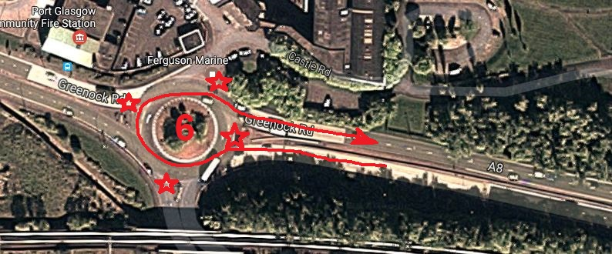
- Finish Slip-Road Approach (point 7)
