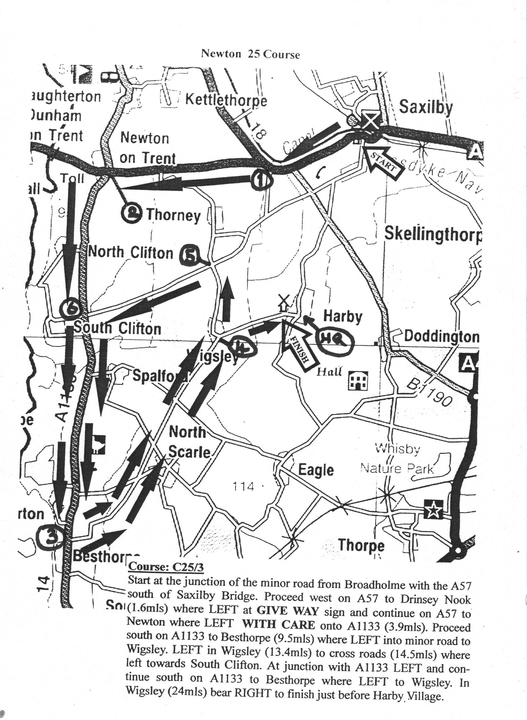

Lincoln Wheelers Tandem and Tricycle 25 mile Events
promoted for and on behalf of CTT under their Rules and Regulations
on Sunday 8th October 2017 from 10.00am

Course C25/3 Newton 25 miles.

Start at junction of minor road from Broadholme with A57 south of Saxilby Bridge. Proceed west on A57 to Drinsey Nook junction (1.6m) where bear left and continue on A57 to Newton. Left at junction in Newton (3.9m) onto A1133. Proceed south on A1133 to Besthorpe (9.5m) where sharp left onto minor road to Wigsley. Left in Wigsley (13.4m) to junction of minor road from Thorney to South Clifton (14.5m) where left again. Left onto A1133 to Besthorpe (20.0m). Sharp left onto minor road through Wigsley (24.0m) to finish at mark in road on approach to Harby village. Please see map

Event Headquarters Harby Village Hall situated in the middle of the Village (see map for location). The hall will be open from 8.00am. Parking is available in the car park and on one side of the road outside the Village Hall only. Please be quiet and be careful to park so as not to inconvenience any residents. (For sat nav use nearby Postcode NG23 7EQ)
NB Notes including up-to-the-minute information will be available at the signing on table. Please read them carefully and take notice for your own safety.

Event Secretary Peter Holland, Stepping Stones, Dunston, LN4 2EZ. 01526 322633.
Time Keeper Steve Walker, Lincoln Wheelers
Time Keeper’s Clerk Keith Barnard, Lincoln Wheelers
Handicapper Neil Winter
Result Board Andy Newham, Heidi De Wolf
Marshals Members and supporters of Lincoln Wheelers & the T.A.
Numbers and Signing on Will be at the event HQ. Exchange numbers for a cup of tea after your ride
ALL RIDERS PLEASE NOTE
No U turns are allowed in the vicinity of the start and finish. No warming up is allowed on the course once the event has started. Riders should clearly indicate their intention when making turns especially during the event.
The Lincolnshire Road Safety Partnership remind you that competitors should observe the Highway Code. The duty of marshals is to indicate which direction you should take. They cannot interfere with other traffic. You are responsible for your own safety. Keep your head up and take care.
A CTT Observer will be present. CTT strongly advise the wearing of a hard shell helmet that meets International Safety standards and to use a rear LED light.
Please allow enough time to reach the start which is approximately 3 miles from the event Headquarters
YOU MUST SIGN OUT AT THIS EVENT

25 MILE TRIKE EVENT
on Sunday 8th October 2017 AT 10.01am

No | Name | Club | Start | H’cap | Notes
1 | Dave Capps | Lincoln Wheelers | 10.01 | 27.00
2 | Ian Matthews | Team For 2000 | 10.02 | 26.00
3 | Jane Moore | Willesden CC | 10.03 | 25.00
4 | Ian Mackenzie | Southend Wheelers | 10.04 | 21.15
5
6
7 | Geoff Booker | Oxonian CC | 10.07 | 10.40
8
9 | Gary Wright | Lincoln Wheelers | 10.09 | 11.20
10
11 | Andy Newham | Lincoln Wheelers | 10.11 | 5.15
12
13 | Lez Young | Lincoln Wheelers | 10.13 | 7.30
14
15 | Ian Pike | Fenland RC | 10.15 | SCR

AWARDS (one prize per machine)
Fastest trike £15.00
2nd Fastest trike £8.00
1st handicap £15.00
2nd handicap £8.00

