Gloucester City CC -rudy project
(Ladies winner Louise Georgi)
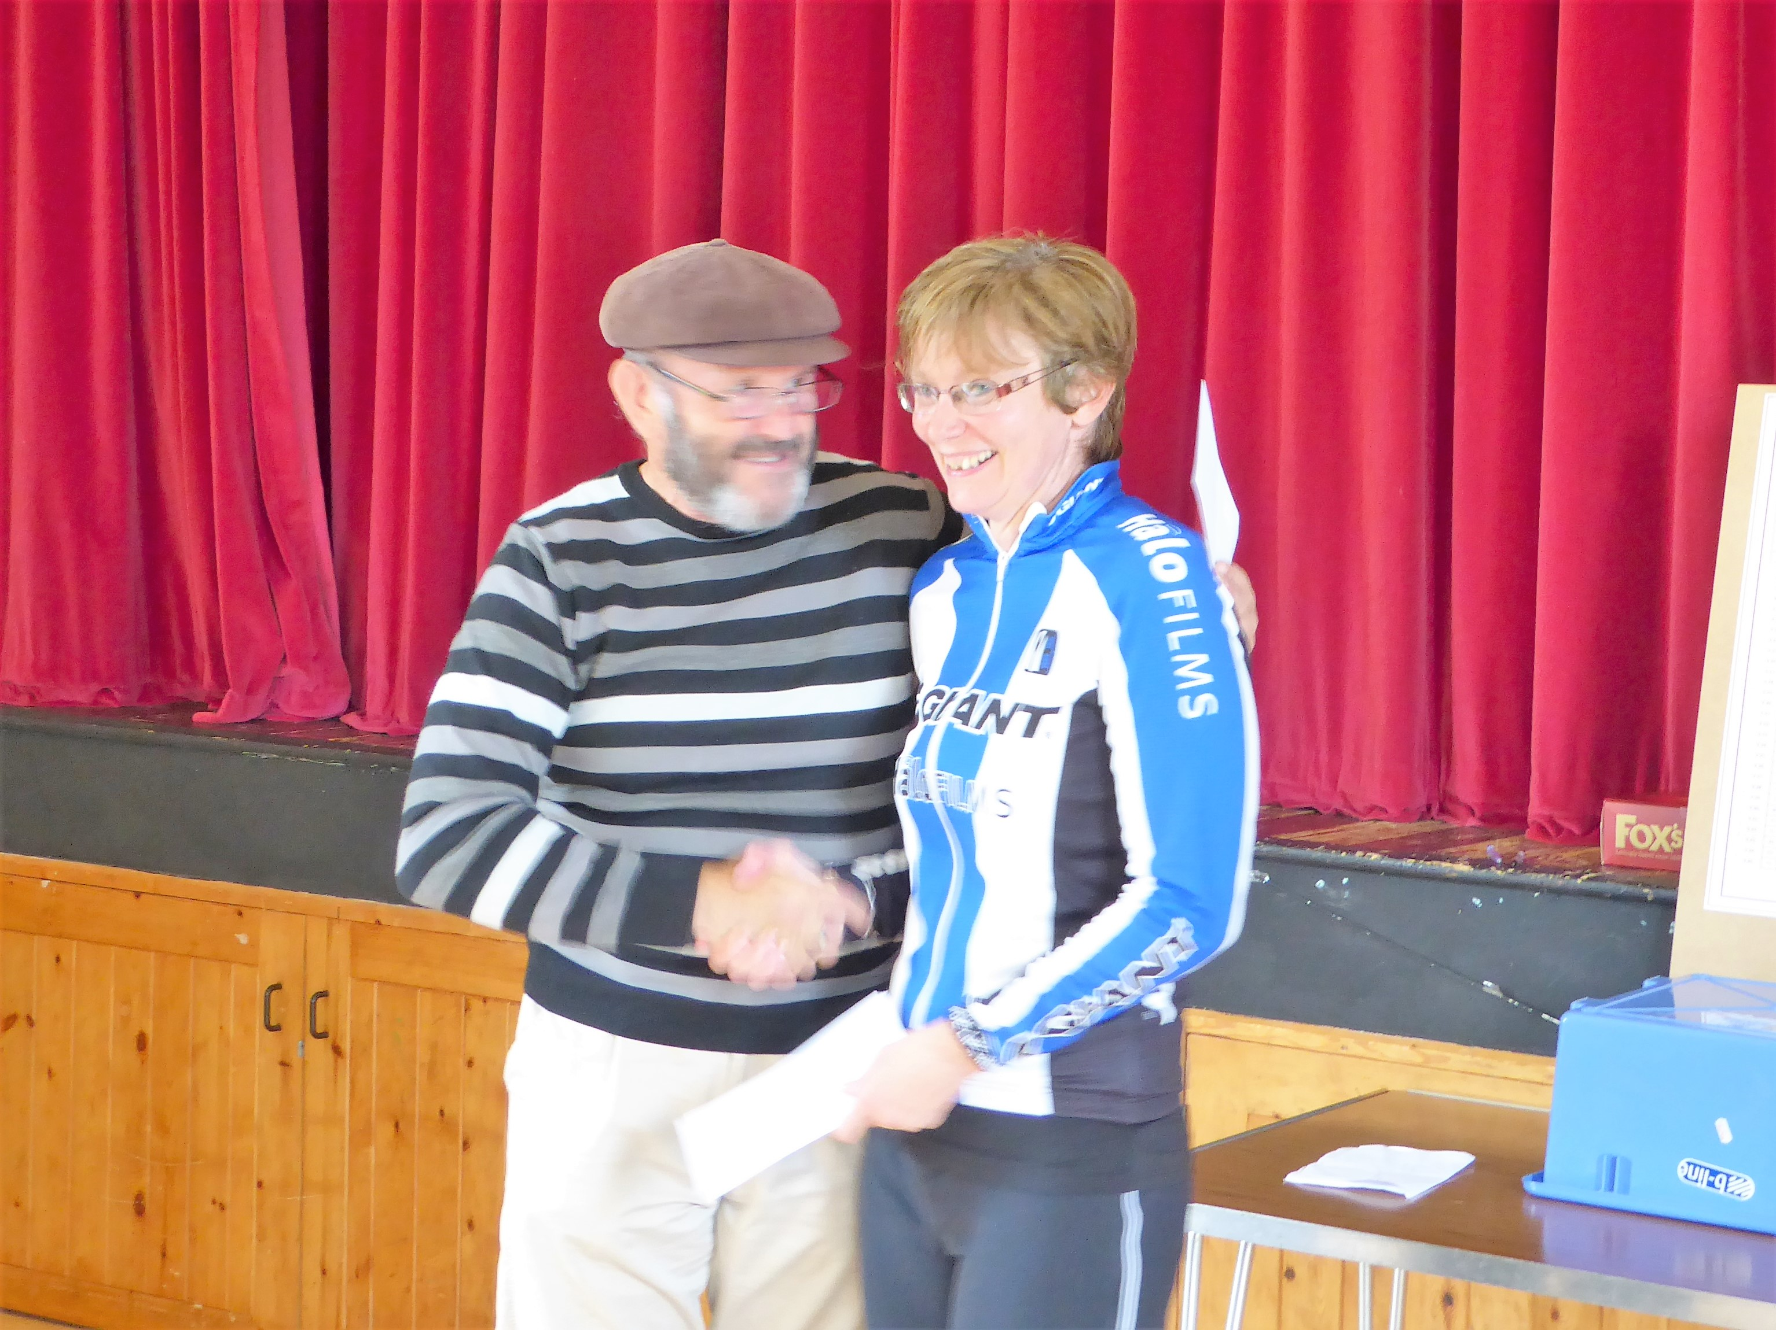

Gloucester 25 mile and 3up Time Trial.
Sunday 24th September 2017 on course U72
(Promoted for and on behalf of Cycling Time trials under their rules and regulations)

RESULT SHEET

Event Secretary: Gerry McGarr Phone No: 01452 451705
‘Tyndale Cottage’ Email: valmcgarr@valmcgarr.f9.co.uk
130 The Wheatridge East
Upton St Leonards
Gloucester
GL4 5DP

Hi everybody -trust you all travelled home safely and enjoyed a Sunday roast -cleaned your bikes and later went to bed happy souls!
(I travelled straight to Cricklade and commentated on the Cotswold League RR and then had a beer afterwards what a long day.)

We had a great morning for the race and congratulations to all prize winners and sorry to now realise that Dean missed course record by 5 seconds -Jeff Jones is still the holder with 53.25. A shame he was held up in places with agricultural vehicles like I hear several of you were. I believe the time has come for us to have an earlier start time on this course.

THANKS:
Mike and Sheila Edwards and Malcolm Grainger Time Keepers, Martyn Heritage-Owen for invaluable help with start and result sheets.
Catering team: ( back up singers! The 3 P’s) Pauline ,Pat, Penny
Results: Gordon Kay
Traffic Count: Jon David
Marshalls: Ted Tedaldi, Roy Hook, Ian Waring, George Unsworth ,Rob Warne, Chris Vasey
Pushers off: Colin Edmonds, Jon David, Gerard Francis Ambrose McGarr !
Result Sheet : Colin Edmonds.
Kit Caretaker: Ken Sheldon
Gloucester City Cycling Club : Donation to prize fund.
Arranging Prizes: Alistaire Goldie

PRIZE WINNERS: 3UP Fastest Team 1st to hold the Dr Henry Trophy
VC SEVALE
Jeremy Pile -Mike Amery-William Davies – 58.20

SOLO EVENT:
1st Dean Robson Northover VT /Rudy Project 53.30
2nd Etienne Georgi Team WIGGINS 55.40
3rdMark Corbett Worcester St Johns CC 56.53

1st Lady : Louise Georgi Giant CC /Halo Films 1.13.34

1st Senior Mark Hudson Bristol South CC 57.02 2nd Mark Davis Dursley RC 58.13
1st 0/40 Simon Garrett Worcester St Johns CC 58.30
1st 0/50 Carlo Toledo Gloucester City CC 1.0.28
1st 0/60 Paul Freegard Chippenham and District Whls 1.7.15
1st 0/70 David Miatt Corinium CC 1.32.18

Winning Team: Worcester St Johns CC. Mark Corbett, Simon Garrett, Steve Clark

I wish you all a good (warm) winter and hopefully see you all racing next season

Gerry McGarr

