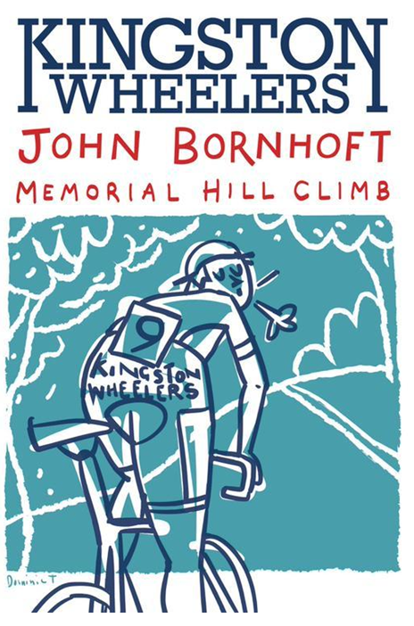
Saturday 30th September 2017 – 11am
FOR AND ON BEHALF OF CYCLING TIME TRIALS UNDER THEIR RULES AND REGULATIONS
TIMEKEEPERS – Michael Irons & Rob Gardner
EVENT SECRETARY: Alex Woods 35 Durlston Road, Kingston Upon Thames, Surrey, KT2 5RR TELEPHONE – 07743779543

John Bornhoft was President of Kingston Wheelers CC until his death in 2003. For many years John ran much of the club and was a constant source of encouragement for new members and an inspiration for the rest of us. Always a keen cyclist, he was a regular on both club runs and races well into his retirement. This race is held in his memory and with a field comprising of riders in their teens to those in their sixties, hill climb novices to National Hill Climb Champions is a fitting tribute to his work for the club.

Event Headquarters Forest Village Hall - Horsham Road, Forest Green , Surrey RH5 5RZ
Car parking for competitors and spectators will be available on Horsham Road. Please avoid using The Parrot Inn car park, as their car park is for patrons only.

Number collection and signing on will be at the Village Hall from 10am. Please sign on at least 30 minutes before your allocated start time. The course start is 1 mile from the village hall.

Prizes will be presented as soon as practicable after 1pm.

Course details: 1.4km, CTT LONDON SOUTH DC – 1,570 YARD HILL CLIMB – GH/42 (see map below);
OS REF | DETAILS | DISTANCES
134418 | START in Abinger Road , just east of Forest Green, at a gate on the west side of the road opposite the footpath to New Barn House at the bottom Leith Hill 580 yards north of the junction with the B2126 | 0.00 | 0..00
131431 | Proceed in a northerly direction past Leith Hill place to FINISH near summit of hill opposite grey metal painted post 70 yards before bridleway to Leith Hill Tower. | 1570 yds | 1570 yds

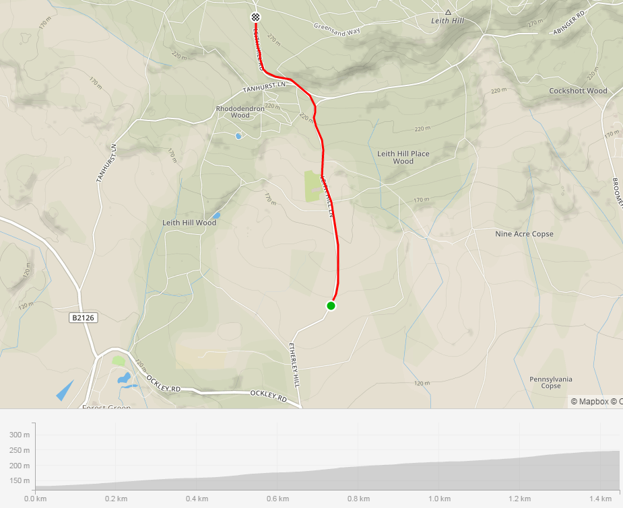

Competitor information
London South District Regulation: No vehicles shall be parked on the highway within sight of the starting and finishing points.
Competitors are requested not to warm up on the course after the first competitor has started.
Details of any hazards not listed on this start sheet will be displayed or advised at the signing on point. All competitors must take note of these details when they sign on.
Protective Helmets
All competitors under the age of 18 years and / or Juniors must wear a properly affixed helmet which must be of hard / soft shell construction. Helmets should conform to a recognised Standard such as SNELL B95, ANSI Z90.4, AUS/NZS 2063:96, DIN 33-954, CPSC or EN 1078. It is the responsibility of the rider (or parent or guardian if the rider is under 18 years of age) to:
(a) Select a Helmet that offers protection against head injury and does not restrict the rider's vision or hearing.
(b) Ensure that the helmet is properly fitted, is undamaged and in good condition.
Competitors under the age of 18 years may only compete with the written consent of their parent or guardian given on the form(s) currently prescribed by the National Committee. No form – No ride!

NUMBERS MUST BE FIXED BELOW WAIST
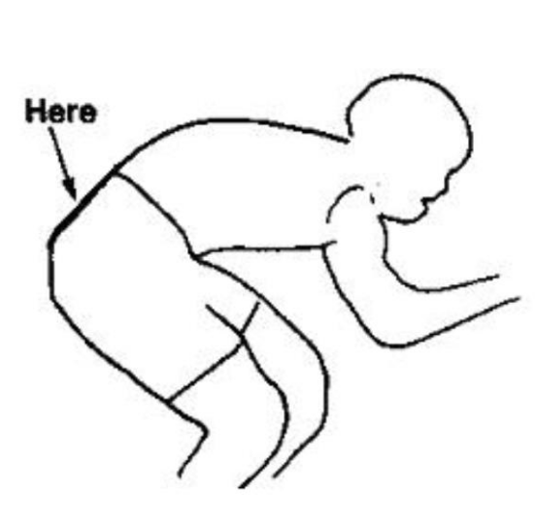
NO TIME MAY BE RECORDED IF NUMBER IS NOT CORRECTLY POSITIONED.
YOUR RESULT WILL BE CALCULATED FROM YOUR SCHEDULED START TIME AND NOT ADJUSTED FOR A LATE START.

Local Area Requirements
There are good toilets at the HQ, please use them rather than anywhere else
No riding ‘three abreast’
No swearing or hand gestures at car drivers
Please be respectful of horse and their riders – do not ride up behind them quietly so as to startle the horse!

Prizes
Prizes
 | 1 | 2 | 3 | 4 | 5 | Total
Senior Male | 50.00 | 40.00 | 30.00 | 20.00 | 10.00 | 150
Senior Female | 50.00 | 40.00 |  |  |  | 90.00
Veteran Male | 50.00 | 40.00 | 30.00 | 20.00 |  | 140.00
Junior | 50.00 |  |  |  |  | 50.00
Total Prize Fund |  |  |  |  |  | 430.00

1st from the Men’s and Women’s category will also receive a commemorative framed print of this year’s poster.
Please note: If you are eligible for multiple categories and podium, you will only receive a prize for the best result within a single category.
Start list
No. | Start Time | Name | Club | Category | Gender
7 | 11:07 | Dominic Wilson | Kingston Wheelers CC | Veteran | Male
8 | 11:08 | Chris Hartono | Brixton Cycles Club | Senior | Male
9 | 11:09 | Matt Harvey | Walden Velo | Senior | Male
10 | 11:10 | Neil Grunshaw | Kingston Wheelers CC | Senior | Male
11 | 11:11 | Jonathan Groves | Rapha Cycling Club | Veteran | Male
12 | 11:12 | David Michael | Kingston Wheelers CC | Veteran | Male
13 | 11:13 | James Scrivener | Reading CC | Senior | Male
14 | 11:14 | Iain Duncan | Crawley Wheelers | Veteran | Male
15 | 11:15 | Ben Speller | Kingston Wheelers CC | Veteran | Male
16 | 11:16 | Sean Taylor | Lea Valley CC | Senior | Male
17 | 11:17 | Debbie Percival | 34 Nomads CC | Veteran | Female
18 | 11:18 | kristin stolpe | Lovelo Cinelli RT | Senior | Female
19 | 11:19 | Jennifer Andrews | CC Ashwell | Senior | Female
20 | 11:20 | Alice Lethbridge | DRAG2ZERO | Senior | Female
21 | 11:21 | Aidan Culhane | Kingston Wheelers CC | Veteran | Male
22 | 11:22 | Oliver Bridgewood | Spokes BPC Racing | Senior | Male
23 | 11:23 | Tristan Abrahams | Kingston Wheelers CC | Senior | Male
24 | 11:24 | Daniel Arthur | VTTA (Surrey & Sussex) | Veteran | Male
25 | 11:25 | Miguel Pereira | Kingston Wheelers CC | Senior | Male
26 | 11:26 | David Wells | CC Ashwell | Veteran | Male
27 | 11:27 | Dominic Trevett | Kingston Wheelers CC | Senior | Male
No. | Start Time | Name | Club | Category | Gender
28 | 11:28 | Peter Franks | Charlotteville Cycling Club | Veteran | Male
29 | 11:29 | Jacob Kilby | G.S. Henley | Junior | Male
30 | 11:30 | lewis winfield | VC de Londres | Junior | Male
31 | 11:31 | Bill Bell | Bigfoot CC | Veteran | Male
32 | 11:32 | Noel Baker | Kingston Wheelers CC | Senior | Male
33 | 11:33 | Martin Headon | Dulwich Paragon CC | Senior | Male
34 | 11:34 | David Churchill | Bigfoot CC | Veteran | Male
35 | 11:35 | Mark Aldred | Kingston Wheelers CC | Senior | Male
36 | 11:36 | Joshua Aiken | Pedal Power Cycles Ipswich | Senior | Male
37 | 11:37 | Dominic Hill | Bec CC | Veteran | Male
38 | 11:38 | Oliver Hassall | Kingston Wheelers CC | Senior | Male
39 | 11:39 | Micha Gamper | Clapham Chasers | Senior | Male
40 | 11:40 | Tom Fricker | Farnham RC | Senior | Male
41 | 11:41 | Ross Bernard | Kingston Wheelers CC | Senior | Male
42 | 11:42 | Jon Heasman | Charlotteville Cycling Club | Veteran | Male
43 | 11:43 | Peter Kilby | Lewes Wanderers CC | Veteran | Male
44 | 11:44 | Alex Hamilton | Dulwich Paragon CC | Senior | Male
45 | 11:45 | Alex Reid | Kingston Wheelers CC | Senior | Male
46 | 11:46 | Sam Dorkings | GS Avanti | Senior | Male
47 | 11:47 | Craig Lawrence | Kingston Wheelers CC | Senior | Male
48 | 11:48 | Joshua Monk | The Cycleroom | Senior | Male
49 | 11:49 | Richard Parrotte | Shaftesbury CC | Veteran | Male
50 | 11:50 | David Ross | LFGSS CC | Senior | Male

