Darlington Cycling Club
Sunday 14TH Aug 2016

Promoted for and on behalf of Cycling Time Trials under their Rules and Regulations.

Event Secretary: Timekeeper:
Mike Drake Ray Lightle
35 Milbank Road Dave Oliver
Darlington
Co. Durham
DL3 9NL

Tel - 07702 311081

Start: First Rider off at 09.01 am Course T254

Course Description
Course Description: Start – on A6055 at expansion joint at south end of bridge, spanning Leeming Bar/Bedale road, approx 0.13mls north of Leeming Services roundabout. Ride South and go over first roundabout (Leeming Services), continuing through 2nd roundabout (RAF on A6055Leeming/Gatenby) to encircle 3rd roundabout (Sinderby 6.5mls). Retrace northwards back to 2nd roundabout (RAF Leeming/Gatenby) where straight over and continue to encircle 1st roundabout (Leeming services 12.8mls) to ride South. Straight on at 2nd roundabout (RAF Leeming/ Gatenby) to encircle 3rd roundabout (Sinderby 19.0mls). Retrace northwards to 2nd roundabout (RAF Leeming/Gatenby) where straight over to finish approx 0.4 mls south of Leeming Services roundabout at horse road sign at south end of armco barrier on bridge over Bedale Beck (25 mls).

The Attention of all riders is drawn to the District RTTC guidelines:

- No U-Turns will be permitted in the vicinity of the Start.
- No warming –up by any rider on course once the event has started.
- No Turbo trainers to be used within 100 yards of any inhabited property.
Marshals will be placed at all junctions.

HQ address - Leeming Village Hall, Mill Lane, Leeming, Northallerton, DL7 9SS.
No warming up at HQ, suggested area is south of the Village Hall heading towards Londonderry on the roadside
Parking/Warm Up Area – See details at H.Q. on the day, due to ongoing road works.
Prize List One Rider – One Prize

Fastest - 1st £50, 2nd £40, 3rd £30
1st 2nd 3rd

Age 20-39 - £30 £20 £15
Age 40-49 - £30 £20 £15
Age 50 -59 - £30 £20 £15
Age 60+ - £30 £20 £15
Fastest lady - £30 £20 £15

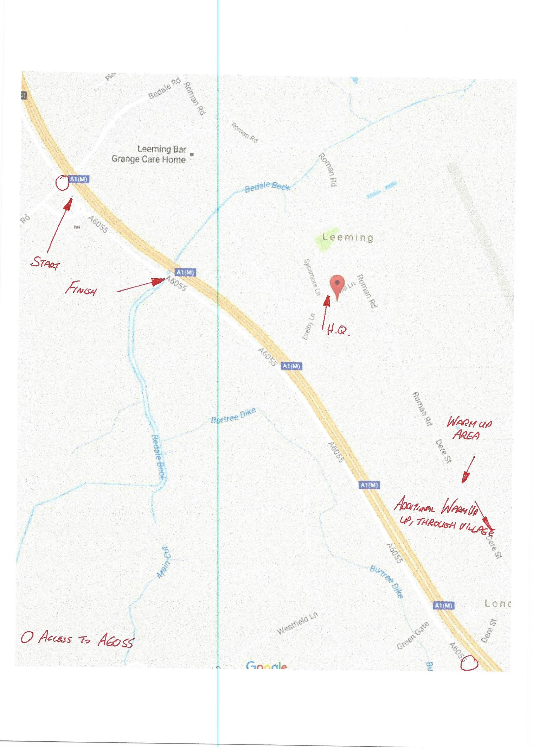

In the interest of safety, Cycling Time Trials and Event promoters strongly advise you to wear hard shell helmet that meets an internationally accepted safety standard. All competitors under the age of 18years/or Juniors must wear a properly affixed helmet, which conforms to recognised standards.

