2 up 10 mile Time Trial Sat 16/09/17 2pm
D10/1 Rainford

FOR AND ON BEHALF OF CYCLING TIME TRIALS
UNDER THEIR RULES AND REGULATIONS

IN THE INTERESTS OF YOUR OWN SAFETY
CYCLING TIME TRIALS AND EVENT PROMOTERS STRONGLY ADVISE YOU TO WEAR A HARD SHELL HELMET THAT MEETS AN INTERNATIONALY ACCEPTED SAFETY STANDARD.

IN ACCORDANCE WITH REGULATION 15 :ALL JUVENILE and JUNIOR COMPETITORS MUST WEAR PROTECTIVE HARD SHELL HELMETS.

IT IS RECOMMENDED THAT A WORKING REAR LIGHT, EITHER FLASHING OR CONSTANT, IS FITTED TO THE MACHINE IN A POSITION VISIBLE TO THE FOLLOWING ROAD USERS AND IS ACTIVE WHILST THE MACHINE IS IN USE.

ALL RIDERS MUST NOW SIGN OFF AS WELL AS SIGNING ON!!
PLEASE ALLOW SUFFICIENT TIME FOR THIS REQUIREMENT.

TIME KEEPERS:

MR STUART DALE (PRINCIPAL) KATHERINE WOODER (ASSISTANT)

ORGANISER:

DUFF FAWCETT duffjoy@blueyonder.co.uk Liverpool Braveheart BC

DO NOT PASS THE START OR FINISH ON YOUR WAY OUT OR BACK! FOLLOW THE ROUTE SHOWN ON THE MAP BY THE GREEN ARROWS. KEEP IN SINGLE FILE !!

PLEASE KEEP AWAY FROM THE BUNGALOWS IN THE HQ AREA. PARK VEHICLES
AT THE FAR END OF THE ROAD. RESIDENTS HAVE COMPLAINED ABOUT CYCLISTS HAVING “COMFORT BREAKS “IN THIS AREA
ANYONE FOUND WILL BE DISQUALIFIED
HEADQUARTERS: SAT NAV DIRECTIONS: WA11 7TA.

ORMSKIRK RD, RUNNING PARALLEL TO A570 RAINFORD RD. NEXT TO THE OLD WHEATSHEAF PUBLIC HOUSE. (SEE COURSE MAP)

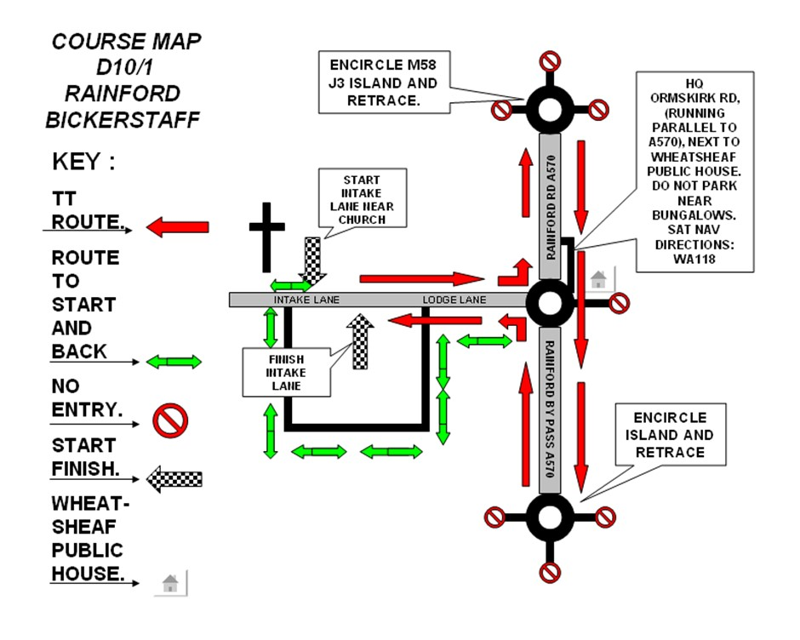

Start at the field entrance on Intake Lane at the first raised kerbstone 210 yds south of Bickerstaffe church. Proceed to Wheatsheaf island A570 Rainford Bypass and turn left (1.691m) Proceed to M58 island -take care here - and encircle (3.353m) Straight across Wheatsheaf island and proceed to Rainford island (6.98m) and retace back on A570 to Wheatsheaf island (8.736m) Left along Lodge Lane / Intake Lane to finish at second gatepost on edge of plantation

PRIZE LIST:
ONE TEAM ONE PRIZE

1st Club Team £60

2nd Club Team £30

3rd Club Team £20

1st Composite Team £30
1st Club Team inc Youth £40
1st Club Team inc Junior £40
1st Club Team inc Lady £40

1st Braveheart Team £40

If possible prizes will be presented in cash at the end of the TTT so please hang around for your cash !

